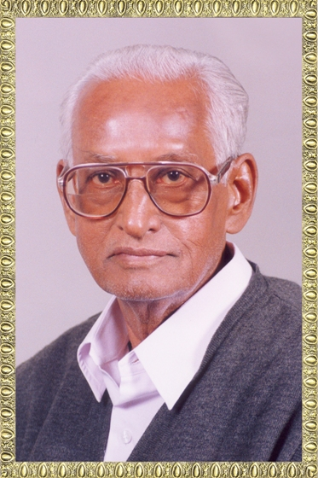


Shree H.N.Shukla College
2, Vaishali Nagar,
Nr. Amrapali Railway under bridge,
Raiya Road, Rajkot.
Ph. (0281)2440478

Shree H.N.Shukla College
3, Vaishali Nagar,
Nr. Amrapali Railway under bridge,
Raiya Road, Rajkot.
Ph. (0281)2471645

Website: www.hnsgroupofcolleges.org

Rules & Regulations

It is necessary for the students to appear in the internal exams, Unit test and submit the assignments given by the college.

Students are supposed to give correct mobile number and WhatsApp number so that they can get updates of all activities and academic things through messages.

Students have to regularly visit College website, Campus noticeboard and their particular class WhatsApp group for important updates.

Students will be responsible for any property damage cause by them in college or found misbehaving in college premise then he/she have to accept the decision taken by the college authority.

It is necessary for all the students to keep I-Card during college hours and in the case of I-Card lost, student should immediately inform to the in charge faculty.

It is desirable that students should participate in activities and celebrations conducted by the college.

It is the responsibility of student to be keep in touch with college for all important things like exam form, college activities, important dates & messages etc. College will not responsible for it.

Students shall not represent the college in any event or activity held outside the college without prior permission from the college authorities.

It will be student’s responsibility to park their vehicle properly.

It is desirable that students have to make project by themselves.
General Directions for upcoming semester (July to December – 2024)
2024

NO. | MONTH | EVENT | INCHARGE
1. | July | Submit Your college Fees | Admin  Department
2. | July | Collect Your College I-Card | Class Teacher
3. | July | Visit your college website | Every Week
4. | July | Collect material of all subjects in  softcopy | Subject Teachers
5. | July | Register your names for N.C.C | Nimesh Sir
6. | July | Register your names for Picnic | Mayur Sir  Vishal Sir
7. | July | Collect your model project  Definitions | Sangita Mam  Kalyani Mam
8. | July | Submit your main Project  Definitions | Your Project Guide
9. | July | Get Ready for Seminar | Vishal Sir
10. | July | Register yourself for different  clubs | Karishma Mam
11. | July | Get Ready for fresher party | Karishma Mam  Vishal Sir
12. | July | Submit your assignments | Subject Teachers
13. | July | Register your names for fun  games | Snehal Mam,  Sangita Mam
14. | July | Create your ABCID | Class Teachers
15. | July | Scholarship Process | Jigar Bhai
1. | August | Register your names for  Independence Day | Snehal Mam  Madhavi Mam
2. | August | Get Ready for Seminar | Vishal Sir
3. | August | Fill your exam form (T.Y) | Vishal Sir,  Karishma Mam
4. | August | Get Ready for Internal MCQ  Exams (S.Y and T.Y) | Brijesh Sir, Sangita  Mam
5. | August | Get Ready for Internal MCQ  Exams (S.Y and T.Y) | Brijesh Sir, Sangita  Mam
6. | August | Register your names for Open Mic  Competition | Snehal Mam,  Kalyani Mam
7. | August | Register your names for reels  making competition | Madhavi Mam,  Bansi Mam
8. | August | Register your names for youth  festival | Snehal Mam,  Leena Mam
9. | August | Register your names for  janmashtami Mahotsav | Karishma Mam,  Snehal Mam
1. | September | Fill up your exam forms (S.Y, F.Y) | Vishal Sir,  Karishma Mam
2. | September | Check your internal marks (T.Y) | Vishal Sir,  Karishma Mam
3. | September | Register yourself for Ganesh Utsav | Brijesh Sir Kalyani Mam  Bansi Mam
4. | September | Get Ready for practical exams  (T.Y) | Mayur Sir + Lab
5. | September | Submit your final project (T.Y) | Project Guide
1. | October | Get Ready for practical exams (S.Y  , F.Y) | Mayur Sir + Lab
2. | October | Get Ready for internal Marks (S.Y,  F.Y) | Vishal Sir,  Karishma Mam
3. | October | Submit your Model Projects (S.Y,  F.Y) | Sangita Mam  Kalyani Mam
4. | October | Get Ready for University Exams  (T.Y) | Mayur Sir,  Karishma Mam
1. | November | Get Ready for University Exams  (S.Y, F.Y) | Mayur Sir,  Karishma Mam
2. | November | Register your names for Live Concert | Karishma Mam Snehal Mam  Madhavi Mam

