Midwifery
INTRODUCTION
Midwifery is an ancient profession, with a proud tradition of providing care for women and babies during pregnancy and childbirth. The earliest birth attendants were women. In ancient mythology, goddesses (but not gods) were present at deliveries. In “primitive” tribes studied by anthropologists in the last century, the laboring woman would be accompanied by her mother or other female relative. Birthing stools and midwives are also mentioned in the Old Testament.
Terminology
Midwives were known by many different titles in antiquity, ranging from iatrinē (Gr. nurse), maia (Gr.,midwife), obstetrix (Lat., obstetrician), medica (Lat., doctor). It appears as though midwifery was treated differently in the Eastern end of the Mediterranean basin as opposed to the West. In the East, some women advanced beyond the profession of midwife (maia) to that of gynaecologist (iatros gynaikeios, translated as women's doctor), for which formal training was required.
Midwifery:
The art of assisting women in the childbirth has grown fulfilling its meaning “with women at birth”.
Midwife (ICM-1992):
A midwife is a person who, having been regularly admitted to a midwifery educational programme, duly recognized in the country in which it is located, has successfully completed the prescribed course of studied in midwifery & has acquired the requisite qualifications to be registered & or legally licensed to practice midwifery.
SCOPE
CERTIFIED NURSE MIDWIFE
- Registered Nurse
- Advanced Practice Nurse (APN)
- Master’s degree in Nursing
- Specializing in Midwifery
- Credentialing necessary for state licensing
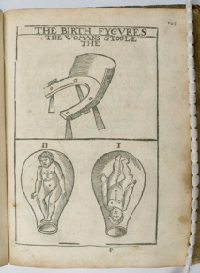
Historical review
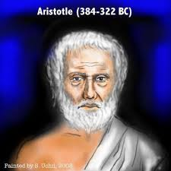
- In ancient Egypt, midwifery was a recognized female occupation, as attested by the Ebers Papyrus which dates from 1900 to 1550 BCE. Five columns of this papyrus deal with obstetrics and gynecology, especially concerning the acceleration of parturition and the birth prognosis of the newborn. The Westcar papyrus, dated to 1700 BCE, includes instructions for calculating the expected date of confinement and describes different styles of birth chairs. Bas reliefs in the royal birth rooms at Luxor and other temples also attest to the heavy presence of midwifery in this culture.
- Hippocrates (460BC), organized trained & supervised midwives. He believed that the fetus had to fight its way out of the womb & membranes.
- Aristotle(384-322BC), the father of Embryology described the uterus & the female pelvic organs. He also described the essential qualities of the midwife.
- Midwifery in Greco-Roman antiquity covered a wide range of women, including old women who continued folk medical traditions in the villages of the Roman Empire, trained midwives who garnered their knowledge from a variety of sources, and highly trained women who were considered female physicians.
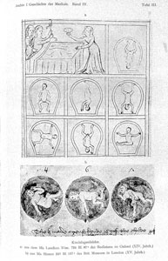
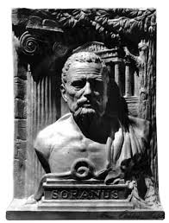
- Soranus of Ephesus writes on gynaecology. These illustrations, from a 14th century version of Soranus' Gynaecology, depict a variety of foetal positions within the uterus which is shown as an upside-down jar or vessel. In Medieval texts, the word vas (vessel) was used as a synonym for woman'. In the top picture, a woman in labour is shown hanging onto a rope. Soranus appreciated that infants did not always present head first, and in difficult labours, he recommended podalic version' whereby a hand is inserted into the uterus and the baby drawn out feet first.
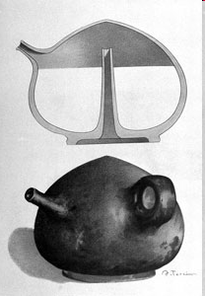
- Romans invent ingenious baby's bottle.
- This bottle, shaped like a female breast, was constructed so that no flies or dust could reach its contents. The milk was introduced by inverting the bottle, and pouring it through an open tube ascending within from the centre of the base almost to the apex (see cross section). This same tube prevented the escape of milk when the bottle was placed on its base. The child sucked through the spout, on the opposite side of which is a small round handle. Bottles like this from the 1st to 5th centuries CE.
- Soranus taught that breast-feeding should not begin until 3 weeks after birth so that the mother might regain her health and produce wholesome milk.
- Substitutes for human milk included honey diluted with water or goat's milk although neither would have provided the correct balance of nutrients and fat content. If a wet-nurse was not available for this important period in a new-born's life, its survival prospects on artificial feeding would have been grim.Votive offering excavated from Forum of Augustus, Rome.
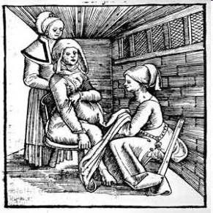
- Leonardo da Vinci(1452-1519) made anatomical drawings of pregnant uterus.
- In 1513 Rösslin publishes first textbook for midwives.This is an illustration from the first printed textbook for midwives, written by a German physician, Eucharius Rösslin. The text was largely compiled from the writings of Soranus although Rösslin added his own woodcuts. The book went through at least 40 editions and, in 1540, was translated into English as The byrthe of mankynde. It maintained its place as a textbook of midwifery until the 18th century.
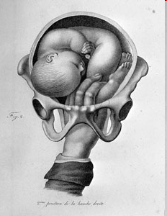
- Ambroise pare(1510-1590) laid the foundations of modern obstetrics. He performed internal podalic version & skillfully delivered women (In this manouevre, the doctor introduces a hand into the womb to turn a malpositioned child so that it can be delivered feet first).
- He was first to deliver a women in bed instead of the birthing stool.
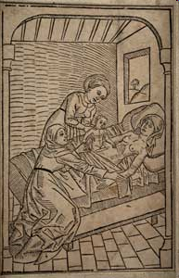
- He founded the school for midwife in Paris.
- Julius Caesar Aranzi, advised the Caesarean Section for the contracted pelvis.
- He wrote the first book for Italian midwives which ran 17 edition.
- 1610 - First documented Caesarian section in which mother survives.
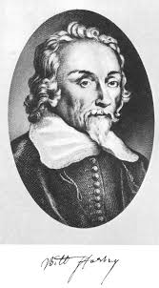
- William Harvey (1578- 1657), the father of British of British midwifery, wrote the first English textbook on midwifery

- He describes the fetal circulation & placenta, & Was the first deliver the fetus by massaging the uterus.

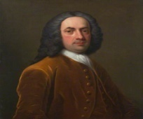
- Mauriceau was the greatest physician of the 17th century. He described the attitude of the fetus in uterus.
- Chamberlen in 1675, designed obstetric forceps.
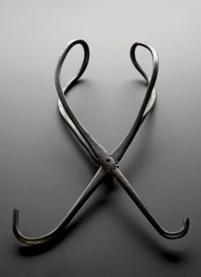
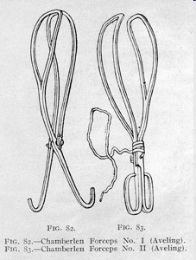
- {The Chamberlens moved in the highest circles although it is doubtful whether this was due entirely to their forceps. They were clearly accomplished men-midwives. In 1628, Hugh Chamberlen's son, Peter, was called to attend Henrietta Maria, wife of Charles I (reigned 1625-1649), after the midwife in charge swooned with fear' on entering the queen's bedchamber. Whether he used the forceps (always carried in a box) is unrecorded. In 1818, several pairs of forceps were found in a secret compartment at Woodham Mortimer Hall near Maldon, Essex, which had once been the home of Peter Chamberlen's son, also called Peter (1602-1683)}.
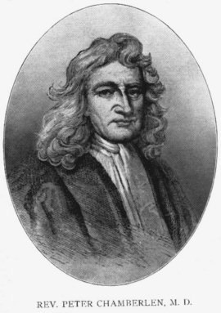

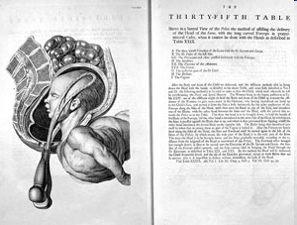
Delivery of a child with forcep
William Smellie at first employed wooden forceps so as to avoid the clinking noise of the metal blades. Later, he modified the shape of metal forceps by adding the long pelvic' curves and bound the blades with strips of leather (as in this illustration). He did suggest that the leather should be renewed after each case. He devised a lock for the obstetric forceps, which is permitted each blade to be introduced separately.
- He explained labor to be a mechanical process & described pelvimetry, cephalometry.
Criminal Abortion
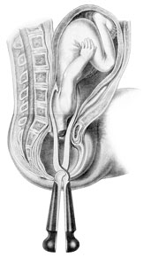
- This illustration, from an early 19th century textbook of operative midwifery', shows a procedure for removing a child during obstructed labour. The head of the child has been broken up (craniotomy) and removed via an instrument introduced into the womb, after which the headless body is delivered with obstetric forceps. This unfortunate and crude delivery technique, practiced since antiquity, often endangered the life of the mother by tearing the cervix and womb or introducing potentially lethal germs into the maternal passage. In the hands of poorly trained doctors, craniotomy was a very dangerous procedure.
- Charles white in 1773, stated that puerperal fever was infectious. He used the lime as disinfectant & clean linen, isolation, adequate ventilation & sitting posture to facilitate drainage.
- Fielding Ould (1710-1789) described the mechanism of labor. & performed the first episiotomy.
- Gordon in 1795 described the puerperal sepsis.
- Laennec in 1816, invented the stethoscope.
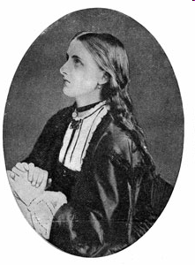
- Francois in 1818, first recognized fetal heart sounds in the pregnant uterus.
- 1847 First child born under anesthesia.
- James Young Simpson discovered the anesthetic effects of chloroform (by accident when he and his assistants were experimenting with chemicals and somebody upset a bottle. When Simpson's wife brought in dinner she found them all asleep).
- Florence Nightingale in 1862 , organised a small training school in connections with the King’s College Hospital, where she conducted the training for midwives.
- 1933 Robert James Minnit invents
gas and air apparatus for the relief of labor pain.
The gas and air machines used by midwives were portable and easy to use. This photograph, showing a midwife applying the mask, was produced for promotional purposes by the British Oxygen Company who supplied the gases used with the machines. Machines donated by the National Birthday Fund carried plaques indicating their provenance.
- Grandly Dick-Read's modern' approach to childbirth included education, correct breathing, relaxation and exercises' which would help a healthy woman achieve a natural birth'. In fact, the techniques were based on his investigations of childbirth practices amongst non-westernised African communities.
Neonatal intensive care – 1990
- By the 1990s, a child born at 22-23 weeks gestation (the normal period is 40 weeks) had about a 24% chance of survival whilst one born at 25 weeks had a 50% chance. Most infants born after 32 weeks survived. The viability of fetuses at such early stages of development raised issues surrounding the 1967 Abortion Act which made termination of pregnancy legal until 28 weeks. Various campaigns were mounted to limit the time to 20 weeks.
- In this hospital labour ward of the 1990s, the mother is attended by a midwife and doctor. The father-to-be, no longer forced to pace the floor outside the delivery room, is encouraged to participate in the birth.
In vitro fertilization 1969
In this colour-enhanced scanning electron micrograph (SEM), a human sperm attempts to fertilise an egg. Once the sperm has fused to the egg cell membrane, the zona reaction' takes place which prevents other sperm from entering the egg.
First test-tube baby 1978
- 8-celled human embryos.Light microscope image of two8-celled human embryos ready to be implanted into their mother's womb. Pre-implantation embryos withstand freezing for long periods of time allowing them to be implanted at intervals coinciding with normal birth spacing.
CONCLUSION
- The history of midwifery is a long and interesting one.
- Women of all countries have done noble work as midwives throughout the countries.
- Socrates mother was a midwife and he considered it “a most respected profession”.
- According to Aristotle, a midwife is a most necessary and honorable office, being a helper of nature.
- Midwife carries a huge responsibility in helping women during childbirth.
- Biblical references to midwives have always been to their honor. There are instances in the Old Testament to show that midwives play vital role.
- Until the end of the sixteenth century, midwifery was practiced entirely by women. Men could be severely punished for attending women in childbirth.
- In the seventeenth century male midwives began to take up midwifery.
- By the middle of the eighteenth century the number of male midwives had increased, though there was great opposition and competition from the midwives and from the general public.
- In English the word midwife means “With woman” (the person with the woman who is in labor).
- Midwives hold an important key to positive care at the time of childbirth that will contribute to a good.

