Shree H.N. Shukla College of I.T. &Mgmt, Rajkot
2-Vaishalinagar, 3-vaishlinagar,
Raiya Road, Raiya Road,
Nr. Amrapali Railway Crossing, Nr. Amrapali Railway Crossing, Rajkot 360001, Rajkot 360001.

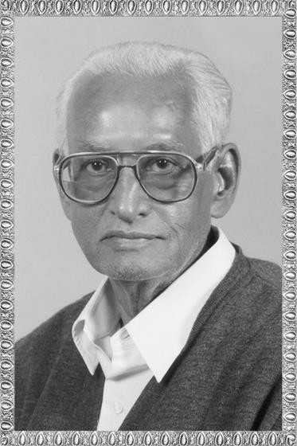

PGDCA - 2 SAD

ShreeH.N.ShuklaCollege Campus, Street No. 2, Vaishali Nagar,
Nr. Amrapali Railway Crossing,
Shree H.N.Shukla College Street No. 3, Vaishali Nagar, Nr. Amrapali Railway Crossing,

Website: www.hnsgroupofcolleges.org Email : hnsinfo@hnshukla.com

SAD, Software Quality Assurance and Testing Page No:1

Shree H.N. Shukla College of I.T. &Mgmt, Rajkot
2-Vaishalinagar, 3-vaishlinagar,
Raiya Road, Raiya Road,
Nr. Amrapali Railway Crossing, Nr. Amrapali Railway Crossing, Rajkot 360001, Rajkot 360001.
 |  |  | SAD, Software Quality Assurance and Testing
 |  |  | Sr.  No. | Topics | Detail | Mark | Min. Lect.
 |  |  | 1 | System analysis & design AND Software Engineering | - Definitions:-  (System, SubSystem, Business System, Information System(Defination only)  - System Analyst  (Role: Information Analyst, System Designer & Programmer Analyst)  - SDLC  - Fact-Finding techniques (Interview, Questionnaires, Record review&observation)  - Tools for documenting procedures and decidions (Decision tree & Decision table)  - Data Folw Analysis Tool  (DFD(context and zero level) and data dictionary)  - Software Engineering  (Brief introduction) |  | 10
 |  |  |  | Concepts of Quality Assurance | - Introduction of QA  - Quality Control(QC)  - Difference between QA & QC  - Quality assurance activities |  | 5
SAD, Software Quality Assurance and Testing Page No:2

Shree H.N. Shukla College of I.T. &Mgmt, Rajkot
2-Vaishalinagar, 3-vaishlinagar,
Raiya Road, Raiya Road,
Nr. Amrapali Railway Crossing, Nr. Amrapali Railway Crossing, Rajkot 360001, Rajkot 360001.

UN IT-1 (PART – 1)

TOPIC:- SYSTEM ANALYSIS & DESIGN AND SOFTWARE ENGINEERING

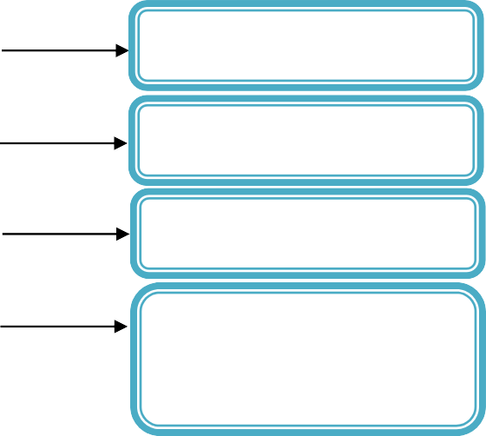
SYSTEM ANALYSIS
SYSTEM
SUBSYSTEM
BUSINESS SYSTEM
INFORMATION
SYSTEM

Definitions:

→ System: -
o A system is simply a set of components that interact with each other to accomplish some purpose or a particular goal.

→ Subsystem: -

SAD, Software Quality Assurance and Testing Page No:3

Shree H.N. Shukla College of I.T. &Mgmt, Rajkot
2-Vaishalinagar, 3-vaishlinagar,
Raiya Road, Raiya Road,
Nr. Amrapali Railway Crossing, Nr. Amrapali Railway Crossing, Rajkot 360001, Rajkot 360001.

- A business is also a system. Its components are marketing, manufacturing, sales, research, shipping, accounting and personnel – all work together to create a profit that benefits the employees and stock holders of the firm. Each of these components is itself a system and it is called subsystem.
→ Business System: -
- A business is also a system. Which is having a set of components that interact with each other to fulfill the business goals? And fulfill the business needs.
→ Information System: -
- Every business system depends on a more or less abstract entity called an information system. This system is the means by which data flow from one person/department to another. Information system helps all the system of business, linking the different component in such a way that they effectively work towards the same purpose.
- The purpose of information systems are to process input, maintain data and produces information, reports and other output.

  - WORD QUESTION ANSWER
 |  | NO. | QUESTION | ANSWER
 |  | 1. | How many Type of System Analysis? | 4 Types
 |  | 2. | What is System? | Set of components that interact with each other
 |  | 3. | What is Business System? | Used to full fill the business goals
 |  | 4. | What is information system | Provide information related to any system
 |  | 5. | What is Purpose of Information System? | The purpose of information systems are to process input, maintain data and produces information, reports and other output.
 |  | SAD, Software Quality Assurance and Testing Page No:4

Shree H.N. Shukla College of I.T. &Mgmt, Rajkot
2-Vaishalinagar, 3-vaishlinagar,
Raiya Road, Raiya Road,
Nr. Amrapali Railway Crossing, Nr. Amrapali Railway Crossing, Rajkot 360001, Rajkot 360001.

- Topic : SYSTEM ANALYST: (2 OR 3 MARKS) (IMP)
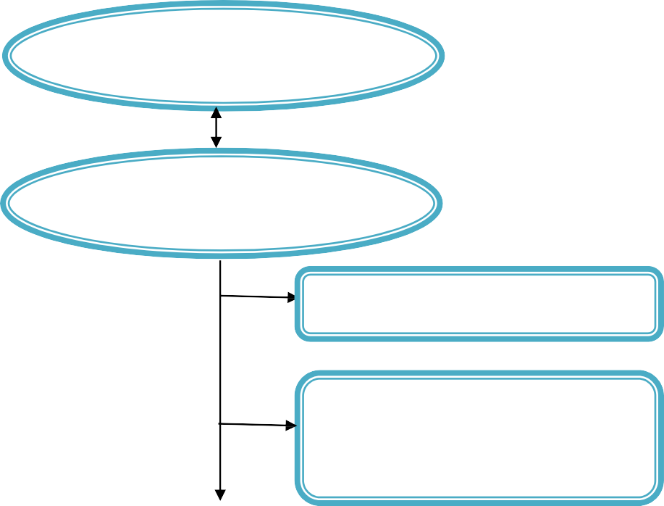
SYSTEM ANALYST
ROLE
Information analyst
System Analysis &
Design

System analyst is a person who is responsible to fulfill the needs of organization and provide the information.
- A system analyst’s primary responsibility is to identify information needs of an organization and obtain a logical design of an information system which will meet these needs.
- Three groups of people are involved in developing information systems for organization managers, users of the systems and computer programmers. The efforts of the system analyst is to co-ordinates all these group, to effectively develop and operate computer based information system, some important function of system analyst can be expressed as follow:
Defining requirement
Categorized the requirements and determines the priority. Gathering data, facts and opinions of facts.
Analysis and evaluation
SAD, Software Quality Assurance and Testing Page No:5

Shree H.N. Shukla College of I.T. &Mgmt, Rajkot
2-Vaishalinagar, 3-vaishlinagar,
Raiya Road, Raiya Road,
Nr. Amrapali Railway Crossing, Nr. Amrapali Railway Crossing, Rajkot 360001, Rajkot 360001.

Solving up specifications Designing system Evaluating syste
- Role:-
  - Information analyst: - In this role the analyst is responsible to find the information and together the information to fulfill the requirement of the organization.
  - System Analysis & Design:- System analysis and design refers to the process of organizing situation with the intent of improving it through better procedures & methods.
  - System developments have two major components:
    - system analysis
    - system design
System design is the process of planning a new business system or one to replace an exiting system.
System analysis is the process of gathering & diagnosing problems & using information to recommends important to the system.

- Role:-
  - Information analyst :-
  - System Analysis & Design:-
 |  | NO. | QUESTION | ANSWER
 |  | 1. | How many components of System developments? | 1.system analysis, 2.system design
 |  | 2. | What is System Design? | The process of planning a new business system.
 |  | 3. | What is System Analysis? | The process of gathering & diagnosing problems
 |  | 4. | What is System Analyst? | System analyst is a person who is responsible to fulfill the needs of organization and provide the information
 |  | SAD, Software Quality Assurance and Testing Page No:6

2-Vaishalinagar, 3-vaishlinagar,
Raiya Road, Raiya Road,
Nr. Amrapali Railway Crossing, Nr. Amrapali Railway Crossing, Rajkot 360001, Rajkot 360001.

- Topic : SDLC: (5 MARKS)(MIMP)

Preliminary investigation

System analysis

SDLC
System design Coding

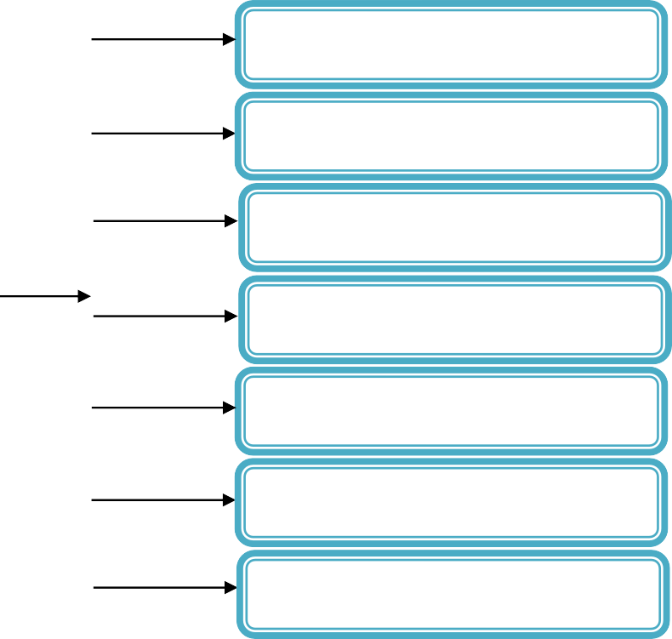Testing

Implementation

Implementation

SDLC is a classical thought of as the set of activities that analysts, designers, and users carry out to develop and implement an information system. SDLC consist of the following six activities:

Preliminary investigation :
A request is made by a manager, an employee or a system specialist for information system. From this point the first system activity, the preliminary investigation starts. It consists of three parts
- Request clarification : The users or the persons who wants the information system, their request are not clear, therefore before any system investigation can be consider, the project request must be examined to determine precisely what the originator wants.

2-Vaishalinagar, 3-vaishlinagar,
Raiya Road, Raiya Road,
Nr. Amrapali Railway Crossing, Nr. Amrapali Railway Crossing, Rajkot 360001, Rajkot 360001.

- Feasibility study: When ever any user request is clarified, then it is very much important to determine whether the system request is feasible or not. There are three aspects in the feasibility study i.e.
Technical feasibility: Can the work for the project be doe with current equipment, existing software technology and available person?
Economic feasibility: Are there sufficient benefits in creating the system to make the cost acceptable?
Operational feasibility: will the system be used if it is developed and implemented? The feasibility study is carried out by a small group of people who are familiar with information system techniques as well as the routine and detail activities of the organization.

- Request approval: All requested projects are not desirable or feasible. However, those projects that are both feasible and desirable should be put into a schedule. If the systems developer are free then the development process will be immediately started otherwise, the proposal will be put into the priority queue depending upon the important.

System Analysis (Determination of system requirements):
The detailed understanding of all important facts of the business area under investigation is the key point or heart of the system analysis. The analyst must study the business process, so that the questions related to study, can be answered. For these the system analyst has to work with variety of persons to gather details about the business process.
As the details are gathered, the analyst studies the requirement data to identify features the new system should have.

System Design:
The design of information system produces the details that state how a system will meet the requirements identified during systems analysis. Some times this stage is called logical design. In controls to the process of development program software, which is referred to as physical design?
System analyst begins the design process by identifying reports and other outputs, usually designer sketch it to appear when the system is complete. This may be done on paper.
The system design also describes the data to be input, calculated or stored. Individual data items and calculation procedure are written in detail.
The detailed design information is passed on to the programmers with complete and clearly outlined software specifications. As programming starts, designers are available to

2-Vaishalinagar, 3-vaishlinagar,
Raiya Road, Raiya Road,
Nr. Amrapali Railway Crossing, Nr. Amrapali Railway Crossing, Rajkot 360001, Rajkot 360001.

answer questions, clarify fuzzy areas & handle problems that confront the programmers when using the design specifications.

- Coding (Development of software):
Software developers may install purchased software or they may write new, custom designed programs. The choice depends on the cost of each option, the time available to write software and the availability of programmers.
Programmers are also responsible for documenting the program, providing an explanation of how and why certain procedures are coded in specific ways.

System testing:
In testing, the system is used experimentally to ensure that the software does not fail.
I.e. that it will run according to its specifications and in the way users expect. Special test data are inputted for processing, and the result examined. A limited number of users may be allowed to use the system so analyst can see whether they try to use it in unforeseen ways.
In many organizations testing is performed by persons other than those who wrote the original programs to ensure more complete and unbiased testing and more reliable software.

Implementation & evaluation:
Implementation is the process of having systems personnel check out and put new equipment into use, train users, install he new applications and construct any files of data needed to use it.
Evaluation of the system is performing to identify its strengths and weakness. The evaluation process can be categorized in following three ways:
  - Operational evaluation: In this, it will determine how system is functioning; it also includes ease of use, response time, suitability of information formats, overall reliability and level of utilization.
  - Organizational impact: Identification and measurement of benefits to the organization in such area as financial concerns (cost, revenue and profit), operational efficiency and competitive impact.
  - User manager assessment: Evaluation of the attitudes of senior and user managers within the organization, as well as end users.
  - Development performance: It measure overall development time and effort, conformance to budgets and standards, and other project management criteria, includes assessment of development methods and tools.

Shree H.N. Shukla College of I.T. &Mgmt, Rajkot
2-Vaishalinagar, 3-vaishlinagar,
Raiya Road, Raiya Road,
Nr. Amrapali Railway Crossing, Nr. Amrapali Railway Crossing, Rajkot 360001, Rajkot 360001.

(7) Maintenance:-
Maintenance follows a CBIS. As users develop faith in a CBIS, their demands on the system will grow. The system design should be flexible enough to accommodate future requests; refinements, modifications and changes to suit users’ requirements. Well documented logical and physical designs of a CBIS will facility its maintenance considerably.
 |  | NO. | QUESTION | ANSWER
 |  | 1. | SDLC | System development life cycle.
 |  | 2. | How many Feasibility study in Preliminary investigation? | Technical feasibility, Economic feasibility,  Operational feasibility
 |  | 3. | How many Part Availabal in Preliminary investigation? | Request clarification, Feasibility study,  Request approval
- Topic : FACT FINDING TECHNIQUES (3 MARKS)(IMP)

FACT FINDING TECHNIQUES

Interview Questionnai Record Review Observation Structured Interview

Unstructured Interview

SAD, Software Quality Assurance and Testing Page No:10

Shree H.N. Shukla College of I.T. &Mgmt, Rajkot
- Vaishalinagar, 3-vaishlinagar,
Raiya Road, Raiya Road,
Nr. Amrapali Railway Crossing, Nr. Amrapali Railway Crossing, Rajkot 360001, Rajkot 360001.

- What is fact finding Techniques?
The specific methods analysts use for collecting data about requirement are called fact-finding techniques. It includes:

Interview
  - Questionnaire

Record Review
  - Observation

Interview:-
The analyst use interviews to collect information from individuals or from Groups. The respondents are generally current users of the existing system or managers.
The interview can either be structured or unstructured type.

Structured Interview
Ensures uniform wording of questions for all respondents. Results in shorter interviews
Easy to administer and evaluate. Limited interviewer training is needed. Cost of preparation is high.
Respondent may not accept high level of structure and mechanical posing of question.

Unstructured Interview
Interviewer has greater flexibility in wording questions to suit respondent. May produce information about the areas that were overlooked or not thought to be important.
Takes extra time to collect essential facts.
Analysis and interpretation of results may be lengthy.
The success of an interview depends on the skill of the interviewer and on his or her preparation for the interview.

Questionnaire
The use of Questionnaire allows analyst to collect information about various aspects of a system from large number of a system from a large number of persons. The use of standardized question formats can yield more reliable data than other fact-finding techniques.

SAD, Software Quality Assurance and Testing Page No:11

Shree H.N. Shukla College of I.T. &Mgmt, Rajkot
2-Vaishalinagar, 3-vaishlinagar,
Raiya Road, Raiya Road,
Nr. Amrapali Railway Crossing, Nr. Amrapali Railway Crossing, Rajkot 360001, Rajkot 360001.

Questionnaires should also be tested and if necessary, modified before being printed and distributed. The analyst should ensure that the respondents’ background and experiences qualify them to answer the question.

- Record Review
Analysts examine the information that has been recorded about the system and users. Record inspection can be performed at the beginning of the study, as an introduction, or later in the study, as a basis for comparing actual operations with what the records indicate should be happening.
It includes written policy manuals, regulations and standard operating procedures used by most organizations as a guide for managers and employees.

- Observation
Through observation, analyst can obtain firsthand information about how activities are carried. This method is useful when analyst need to actually observe how documents are handled, how processes are carried out and whether specified steps are actually followed. Experience observer knows what to look for and how to assess the significance of what
they observe.
 |  | NO. | QUESTION | ANSWER
 |  | 1. | How many types of interview in Fact fiding Techniques? | Structured Interview, Unstructured Interview
 |  | 2. | Fact Finding Techniques | Interview,Questionnaire,Record Review, Observation
 |  | 3. | What is interview? | to collect information from individuals or from Groups
 |  | 4. | What is Structured interview? | Ensures uniform wording of questions for all respondents.
 |  | 5. | What is unstructured interview? | Interviewer has greater flexibility in wording questions to suit  respondent.
 |  | 6. | What is Record Review? | Analysts examine the information that has been recorded about the system and users
 |  | 7. | What is observation? | Analyst can obtain firsthand information about how activities are carried.
 |  | SAD, Software Quality Assurance and Testing Page No:12

2-Vaishalinagar, 3-vaishlinagar,
Raiya Road, Raiya Road,
Nr. Amrapali Railway Crossing, Nr. Amrapali Railway Crossing, Rajkot 360001, Rajkot 360001.

- Topic : Tools for documenting procedure and decisions
Tools
Decision tree
Decision table

Decision tree (3 OR 5 MARKS)
  - Decision table (3 OR 5 MARKS)
A tool is any device, object or operations used to accomplish a specific task. System analysts rely on such type of tools. There tools help analyst in so many different ways (i.e. To collect data, present data, explain processes etc.) To explain the procedures or documenting the procedures there are three tools:

Decision tree (3 OR 5 MARKS)
Decision table (3 OR 5 MARKS)

When analyst starts the study of any information system, the first question is about, what are possibilities? Or what can happen? Means he/she is asking about the condition to take any appropriate action. In real situation the problem is not same; hence the conditions vary for different problems and different situations, so some time it is referred as decision variable.
When all possible conditions are known, the analyst next determines what to do when certain condition occurs. Actions are alternatives, the steps, activities or procedures that an individual may decide to take when confronted with a set of conditions. The actions will be simple or it may be complex in different situation.

o Decision tree:
A single matter can be explained in so many different ways, for example, a company might give discount amount on three different values for the condition on size of order (i.e. over 10,000 – 4 %, in between 5000 to 10000 – 3 % and below 5000 - 2 %)

2-Vaishalinagar, 3-vaishlinagar,
Raiya Road, Raiya Road,
Nr. Amrapali Railway Crossing, Nr. Amrapali Railway Crossing, Rajkot 360001, Rajkot 360001.

and the payment occurs within 10 days or not. The same process can be explained in following different ways.
Greater than 10,000. Greater than or equal to 5000 but less than or equal to 10,000 and below 5000.
Not less than 10,000, not more than 10,000 but at least 5000 and not 5000 or
more.
Having different ways of saying the same thing can create difficulties in
communications during system study.
Decision tree is one of the methods for describing decisions, while avoiding difficulties in communications.
A Decision tree is diagram that presents conditions and actins sequentially and thus shows which conditions to consider first, which second and so on. It is also a method of showing the relationship of each condition and its permissible actions. The diagram resembles branches on a tree.

Action

Condition
Action

Condition Action

Condition
Action
Root Action
Condition

Condition Action
Action
Condition

Action

o Decision tree

2-Vaishalinagar, 3-vaishlinagar,
Raiya Road, Raiya Road,
Nr. Amrapali Railway Crossing, Nr. Amrapali Railway Crossing, Rajkot 360001, Rajkot 360001.

The root of the tree, on the left of the diagram, is the storing point of the decision sequence. The particular branch to be followed depends on the conditions that exists and the decision to be made. Progression from left to right in any branch will give the sequence of decision. One decision point will lead to another decision point. The nodes of the three thus represents conditions and indicates that a determination must be made about which condition exists before the next path can be chosen. The right side of the tree lists the actions to be taken, depending upon the sequence of condition that is followed.
Developing decision tree is very much beneficial i.e. The need to describe conditions and actions forces analyst to formally identify the actual decision that must be made. It also force analyst to consider the sequence of condition.

Over 10000 4%

Within 10 days 5000 to 10000 3%

Below 5000 2%

After 10 days Full payment

Decision trees may not always be the best tools for decision analysis. A decision tree for a complex system with many sequences of steps and combination of conditions will be unwieldy. A large number of branches with many paths through them will could rather than aid analysis. When these problems arise, decision table should be considered.

Decision table
A decision table is a matrix of rows and columns, rather than a tree, thatshows conditions and actions. Decision rules, included in a decision table, state what procedure to follow when certain conditions exists.

2-Vaishalinagar, 3-vaishlinagar,
Raiya Road, Raiya Road,
Nr. Amrapali Railway Crossing, Nr. Amrapali Railway Crossing, Rajkot 360001, Rajkot 360001.

The decision table is made up of four sections: Condition statements, condition entry, action statements, and actions entries. The condition statement identifies relevant conditions. Condition entries tell which value, if any applies for a particular condition. Action statements list the set of all steps that can be taken when a certain condition occurs. Action entries show what specific actions in the set to take when selected conditions or combinations of conditions ate true. Sometimes notes are added below the table of indicate when to use the table or to distinguish it from other decision tables.

Action statements Action entry
Condition
Decision rules
Condition statements
Condition entry

The columns on the right side of the table, linking conditions and actions; form decision rules, which state the conditions that must be satisfied for a particular set of actions to be taken.
Condition
Decision rules
C1 : Patient has health insurance C2 : Patient has social health ins.
Y Y N N
Y N Y N
A1 :
A2 :
A3 :
Pay only visit charge Pay nothing
full payment
X
X
X
X

Table T – 1
The above decision table describes action taking in payment to a doctor. There are two types of insurance

Health insurance (Condition – I)

2-Vaishalinagar, 3-vaishlinagar,
Raiya Road, Raiya Road,
Nr. Amrapali Railway Crossing, Nr. Amrapali Railway Crossing, Rajkot 360001, Rajkot 360001.

Social health insurance (Condition – II)
If the patient has only health insurance he/she has to pay visit charge, if patient has only social or both type of insurance, he/she has to pay nothing. If the patient does not have any insurance, he/she has to pay full payment.
The above matter is stated in decision table. There are two conditions statements and corresponding four condition entries, with three actions statements and corresponding action entries.
The payment discount (Discuss in decision tree) can also be described using decision table as follow:

 | X | X | X |  | X |  |  | X | X | X | X |  | X |  |  | X
Within 10  days | Y | Y | Y | Y | Y | Y | Y | Y | N | N | N | N | N | N | N | N
> 10,000 | Y | Y | Y | Y | N | N | N | N | Y | Y | Y | Y | N | N | N | N
5000 to  10000 | Y | Y | N | N | Y | Y | N | N | Y | Y | N | N | Y | Y | N | N
Below 5000 | Y | N | Y | N | Y | N | Y | N | Y | N | Y | N | Y | N | Y | N
4 % Discount
3 % discount
2% discount
Full payment

Table T – 2
In the above table ‘X’ indicates the contradiction entries, so it must be removed from the table, hence the table will be as follow:

2-Vaishalinagar, 3-vaishlinagar,
Raiya Road, Raiya Road,
Nr. Amrapali Railway Crossing, Nr. Amrapali Railway Crossing, Rajkot 360001, Rajkot 360001.

Condition | Decision rules
Within 10  days | Y | Y | Y | N | N | N
> 10,000 | Y | N | N | Y | N | N
5000 to  10000 | N | Y | N | N | Y | N
Below 5000 | N | N | Y | N | N | Y
4 % Discount | X
3 % discount |  | X
2% discount |  |  | X
Full payment |  |  |  | X | X | X

Building decision table: To develop decision table analyst should use the following steps:
- Identifies the conditions in the decision. Each condition selected should have the potential to either occur or nor occur, partial occurrences is not possible.
- Determine the actions.
- Study the combinations of conditions that are possible. For N conditions there are 2n combinations.
- Fill in the table with decision rules.
o Mark the action entries with X to signal action to take, leave a cell blank for no action applies.
- Examine the table for redundant rules or for contradictions within rules.
After constructing a table, analyst verifies it for correctness and completeness to ensure that the table includes all the conditions. Along with the decision rules that relate them to the actions. Analyst should also examine the table for redundancy and contradictions.
Eliminating redundancy:
Decision table can become too large and unwieldy if allowed to grow in an uncontrolled fashion. Removing redundant entries can help manage table size. Redundancy occurs when both of the following are true

Two decision rules are identical except for one condition row. The action for the two rules is identical.
In Table T – 1 the decision rules 1 and 3. for both action entry is same. Here action entry is not dependent on condition –1 entry, hence these two rules are redundant and can

Shree H.N. Shukla College of I.T. &Mgmt, Rajkot
2-Vaishalinagar, 3-vaishlinagar,
Raiya Road, Raiya Road,
Nr. Amrapali Railway Crossing, Nr. Amrapali Railway Crossing, Rajkot 360001, Rajkot 360001.

combined into one rule. The condition row where they differ can be replaced by a – as shown in the following table :
Condition Decision rules

C1 : Patient has health insurance - Y N C2 : Patient has social health ins. Y N N

A1 : Pay only visit charge X A2 : Pay nothing X
A3 : full payment X

Removing contradictions:
Decision rules contradict each other when tw0 or more rules have the same set of conditions and the actions are different.
Contradictions mean either that the analyst’s information is incorrect or that there is an error in the construction of the table. In table T-2 many contradictory rules are shown with ‘X’ on the top.
The usefulness of decision table processors is in saving programming time and checking for errors.
 |  | NO. | QUESTION | ANSWER
 |  | 1. | Tools | Decision tree , Decision table
 |  | 2. | Decision Table | matrix of rows and columns
 |  | 3. | How many Sections made up of Decision Table? | Condition statements, condition entry, action statements, and actions entries.
 |  | 4. | What is Decision tree? | A single matter can be explained in so many different ways.
 |  | SAD, Software Quality Assurance and Testing Page No:19

2-Vaishalinagar, 3-vaishlinagar,
Raiya Road, Raiya Road,
Nr. Amrapali Railway Crossing, Nr. Amrapali Railway Crossing, Rajkot 360001, Rajkot 360001.

- Topic : DATA FLOW ANALYSIS TOOL

DATA FLOW ANALYSIS TOOL

DATA FLOW DIAGRAM

DATA FLOW DIAGRAM SYMBOLS

Physical data flow diagram

Logical data flow diagram

Data Flow Processes Source & Destination
Data store

A graphical tool used to describe and analyze the movement of data through a system including the processes, stores of data and delays in the system. DFD are the central tool and the basis from which other components are developed. The transformation of data from input to output, through process, may be described logically and independently of the physical components are called logical DFD. In contrast, physical DFD show the actual implementation and the movement of data between people, departments and workstations.
Logical DFD can be completed using only four simple notations. The symbols are developed by two different organizations (i.e. Yourdon and Gane & Sarson). The symbols are as follow

Data Flow:
It shows the direction of data flow, from an origin to a destination in the form of document, letter, and telephone call.
Yourdon Gane & Sarson

2-Vaishalinagar, 3-vaishlinagar,
Raiya Road, Raiya Road,
Nr. Amrapali Railway Crossing, Nr. Amrapali Railway Crossing, Rajkot 360001, Rajkot 360001.

Processes:
People, procedures or device that use or produce data.
Yourdon Gane & Sarson

Source & Destination:
External sources or destination of data, which may be people, programs, organizations or other entities interact with the system bur are outside its boundary. The term source or sink are interchangeably used with origin & destination.
Yourdon Gane & Sarson

Data store:
Here data are stored or referenced by a process in the system.

Yourdon Gane & Sarson

Each component in a DFD is labeled with a descriptive name. Process name are identified with a number. The umber assigned to a specific process does not represent the sequence of process. It is strictly for identification and will take on added value when we study the components that make up a specific process.

2-Vaishalinagar, 3-vaishlinagar,
Raiya Road, Raiya Road,
Nr. Amrapali Railway Crossing, Nr. Amrapali Railway Crossing, Rajkot 360001, Rajkot 360001.

D.F. -1 D.F. -4
P1
Destination
Source

D.F. -2
P2
D.F. -5

D.F. -3 Data Store

Several data flow can be going on simultaneously. In above DFD d. flow – 1 & d; flow – 2 may occur I parallel.
As the name suggest, DFD concentrate on the data moving through the system, not on device or equipment. Analyst explains why the data are being input or output and what processing s done. It is just as important to determine when data enter the application area and when they leave. Sometimes data are stored for later use or retrieved from previous storage. DFD also show this.

Developing Data Flow Diagram:
System analyst must first study the current system, that is, the actual activities and processes that occur. In the terminology of structured analysis, this is a study of the physical system.
The physical system is translated into a logical description that focuses on data and processes. It emphasizes data and processes in order to focus on actual activities that occur and the resources needed to perform them, rather than on who performs the work.

Data flow diagrams are of two type:

Physical data flow diagram:

2-Vaishalinagar, 3-vaishlinagar,
Raiya Road, Raiya Road,
Nr. Amrapali Railway Crossing, Nr. Amrapali Railway Crossing, Rajkot 360001, Rajkot 360001.

It is an implementation dependent view of the current system, showing what tasks are carried out and how they are carried out and how they performed. Its characteristics includes (name of people, form and document names or numbers, names of dept, master & transaction file, equipment & device used, locations, name of procedures etc.)

Logical data flow diagram:
It is an implementation independent view of a system, focusing on the flow of the data between processes without any concern of specific devices, storage location or people in the system.

Drawing context diagram:
The first steps in requirement analysis are to learn about the general characteristics of the business process under investigation. The data flow diagram describes account payable processing at a very general or top level.

Account Payable
balance
invoice
Account Payable
vendor
check vendor data

This diagram shows that vendors submit invoice and receives checks from organization. This accounts payable process requires accounts payable and vendor data. In the figure each arrow represent the data flow, is labeled to show what data are being used. Balance data are retrieved from the accounts payable data store and vendor address is retrieved from the vendor data store.

This diagram often called context diagram. It contains a single process, but it plays a very important role in studying the current system.

o Developing the second level diagram :

2-Vaishalinagar, 3-vaishlinagar,
Raiya Road, Raiya Road,
Nr. Amrapali Railway Crossing, Nr. Amrapali Railway Crossing, Rajkot 360001, Rajkot 360001.

Purchase order vendor account accounts payable

account balance payable balance
Purchase order detail
invoice
Invoice
approval 1.0
V endor

Revised balance 2.0
acc. due
Write check 3.0

check
payable invoice amount
balance

V endor

The description of the accounts payable system in context diagram requires more detail. The Fig – II represent 2nd level diagram. In this, three process are explained i.e. invoice approval, revise balance due and write vendor check.
In invoice approval, the invoice using the purchase order store and all invoices are approved or rejected. The approved invoices are stored in an invoice data store.
In revised balance due, the payable invoice (i.e. the out come of the invoice approval) is scrutinized with vendors account, and vendor’s accounts will be updated and the balance will be stored and accounts due will be return for the next process.
In write vendor check, the account due amount is checked using account payable and then check will be prepared.
The check is sent to the vendor.
While drawing second level diagram the following point should keep in mind:
All data flow that appeared on the previous diagram explaining the processes are included in the lower level diagram.
New data flows and data stores are added if they are used.
No entries should contradict the description of the higher level DFD.

2-Vaishalinagar, 3-vaishlinagar,
Raiya Road, Raiya Road,
Nr. Amrapali Railway Crossing, Nr. Amrapali Railway Crossing, Rajkot 360001, Rajkot 360001.

General rules for drawing logical DFD

Any data flow leaving a process must be based on data that are input to the process. All data flow are named, the name reflects the data flowing between processes, data stores, sources, or sinks.Consider only those data which are needed in process.

Topic : Data Dictionary:- (3 MARKS)
Data Dictionary
Importance
- To manage the detail in large system
- To communicate a common meaning for all system elements
- To document the features of the system
- Locate errors and omissions
When the volume of data is very large, it is very much difficult for analyst to manage the data definitions. If the information system is very big, then more than one person are working on the same data, at that time, any data defined by any person, can be used by the other person, hence they need the definition or description of the data.
Data dictionaries are an integral component of structured analysis; it provides additional information about the system.
A data dictionary is a catalog – a repository – of the elements in a system. As the name suggest, these elements center around data and the way they are structured to meet user requirements and organization needs. It contains a list of all the elements composing the data flowing through a system. The major elements are data flows, data stores and processes. The data dictionary stores details and descriptions of these

2-Vaishalinagar, 3-vaishlinagar,
Raiya Road, Raiya Road,
Nr. Amrapali Railway Crossing, Nr. Amrapali Railway Crossing, Rajkot 360001, Rajkot 360001.

elements. If data dictionary is developed properly, then any data related questions –
answer can be extracted from data dictionary.
It is developed during data flow analysis and assists the analysts. The stored details are used during system design.

Importance of Data dictionary:

To manage the detail in large system: Large system has huge volumes of data flowing through them in the form of documents, reports and even conversations. The analyst should remember all the definition for letter use, the best organized and most effective analyst use automated data dictionary designed specifically for systems analysis and design.
To communicate a common meaning for all system elements: Data dictionary assists in ensuring common meanings for system elements and activities. It records additional details about the data flow in a system so that all persons involved can quickly look up the description of data flows, data stores, or processes.
To document the features of the system: It includes the parts or components and characteristics that distinguish each. Sometimes we also need to know under what circumstances each process is performed and how often the circumstance occurs. Once a feature have been articulated and recorded, all participants in the project will have a common source for information about the system.
To facilitate analysis of the details in order to evaluate characteristics and determination when system changes should be made: It is used to determine whether new features are needed in a system or whether changes of any type are in order.
Locate errors and omissions: It is also used to locate errors in the system descriptions. Conflicting data flow descriptions, processes that neither receive input nor generate output, data store that are never updated etc. indicate incomplete or incorrect analysis. Automatic data dictionary system have feature that will detect these difficulties to present in report.

Data structure is a set of data items that are related to one another and that collectively describe components of the system.
In addition, the data dictionary also gives information about data element/data structure, process list, cross-reference checking, and error detection.

Shree H.N. Shukla College of I.T. &Mgmt, Rajkot
2-Vaishalinagar, 3-vaishlinagar,
Raiya Road, Raiya Road,
Nr. Amrapali Railway Crossing, Nr. Amrapali Railway Crossing, Rajkot 360001, Rajkot 360001.

Data dictionary are an essential aspect of data flow analysis and requirement determination. They should be used in conjunction. They should be used in conjunction with logic and process definitions.
 |  | NO. | QUESTION | ANSWER
 |  | 1. | Data Dictionary | A catalog – a repository – of the elements in a system.
 |  | 2. | What is importance of data dictionary? | To manage the detail in large system: Large system have huge volumes of data flowing through  them in the form of documents, reports and even conversations.
- Topic : SOFTWARE ENGINEERING (2 OR 3 MARKS)

SOFTWARE ENGINEERING

Control Flow Data Structure Data Flow Object oriented design Oriented design Oriented design design

Definition of Software Engineering:
Software Engineering is the establishment and use of sound engineering principles in order to obtain economically software that is reliable and works efficiently on real machine.
Software Engineering is the application of systematic, disciplined, quantifiable approach to the development, operation and maintenance of software; that is the application of Engineering to software.

It consist the following phases.
  - Control Flow design

SAD, Software Quality Assurance and Testing Page No:27

Shree H.N. Shukla College of I.T. &Mgmt, Rajkot
2-Vaishalinagar, 3-vaishlinagar,
Raiya Road, Raiya Road,
Nr. Amrapali Railway Crossing, Nr. Amrapali Railway Crossing, Rajkot 360001, Rajkot 360001.

Data Structure Oriented design
  - Data Flow Oriented design

Object oriented design

- Control Flow:-
As the size and complexity of programs increased programmers found that it is not only difficult to write cost-effective and correct programs but also to understand and maintain programs written by other programmers. To overcome from these problem programmers have started the design of the programs control structure.

- Data Structure:-
As computer became more powerful with the advent of integrated circuits, they were used to solve more complex problems. The control flow-based program development techniques were not sufficient to handle these problem and more effective program development techniques were needed
While developing a program it is more important to consider the design of the data structure of the program than to the design of its control structure.
Design techniques based on this principle are called data structure oriented design techniques.
The program code structure should correspond to the data structure. The data structure oriented design avoids any error related data.

- Data Flow Oriented design:-
As the requirement of more complexes, integrated and sophisticated software arises the new concept of data flow-oriented techniques were proposed.
In this concept the major data items handled by a system must be first identified and then the processing required on these data items to be producing the required outputs should be determined.

The data flow techniques identify the different processing statements in system and the data that flow between the different processing stations.
This is useful in creating data flow model of entire system, which covers all the processing and data flow in any system i.e. in below figure represents the data flow representation of a car assembly unit where each processing station consumes certain input items and produces certain output.

SAD, Software Quality Assurance and Testing Page No:28

Shree H.N. Shukla College of I.T. &Mgmt, Rajkot
2-Vaishalinagar, 3-vaishlinagar,
Raiya Road, Raiya Road,
Nr. Amrapali Railway Crossing, Nr. Amrapali Railway Crossing, Rajkot 360001, Rajkot 360001.

(3) Object oriented design:-
With the further advancements in the field of software design, the data flow orientedtechnique or design is reached to a concept of object-oriented design. An object oriented techniques is a design approach where the natural objects such asemployees, payroll, register etc. occurring in a problem are first identified and then therelationship among the objects such as composition, reference and inheritance aredetermined.
Each object essentially acts as data hiding or data abstraction entity. Object oriented designed approach is targeting the convenience of users than developer.
 |  | NO. | QUESTION | ANSWER
 |  | 1. | SE | Software Engineering
 |  | 2. | How many Phases in SE? | Control Flow design, Structure Oriented design, Data Flow Oriented design, Object oriented design,
 |  | 3. | What is control flow? | As the size and complexity of programs increased programmers found that it is not only difficult to write cost-effective and correct programs but also to understand and maintain programs written by  other programmers.
 |  | 4. | What is Data structure? | More powerful with the advent of integrated circuits, they were used to solve more complex problems.
 |  | 5. | What is object oriented design? | With the further advancements in the field of software design.
 |  | SAD, Software Quality Assurance and Testing Page No:29

Shree H.N. Shukla College of I.T. &Mgmt, Rajkot
2-Vaishalinagar, 3-vaishlinagar,
Raiya Road, Raiya Road,
Nr. Amrapali Railway Crossing, Nr. Amrapali Railway Crossing, Rajkot 360001, Rajkot 360001.

UNIT-1 (PART – 2)
CONCEPTS OF QUALITY ASSURANCE

Topic: Introduction to QA. (2 OR 3 MARKS)
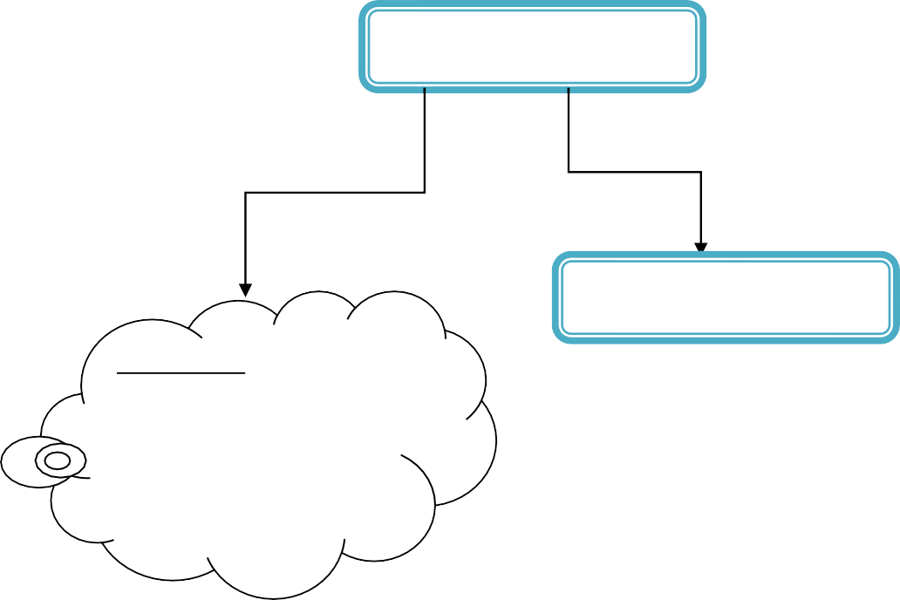
QA
Full form
QUALITYASSURANCE
Yes I got it…

Quality means standard of product.

Assurance means

The full form of QA is Quality Assurance.
- Now its require to know that what is Quality???????????………………..
- Quality word has many thinking on your mind but one definition tells that quality means

“Characteristic of attribute of something.”
- As an attribute of an item, quality refers to measurable characteristics— things we are able to compare to known standards such as length, color, electrical properties.
- For example you can buy your shirt with Rs.200 and also you can buy your shirt with
SAD, Software Quality Assurance and Testing Page No:30

Shree H.N. Shukla College of I.T. &Mgmt, Rajkot
2-Vaishalinagar, 3-vaishlinagar,
Raiya Road, Raiya Road,
Nr. Amrapali Railway Crossing, Nr. Amrapali Railway Crossing, Rajkot 360001, Rajkot 360001.

Rs.800 also.
- Why you give more money because you are assured by Co. of shirt that the shirt is best in its category. And the quality is best to use.
- Now that’s quality and standard. As per your requirement you can find different quality which is assured by different persons.

- So now question is that what is assurance??????????????????????
  - Assurance consists of the auditing and reporting functions of management.
  - The goal of quality assurance is to provide management with the data necessary to be informed about product quality, thereby gaining insight and confidence that product quality is meeting its goals.
  - Of course, if the data provided through quality assurance identify problems, it is management’s responsibility to address the problems and apply the necessary resources to resolve quality issues.

Yes I got it…

Quality means standard of product.

Assurance means guarantee
 |  | NO. | QUESTION | ANSWER
 |  | 1. | QA | QUALITY ASSURANCE
 |  | 2. | What is Quality? | “Characteristic of attribute of something.”
 |  | 3. | What is goal of QA? | The goal of quality assurance is to provide management with the data necessary to be informed about product quality.
 |  | SAD, Software Quality Assurance and Testing Page No:31

Shree H.N. Shukla College of I.T. &Mgmt, Rajkot
2-Vaishalinagar, 3-vaishlinagar,
Raiya Road, Raiya Road,
Nr. Amrapali Railway Crossing, Nr. Amrapali Railway Crossing, Rajkot 360001, Rajkot 360001.

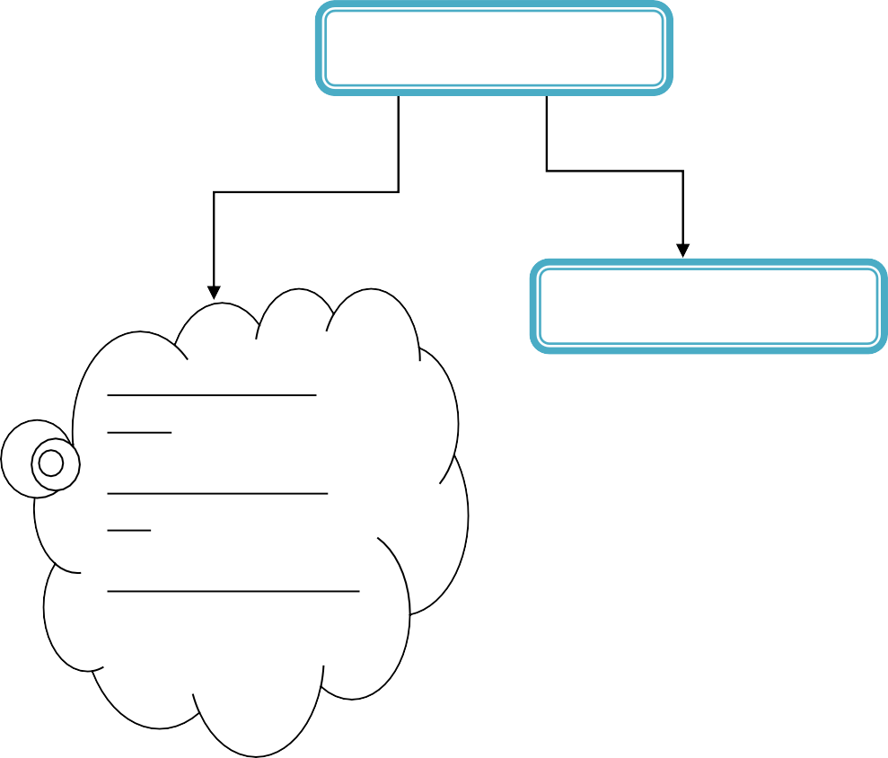Topic: Introduction to QC. (2 OR 3 MARKS)
QC
Full form
QUALITY CONTROL
Yes I remember QC
word.

I see it in newspaper that

“Wanted QC operator.”

The full form of QC is Quality control.
- QC process includes the Controlling of product that fulfills or satisfied the development process of any product from starting to ending.

QC involves the series of inspections, reviews, and andtests of product.
- Here you can use QC throughout the software process to ensure each work product meets the customer requirements or not.
- Remember somewhere you read in newspaper that “Wanted QC operator”.

SAD, Software Quality Assurance and Testing Page No:32

Shree H.N. Shukla College of I.T. &Mgmt, Rajkot
2-Vaishalinagar, 3-vaishlinagar,
Raiya Road, Raiya Road,
Nr. Amrapali Railway Crossing, Nr. Amrapali Railway Crossing, Rajkot 360001, Rajkot 360001.

Yes I remember QC word. I see it in newspaper that “Wanted QC operator.”

- Quality control includes a feedback loop to the process that created the work product.
- Quality control activities may be fully automated or entirely manual, or a combination of automated tools and human interaction. A key concept of quality control is that all work products have defined, measurable specifications to which we may compare the output of each process. The feedback loop is essential to minimize the defects produced
- Quality assurance consists of the auditing and reporting functions of management.
- The goal of quality assurance is to provide management with the data necessary to be informed about product quality, thereby gaining insight and confidence that product quality is meeting its goals. Of course, if the data provided through quality assurance identify problems.
- It is management’s responsibility to address the problems and apply the necessary
resources to resolve quality issues.
 |  | NO. | QUESTION | ANSWER
 |  | 1. | QC | QUALITY CONTROL
 |  | 2. | What is involves Quality Control? | the series of inspections, reviews, andtests of product.
- QA v/s QC:- (2 OR 3 MARKS)
  - QA is a set of activities designed to ensure that the development and/or maintenance process is adequate to ensure a system will meet its objectives.
While
QC is a set of activities designed to evaluate a developed work product.

  - QA activities ensure that the process is defined and appropriate.

SAD, Software Quality Assurance and Testing Page No:33

2-Vaishalinagar, 3-vaishlinagar,
Raiya Road, Raiya Road,
Nr. Amrapali Railway Crossing, Nr. Amrapali Railway Crossing, Rajkot 360001, Rajkot 360001.

While
QC activities focus on finding defects in specific task.

  - Standards development and proper methods are examples of QA activities.
While
Testing is an example of QC activity. (Inspections)

  - The goal of QA is to provide management with necessary data, & informed about product quality.
While
QC goal is that all work products have defined and compare the output of each process.

  - QA consists of the auditing and reporting functions of management.
While
QC involves the series of inspections, reviews, and tests used throughout the software process.

2-Vaishalinagar, 3-vaishlinagar,
Raiya Road, Raiya Road,
Nr. Amrapali Railway Crossing, Nr. Amrapali Railway Crossing, Rajkot 360001, Rajkot 360001.

