Shree H.N. Shukla College of I.T. &Mgmt, Rajkot
2-Vaishalinagar, 3-vaishlinagar,
Raiya Road, Raiya Road,
Nr. Amrapali Railway Crossing, Nr. Amrapali Railway Crossing, Rajkot 360001, Rajkot 360001.

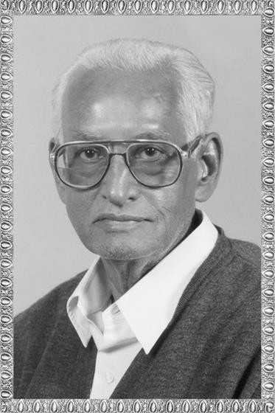

PGDCA – 2 SAD

ShreeH.N.ShuklaCollege Campus, Street No. 2, Vaishali Nagar,
Nr. Amrapali Railway Crossing,
Shree H.N.Shukla College Street No. 3, Vaishali Nagar, Nr. Amrapali Railway Crossing,

Website: www.hnsgroupofcolleges.org Email : hnsinfo@hnshukla.com

SAD, Software Quality Assurance and Testing Page No:1

Shree H.N. Shukla College of I.T. &Mgmt, Rajkot
2-Vaishalinagar, 3-vaishlinagar,
Raiya Road, Raiya Road,
Nr. Amrapali Railway Crossing, Nr. Amrapali Railway Crossing, Rajkot 360001, Rajkot 360001.
 |  |  | SAD, Software Quality Assurance and Testing
 |  |  | Sr.  No. | Topics | Detail | Mark | Min. Lect.
 |  |  | 5 | CAD project management tools | - MS-VISIO for designing & documentation  - MS-Project for controlling and Project Management |  | 5
 |  |  |  | UML | - UML design and skill based tools  - Overview of  Class Diagram Use Case Diagram Activity Diagram |  | 3
SAD, Software Quality Assurance and Testing Page No:2

Shree H.N. Shukla College of I.T. &Mgmt, Rajkot
2-Vaishalinagar, 3-vaishlinagar,
Raiya Road, Raiya Road,
Nr. Amrapali Railway Crossing, Nr. Amrapali Railway Crossing, Rajkot 360001, Rajkot 360001.

UNIT-5 (PART – 1)

CAD PROJECT MANAGEMENT TOOLS
- Topic : MS-VISIO (3 OR 5 MARKS) (IMP)

MS VISIO
Addition Means

Two additions

- Standard.
- Professional.
Diagramming program for Microsoft Windows that uses vector graphics to create diagrams.

Microsoft Visio marketed as Microsoft Office Visio, is a diagramming program for Microsoft Windows that uses vector graphics to create diagrams. It is currently available in two editions: Standard and Professional.
- The Standard and Professional editions both share the same interface, but the latter has additional templates for more advanced diagrams and layouts as well as unique functionality that makes it easy for users to connect their diagrams to a number of data sources and display the information graphically.
- Microsoft acquired Visio Corporation in 2000. Visio 2007 was released on 30 November 2006. Also released alongside version 2002 were Enterprise Network Tools, an add-on product enabling automated network and directory services diagramming, and the Visio Network Center, a Web site where users could locate the latest network documentation content and exact-replica network equipment shapes
SAD, Software Quality Assurance and Testing Page No:3

Shree H.N. Shukla College of I.T. &Mgmt, Rajkot
2-Vaishalinagar, 3-vaishlinagar,
Raiya Road, Raiya Road,
Nr. Amrapali Railway Crossing, Nr. Amrapali Railway Crossing, Rajkot 360001, Rajkot 360001.

from 500 leading manufacturers. The former has been discontinued, while the latter's shape-finding features are now integrated into the program itself.
- Microsoft has revealed that the next version of Microsoft Visio will feature the ribbon user interface.
- Visio began as a standalone product produced by the Visio Corporation; as of Visio 2000, Microsoft acquired it and branded it as a Microsoft Office application, like Microsoft Project; however, it has never been included in any of the Office suites. Microsoft included a Visio for Enterprise Architects edition with some editions of Visual Studio .NET 2003 and Visual Studio 2005.

- Different Versions

  - Visio 1.0 (Standard, Lite, Home)
  - Visio 2.0
  - Visio 3.0
  - Visio 4.0 (Standard, Technical)
  - Visio 4.1 (Standard, Technical)
  - Visio 4.5 (Standard, Professional, Technical)
  - Visio 5.0 (Standard, Professional, Technical)
  - Visio 2000 (6.0; Standard, Professional, Technical, Enterprise), later updated to SP-1 and Microsoft branding after Visio Corporation's acquisition
  - Visio 2002 (10.0; Standard, Professional)
  - Visio Enterprise Network Tools, Visio Network Center
  - Visio for Enterprise Architects 2003 (VEA 2003) (based on Visio 2002 and included with Visual Studio .NET 2003 Enterprise Architect)
  - Office Visio 2003 (11.0; Standard, Professional)
  - Office Visio for Enterprise Architects 2005 (VEA 2005) (based on Visio 2003 and included with Visual Studio 2005 Team Suite and Team Architect editions)
  - Office Visio 2007 (12.0; Standard, Professional).
  - Office Visio 2010 (14.0; Upcoming Version, Currently on Technical Preview)
 |  | NO. | QUESTION | ANSWER
 |  | 1. | What is MS VISIO? | diagramming program for Microsoft Windows that uses vector graphics to create diagrams
 |  | 2. | How many version available MS VISIO? | 1.Standard 2.Professional
 |  | SAD, Software Quality Assurance and Testing Page No:4

Shree H.N. Shukla College of I.T. &Mgmt, Rajkot
2-Vaishalinagar, 3-vaishlinagar,
Raiya Road, Raiya Road,
Nr. Amrapali Railway Crossing, Nr. Amrapali Railway Crossing, Rajkot 360001, Rajkot 360001.

Topic: MS-Project. (3 OR 5 MARKS) (IMP)
Enterprise Project Management (EPM)
MSP: (Microsoft Project)
Microsoft Project is a project management software program
MS-Project
  - Microsoft Project (or MSP) is a project management software program developed and sold by Microsoft which is designed to assist project managers in developing plans, assigning resources to tasks, tracking progress, managing budgets and analyzing workloads.
  - The application creates critical path schedules, although critical chain and event chain methodology third-party add-ons are available. Schedules can be resource leveled, and chains are visualized in a Gantt chart. Additionally, Project can recognize different classes of users. These different classes of users can have differing access levels to projects, views, and other data.
  - Custom objects such as calendars, views, tables, filters and fields are stored in an enterprise global which is shared by all users.
  - Microsoft Project was the company's third Windows-based application, and within a couple of years of its introduction WinProj was the dominant PC-based project management software.
  - Although branded as a member of the Microsoft Office family, it has never been included in any of the Office suites before Office 2010 beta 1. It is available currently in two editions, Standard and Professional. MS Project's proprietary file format is
.mpp.

SAD, Software Quality Assurance and Testing Page No:5

Shree H.N. Shukla College of I.T. &Mgmt, Rajkot
2-Vaishalinagar, 3-vaishlinagar,
Raiya Road, Raiya Road,
Nr. Amrapali Railway Crossing, Nr. Amrapali Railway Crossing, Rajkot 360001, Rajkot 360001.

o Microsoft Project and Microsoft Project Server are the cornerstones of the Microsoft OfficeEnterprise Project Management (EPM) product. Microsoft has revealed that the next version of Microsoft Project will be featuring the Fluent user interface.
- Features:
  - Project creates budgets based on assignment work and resource rates. As resources are assigned to tasks and assignment work estimated, the program calculates the cost equals the work times the rate, which rolls up to the task level and then to any summary tasks and finally to the project level. Resource definitions (people, equipment and materials) can be shared between projects using a shared resource pool. Each resource can have its own calendar, which defines what days and shifts a resource is available.
  - Resource rates are used to calculate resource assignment costs which are rolled up and summarized at the resource level. Each resource can be assigned to multiple tasks in multiple plans and each task can be assigned multiple resources, and the application schedules task work based on the resource availability as defined in the resource calendars. All resources can be defined in an enterprise-wide resource pool.
  - MS Project presumes additional physical raw materials are always available without limit.
  - Therefore it cannot determine how many finished products can be produced with a given amount of raw materials. This makes MS Project unsuitable for solving problems of available materials constrained production. Additional software is necessary to manage a complex facility that produces physical goods.
 |  | NO. | QUESTION | ANSWER
 |  | 1. | MSP | Microsoft Project
 |  | 2. | What is MS Project? | Microsoft Project (or MSP) is a  project management software program.
 |  | 3. | EPM | Enterprise Project Management (EPM).
 |  | 4. | MS Project's proprietary file format  is….. | .mpp
 |  | SAD, Software Quality Assurance and Testing Page No:6

Shree H.N. Shukla College of I.T. &Mgmt, Rajkot
2-Vaishalinagar, 3-vaishlinagar,
Raiya Road, Raiya Road,
Nr. Amrapali Railway Crossing, Nr. Amrapali Railway Crossing, Rajkot 360001, Rajkot 360001.

UNIT-5 (PART – 2)

UML
- Topic: UML (2 OR 3 MARKS) (IMP)
UML Consits 3 Types of Diagram
- Class Diagram
- Use Case Diagram
- Activity Diagram
UML is a language for specifying, visualizing, documenting and constructing the artifacts of software systems.
UML: Unified Modeling Language
UML
FullForm
Means

- UML is a language for specifying, visualizing, documenting and constructing the artifacts of software systems, as well as for business modeling and other non-software systems.
- Goals of UML as stated by the designers are
  - To model systems using OO concepts
  - To establish an explicit coupling to conceptual as well as executable artifacts
  - To address the issues of scale inherent in complex, mission-critical systems
  - To create a modeling language usable by humans and machine

SAD, Software Quality Assurance and Testing Page No:7

Shree H.N. Shukla College of I.T. &Mgmt, Rajkot
2-Vaishalinagar, 3-vaishlinagar,
Raiya Road, Raiya Road,
Nr. Amrapali Railway Crossing, Nr. Amrapali Railway Crossing, Rajkot 360001, Rajkot 360001.

- Provide users a ready-to-use, expressive visual modeling language so they can develop and exchange meaningful models.
- Provide extensibility and specialization mechanisms to extend the core concepts.
- Be independent of particular programming languages and development processes.
- Encourage the growth of the OO tools market.
- Support higher-level development concepts such as collaborations, frameworks, patterns, and components.
- Integrate best practices.

- The Unified Modeling Language (UML) is a language for
  - Specifying the structure and behavior of a system
  - Visualizing a system as it is or as we want it to be
  - Constructing a system from the template provided by the model
  - Documenting the decisions made
  - UML represents a collection of best engineering practices that have proven successful in the modeling of large and complex systems

- UML Consist Three types of Diagrams
  - Class Diagram
  - Use Case Diagram
  - Activity Diagram
 |  | NO. | QUESTION | ANSWER
 |  | 1. | UML | Unified Modeling Language
 |  | 2. | What is UML? | UML is a language for specifying, visualizing, documenting and constructing the artifacts of  software systems
 |  | 3. | How many available Diagrams in UML? | - Class Diagram  - Use Case Diagram  - Activity Diagram
 |  | SAD, Software Quality Assurance and Testing Page No:8

Shree H.N. Shukla College of I.T. &Mgmt, Rajkot
2-Vaishalinagar, 3-vaishlinagar,
Raiya Road, Raiya Road,
Nr. Amrapali Railway Crossing, Nr. Amrapali Railway Crossing, Rajkot 360001, Rajkot 360001.

- Topic: Class Diagrams (3 MARKS)
UML class diagrams are the mainstay of object-oriented analysis and design
Class Diagrams

UML class diagrams are the mainstay of object-oriented analysis and design.
  - UML class diagrams show the classes of the system, their interrelationships (including inheritance, aggregation, and association), and the operations and attributes of the classes. Class diagrams are used for a wide variety of purposes, including both conceptual/domain modeling and detailed design modeling. Although I prefer to create class diagrams on whiteboards because simple tools are more inclusive most of the diagrams that I’ll show in this article are drawn using a software-based drawing tool so you may see the exact notation
  - Class diagrams show the static structure of the model, in particular, the things that exist (such as classes and types), their internal structure, and their relationships to other things.
  - A class in a class diagram can be directly implemented in an OOP language that has the construct for a class.
  - To create a class diagram, the classes have to be identified and described and when a number of classes exist, they can be related to each other using a number of relationships.
  - Class diagrams show the static structure of the model, in particular, the things that exist (such as classes and types), their internal structure, and their relationships to other things. Class diagrams do not show temporal information, although they may contain reified occurrences of things that have or things that describe temporal behavior. An object diagram shows instances compatible with a particular class diagram

SAD, Software Quality Assurance and Testing Page No:9

Shree H.N. Shukla College of I.T. &Mgmt, Rajkot
2-Vaishalinagar, 3-vaishlinagar,
Raiya Road, Raiya Road,
Nr. Amrapali Railway Crossing, Nr. Amrapali Railway Crossing, Rajkot 360001, Rajkot 360001.

Class Diagram – Example

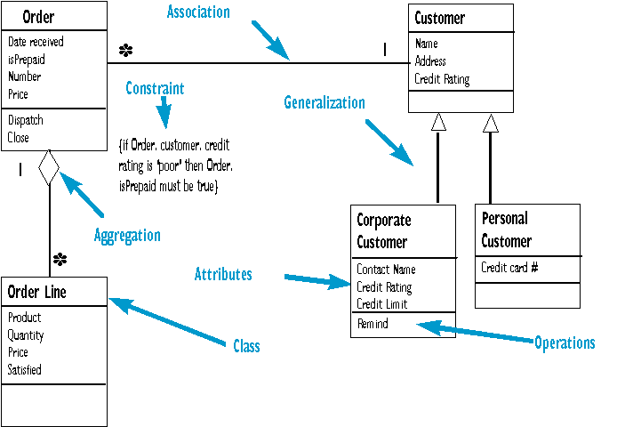

- Well Structured Class Diagram.
- Is focused on communicating one aspect of a system
- Contains only elements that are essential to understanding that aspect
- Provides details consistent with its level of abstraction
- Is not so minimalist.
- Has a name that communicates its purpose.
 |  | NO. | QUESTION | ANSWER
 |  | 1. | What is Class Diagram? | UML class diagrams are the mainstay of object-oriented analysis  and design
 |  | 2. | OOP | Object Oriented Programming
 |  | 3. | UML | Unified Modeling Language
 |  | SAD, Software Quality Assurance and Testing Page No:10

Shree H.N. Shukla College of I.T. &Mgmt, Rajkot
2-Vaishalinagar, 3-vaishlinagar,
Raiya Road, Raiya Road,
Nr. Amrapali Railway Crossing, Nr. Amrapali Railway Crossing, Rajkot 360001, Rajkot 360001.

- Topic: Use case Diagram:- (3 OR 5 MARKS) (IMP)
Use case Diagram

- Diagram building blocks
- Actor inheritance
- Use case relationships
- Actor interaction
A Use Case Diagram shows a set of external Actors and their Use Cases connected with communication associations.

  - In software engineering, a use case diagram in the Unified Modeling Language (UML) is a type of behavioral diagram defined by and created from a Use-case analysis. Its purpose is to present a graphical overview of the functionality provided by a system in terms of actors, their goals (represented as use cases), and any dependencies between those use cases.
  - The main purpose of a use case diagram is to show what system functions are

performed for which actor.Roles of the actors in the system can be depicted.
  - A Use Case Diagram shows a set of external Actors and their Use Cases connected with communication associations. The communication associations between the Actors and their Use Cases define the boundary between the system and its external environment. The communication associations may be augmented to show the messages and events exchanged between Actors and Use Cases. Messages and events may be shown through relevant notes attached to specific communication associations.

SAD, Software Quality Assurance and Testing Page No:11

Shree H.N. Shukla College of I.T. &Mgmt, Rajkot
2-Vaishalinagar, 3-vaishlinagar,
Raiya Road, Raiya Road,
Nr. Amrapali Railway Crossing, Nr. Amrapali Railway Crossing, Rajkot 360001, Rajkot 360001.

Diagram building blocks
- Actor inheritance

Use case relationships
- Actor interaction
  - Interaction among actors is not shown on the use case diagram. If this interaction is essential to a coherent description of the desired behavior, perhaps the system or use case boundaries should be re-examined.
  - Alternatively, interaction among actors can be part of the assumptions used in the use case.

SAD, Software Quality Assurance and Testing Page No:12

Shree H.N. Shukla College of I.T. &Mgmt, Rajkot
2-Vaishalinagar, 3-vaishlinagar,
Raiya Road, Raiya Road,
Nr. Amrapali Railway Crossing, Nr. Amrapali Railway Crossing, Rajkot 360001, Rajkot 360001.

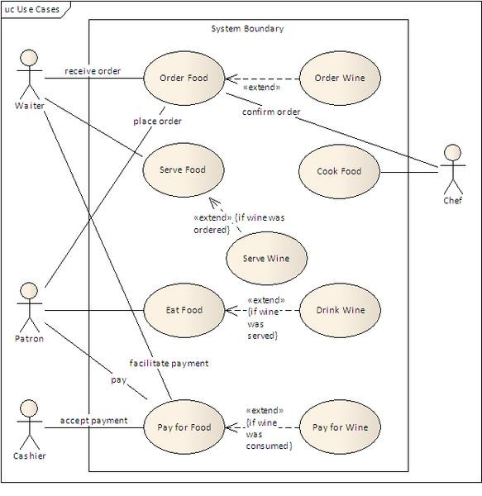

Actor Generalization
  - One popular relationship between Actors is Generalization/Specialization. This is useful in defining overlapping roles between actors. The notation is a solid line ending in a hollow triangle drawn from the specialized to the more general actor.

Use Case Relationships
  - Three relationships among use cases are used often in practice.

SAD, Software Quality Assurance and Testing Page No:13

Shree H.N. Shukla College of I.T. &Mgmt, Rajkot
2-Vaishalinagar, 3-vaishlinagar,
Raiya Road, Raiya Road,
Nr. Amrapali Railway Crossing, Nr. Amrapali Railway Crossing, Rajkot 360001, Rajkot 360001.

Include

"Include is a Directed Relationship between two use cases, implying that the behavior of the included use case is inserted into the behavior of the including use case"[1].
The first use case often depends on the outcome of the included use case. This is useful for extracting truly common behaviors from multiple use cases into a single description. The notation is a dashed arrow from the including to the included use case, with the label "«include»". This usage resembles a macro expansion where the included use case behavior is placed inline in the base use case behavior. There are no parameters or return values.
Extend

This relationship indicates that the behavior of the extension use case may be inserted in the extended use case under some conditions. The notation is a dashed arrow from the extension to the extended use case, with the label "«extend»". Notes or constraints may be associated with this relationship to illustrate the conditions under which this behaviour will be executed.
Modelers use the «extend» relationship to indicate use cases that are "optional" to the base use case. Depending on the modeler's approach "optional" may mean "potentially not executed with the base use case" or it may mean "not required to achieve the base use case goal."
Generalization

In the third form of relationship among use cases, a generalization/specialization relationship exists. A given use case may be a specialized form of an existing use case. The notation is a solid line ending in a hollow triangle drawn from the specialized to the more general use case. This resembles the object-oriented concept of sub-classing, in practice it can be both useful and effective to factor out common behaviors, constraints and assumptions to the general use case, describe them once, and deal with it in the same way, except for the details in the specialized cases.
 |  | NO. | QUESTION | ANSWER
 |  | 1. | What is main purpose of Usecase | The main purpose of a use case
 |  | SAD, Software Quality Assurance and Testing Page No:14

Shree H.N. Shukla College of I.T. &Mgmt, Rajkot

2-Vaishalinagar, Raiya Road,
Nr. Amrapali Railway Crossing, Rajkot 360001,
- vaishlinagar, Raiya Road,
Nr. Amrapali Railway Crossing, Rajkot 360001.

diagram?
2.
What is Actor Generalization?
3.
diagram is to show what system functions are performed for which actor.Roles of the actors in the system can be depicted
One popular relationship between Actors is Generalization / Specialization
How many Relationsheep Usecase 1.Include diagram? 2.Extend
3. Generalization.

Topic: Activity Diagram:- (3 OR 5 MARKS) (IMP)
Activity Diagram
Technique for showing workflows of stepwise activities and actions, with support for choice, iteration and concurrency.
- Initial node.
- Activity final node.
- Activities

    - Activity diagrams are a loosely defined diagram technique for showing workflows of stepwise activities and actions, with support for choice, iteration and concurrency. In the Unified Modeling Language, activity diagrams can be used to describe the business and operational step-by-step workflows of components in a system. An activity diagram shows the overall flow of control.

SAD, Software Quality Assurance and Testing
Page No:15

Shree H.N. Shukla College of I.T. &Mgmt, Rajkot
2-Vaishalinagar, 3-vaishlinagar,
Raiya Road, Raiya Road,
Nr. Amrapali Railway Crossing, Nr. Amrapali Railway Crossing, Rajkot 360001, Rajkot 360001.

- In SysML the activity diagram has been extended to indicate flows among steps that convey physical element (e.g., gasoline) or energy (e.g., torque, pressure). Additional changes allow the diagram to better support continuous behaviors and continuous data flows.
- In UML 1.x, an activity diagram is a variation of the UML State diagram in which the "states" represent activities, and the transitions represent the completion of those activities.
Construction

Activity diagrams are typically used for business process modeling. They consist of:
Initial node. Activity final node. Activities
The starting point of the diagram is the initial node, and the activity final node is the ending. An activity diagram can have zero or more activity final nodes. In between activities are represented by rounded rectangles.
 |  | NO. | QUESTION | ANSWER
 |  | 1. | What is Activity Diagram? | Activity diagrams are a loosely defined diagramtechnique for showing workflows of stepwise activities and actions, with support
 |  | SAD, Software Quality Assurance and Testing Page No:16

Shree H.N. Shukla College of I.T. &Mgmt, Rajkot
2-Vaishalinagar, 3-vaishlinagar,
Raiya Road, Raiya Road,
Nr. Amrapali Railway Crossing, Nr. Amrapali Railway Crossing, Rajkot 360001, Rajkot 360001.
 |  |  |  | for choice, iteration and concurrency.
 |  | 2. | An Activity Diagram shows……. | An activity diagram shows the overall flow of control.
 |  | 3. | How many Business Process Modeling in Activity Diagram? | - Initial node.  - Activity final node.  - Activities
 |  | 4. | UML | The Unified Modeling Language
- SUMMARY:-
  - UML is a language for specifying, visualizing, documenting and constructing the artifacts of software systems.
  - Goals of UML as stated by the designers are
    - To model systems using OO concepts
    - To establish an explicit coupling to conceptual as well as executable artifacts
    - To create a modeling language usable by humans and machine
    - Provide users a ready-to-use.
    - Encourage the growth of the OO tools market.
    - Support higher-level development concepts such as collaborations, frameworks, patterns, and components.
    - Integrate best practices.
  - The Unified Modeling Language (UML) is a language for
    - Specifying the structure and behavior of a system
    - Visualizing a system as it is or as we want it to be
    - Constructing a system from the template provided by the model
    - Documenting the decisions made
  - UML Consist Three types of Diagrams
    - Class Diagram
    - Use Case Diagram
    - Activity Diagram
  - Class Diagrams
    - UML class diagrams are the mainstay of object-oriented analysis and design.

SAD, Software Quality Assurance and Testing Page No:17

Shree H.N. Shukla College of I.T. &Mgmt, Rajkot
2-Vaishalinagar, 3-vaishlinagar,
Raiya Road, Raiya Road,
Nr. Amrapali Railway Crossing, Nr. Amrapali Railway Crossing, Rajkot 360001, Rajkot 360001.

    - UML class diagrams show the classes of the system, their interrelationships
  - Use case Diagram:-
    - A use case diagram in the Unified Modeling Language (UML) is a type of behavioral diagram defined by and created from a Use-case analysis.
    - The main purpose of a use case diagram is to show what system functions are performed for which actor.
    - Roles of the actors in the system can be depicted.
  - Activity Diagram:-
    - Activity diagrams are a loosely defined diagramtechnique for showing workflows of stepwise activities and actions, with support for choice, iteration and concurrency.
    - An activity diagram shows the overall flow of control.
    - In UML 1.x, an activity diagram is a variation of the UML State diagram in which the "states" represent activities, and the transitions represent the completion of those activities.

SAD, Software Quality Assurance and Testing Page No:18

