Shree H.N. Shukla College of I.T. &Mgmt, Rajkot
2-Vaishalinagar, 3-vaishlinagar,
Raiya Road, Raiya Road,
Nr. Amrapali Railway Crossing, Nr. Amrapali Railway Crossing, Rajkot 360001, Rajkot 360001.

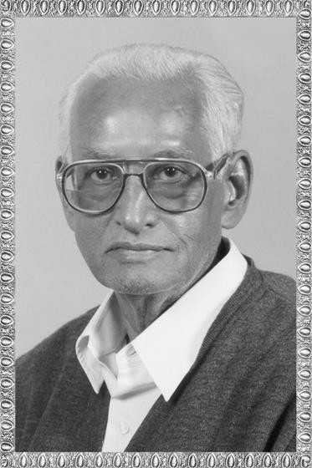

PGDCA – 2 SAD

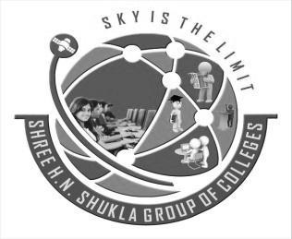

ShreeH.N.ShuklaCollege Campus, Street No. 2, Vaishali Nagar,
Nr. Amrapali Railway Crossing,
Shree H.N.Shukla College Street No. 3, Vaishali Nagar, Nr. Amrapali Railway Crossing,

Website: www.hnsgroupofcolleges.org Email : hnsinfo@hnshukla.com

SAD, Software Quality Assurance and Testing Page No:1

Shree H.N. Shukla College of I.T. &Mgmt, Rajkot
2-Vaishalinagar, 3-vaishlinagar,
Raiya Road, Raiya Road,
Nr. Amrapali Railway Crossing, Nr. Amrapali Railway Crossing, Rajkot 360001, Rajkot 360001.
 |  |  | SAD, Software Quality Assurance and Testing
 |  |  | Sr.  No. | Topics | Detail | Mark | Min. Lect.
 |  |  | 3 | Software Development Life Cycle Models | - Watefall Model  - Iterative Model  - V-Model  - Sprial Model  - Big Bang Model  - Prototyping Model |  | 2
 |  |  |  | Autometed Testing | - Introduction  (Concept of Freeware. Sharewere, Licensed Tools)  - Theory and Practical case study of Testing Tools  (Win runner,Load runner, QTP, Rational  Suite) |  | 8
SAD, Software Quality Assurance and Testing Page No:2

2-Vaishalinagar, 3-vaishlinagar,
Raiya Road, Raiya Road,
Nr. Amrapali Railway Crossing, Nr. Amrapali Railway Crossing, Rajkot 360001, Rajkot 360001.

UNIT – 3 (PART-1)
SOFTWARE DEVELOPMENT LIFECYCLE MODEL
- TOPIC:- Waterfall Model. (3 OR 5 MARKS)
Waterfall Model
called
Classic life cycle Or
The linear sequential model

- The waterfall model is a sequential software development process, in which progress is seen as flow like a waterfall.
- It is also called the classic life cycleor the waterfall model or the linear sequential model.
- It suggests a systematic, sequential approach to software development that begins at the system level and progresses through analysis, design, coding, testing, and support. Figure illustrates the linear sequential model for software engineering.
- Progress flows from the top to the bottom, like a waterfall.

2-Vaishalinagar, 3-vaishlinagar,
Raiya Road, Raiya Road,
Nr. Amrapali Railway Crossing, Nr. Amrapali Railway Crossing, Rajkot 360001, Rajkot 360001.

- To follow the waterfall model, one proceeds from one phase to the next in a sequential manner.
- For example, one first completes requirements specification, which after sign-off are considered "set in stone."
- When the requirements are fully completed, one proceeds to design. The software in question is designed and a blueprint is drawn for implementers (coders) to follow — this design should be a plan for implementing the
requirements given.
- When the design is fully completed, an implementation of that design is made by

coders.
- Towards the later stages of this implementation phase, separate software components produced are combined to introduce new functionality and reduced risk through the removal of errors.
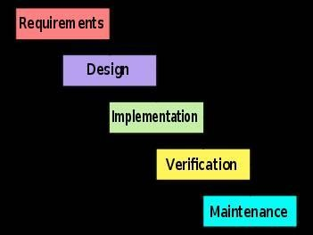

2-Vaishalinagar, 3-vaishlinagar,
Raiya Road, Raiya Road,
Nr. Amrapali Railway Crossing, Nr. Amrapali Railway Crossing, Rajkot 360001, Rajkot 360001.

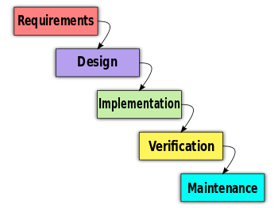
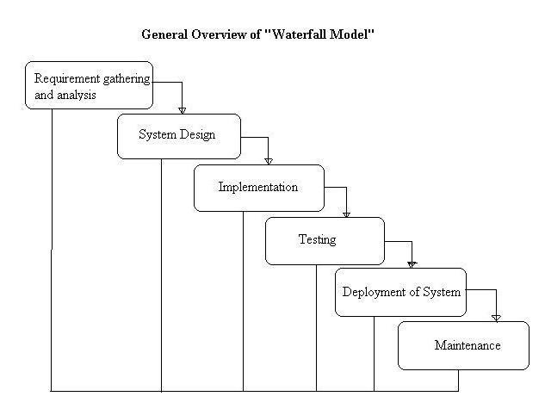

2-Vaishalinagar, Raiya Road,
Nr. Amrapali Railway Crossing, Rajkot 360001,
- vaishlinagar, Raiya Road,
Nr. Amrapali Railway Crossing, Rajkot 360001.

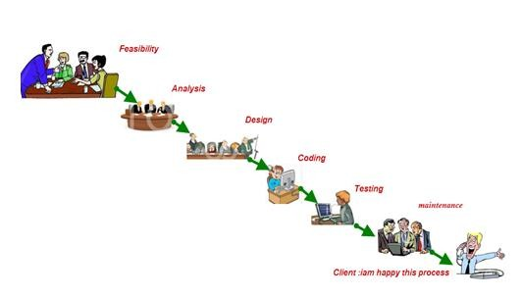
NO.
1.
QUESTION
What is Waterfall Model?
2.
Waterfall Model also known as….
ANSWER
sequential software development process
Classic life cycle or the linear sequential model.

  - 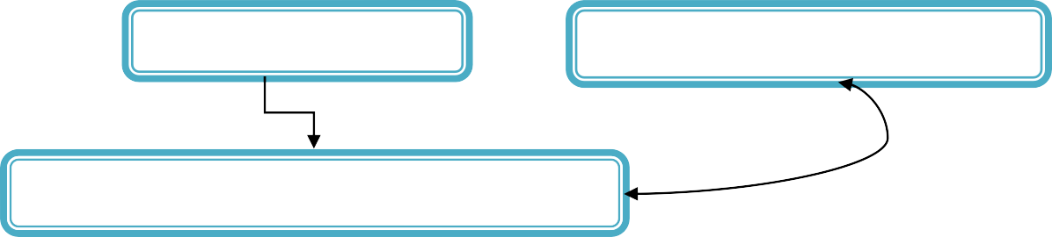TOPIC: - Iterative Model. (3 OR 5 MARKS)
Iterative Model
Cyclic software development
Process
Iterative and incremental development

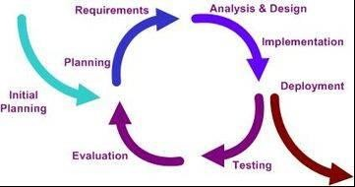2-Vaishalinagar, 3-vaishlinagar,
Raiya Road, Raiya Road,
Nr. Amrapali Railway Crossing, Nr. Amrapali Railway Crossing, Rajkot 360001, Rajkot 360001.

Iterative and incremental development
- Iterative and Incremental development is a cyclic software development process developed in response to the weaknesses of the waterfall model. It starts with an initial planning and ends with deployment with the cyclic interaction in between.
- The iterative and incremental development is an essential part of the Rational Unified Process, the Dynamic Systems DevelopmentMethod, Extreme Programming and generally the agile software development frameworks.
- Incremental development is a scheduling and staging strategy, in which the various parts of the system are developed.
- The basic idea behind iterative enhancement is to develop a software system incrementally, allowing the developer to take advantage of what was being learned during the development of earlier, incremental, deliverable versions of the system.

2-Vaishalinagar, 3-vaishlinagar,
Raiya Road, Raiya Road,
Nr. Amrapali Railway Crossing, Nr. Amrapali Railway Crossing, Rajkot 360001, Rajkot 360001.

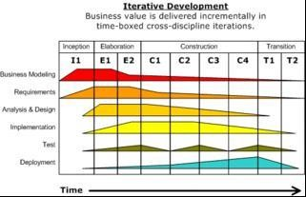
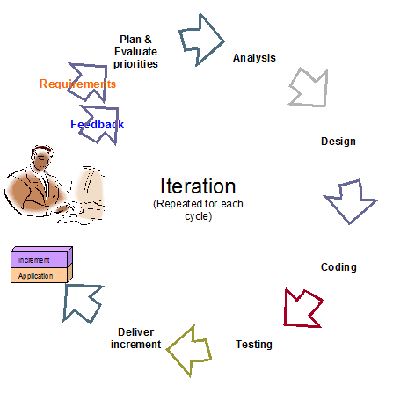

2-Vaishalinagar, Raiya Road,
Nr. Amrapali Railway Crossing, Rajkot 360001,
- vaishlinagar, Raiya Road,
Nr. Amrapali Railway Crossing, Rajkot 360001.

NO.
1.
QUESTION
What is Iterative and Incremental development?
ANSWER
Iterative and Incremental development is a cyclic software development process developed in response to the weaknesses of the waterfall model

  - TOPIC: - V Model. (3 OR 5 MARKS)
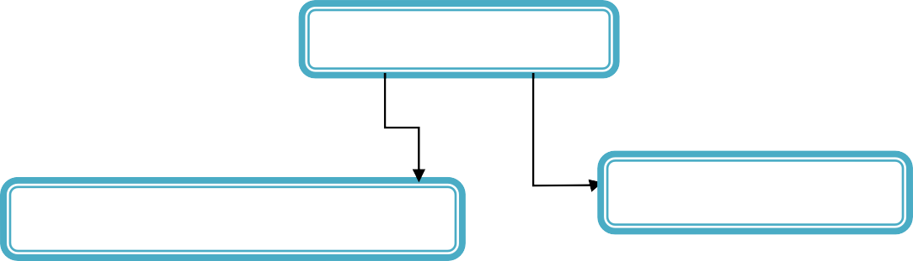
V Model
Means
Software development Process
Verification Phases
Requirements analysis
System Design
Architecture
Module Design

    - The V-model is a software development process (also applicable to hardware development) which can be presumed to be the extension of the waterfall model.

2-Vaishalinagar, 3-vaishlinagar,
Raiya Road, Raiya Road,
Nr. Amrapali Railway Crossing, Nr. Amrapali Railway Crossing, Rajkot 360001, Rajkot 360001.

    - Instead of moving down in a linear way, the process steps are upwards after the coding phase, to form the typical V shape. The V-Model demonstrates the relationships between each phase of the development life cycle and its associated phase of testing. The horizontal and vertical axes represents time or projectcompleteness (left-to-right) and level of abstraction (coarsest-grain abstraction uppermost), respectively.

Verification Phases
    - Requirements analysis
    - System Design
    - Architecture Design
      - Module Design
        - (1)In the Requirements analysis phase, therequirements of the proposed system are collected by analyzing the needs of the user(s). This phase is concerned about establishing what the ideal system has to perform.
        - (2)Systems design is the phase where system engineers analyze and understand the business of the proposed system by studying the user requirements document. They figure out possibilities and techniques by which the user requirements can be implemented.
        - (3)The phase of the design of computer architecture and software architecture can also be referred to as high-level design. The baseline in selecting the architecture is that it should realize all which typically consists of the list of modules, brief functionality of each module, their interface relationships, dependencies, databasetables, architecture diagrams, technology details etc.
        - (4)The module design phase can also be referred to as low-level design. The designed system is broken up into smaller units or modules and each of them is explained so that the programmer can start coding directly.

2-Vaishalinagar, Raiya Road,
Nr. Amrapali Railway Crossing, Rajkot 360001,
- vaishlinagar, Raiya Road,
Nr. Amrapali Railway Crossing, Rajkot 360001.

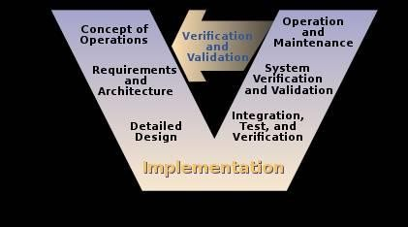
NO.
1.
2.
QUESTION
What is V Model?
V Model verification Phases?
ANSWER
Software development process.
Requirements analysis, System Design, Architecture Design

  - TOPIC: - Spiral model. (3 OR 5 MARKS)

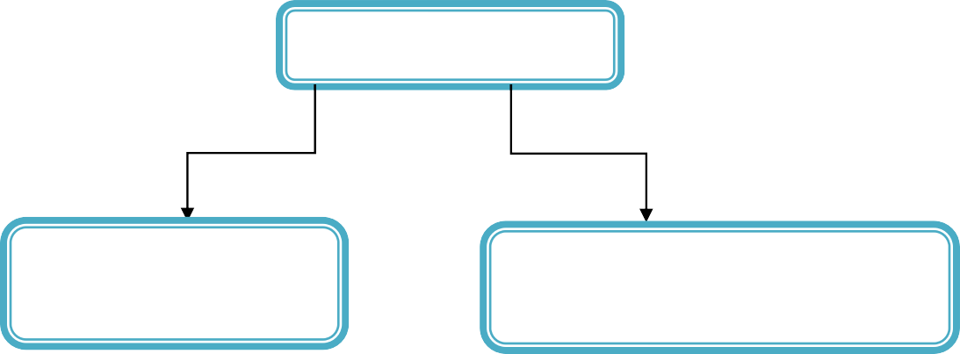
Spiral model
Known as
Method
Spiral lifecycle
model
Systems development
method (SDM)

2-Vaishalinagar, 3-vaishlinagar,
Raiya Road, Raiya Road,
Nr. Amrapali Railway Crossing, Nr. Amrapali Railway Crossing, Rajkot 360001, Rajkot 360001.

    - The spiral model is a software development process combining which elements of both design and prototyping-in-stages, (the first or original model from which others are copied) in an effort to combine advantages of top-down and bottom-up concepts. Also known as the spiral lifecycle model (or spiral development), it is a systems development method (SDM) used in information technology (IT).
    - This model of development combines the features of the prototyping model and the waterfall model. The spiral model is intended for large, expensive and complicated projects.
    - "A Spiral Model of Software Development and Enhancement”. This model was not the first model to discuss iterative development, but it was the first model to explain why the iteration matters.
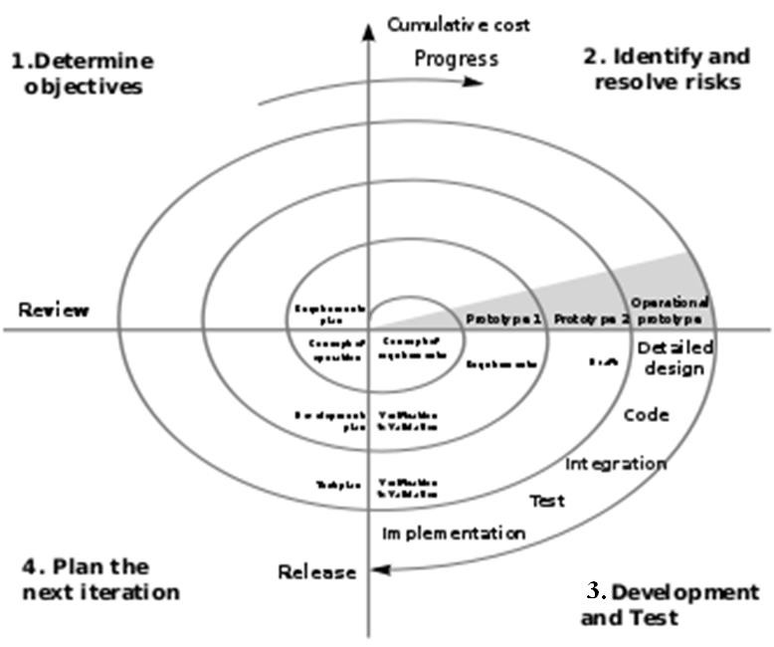

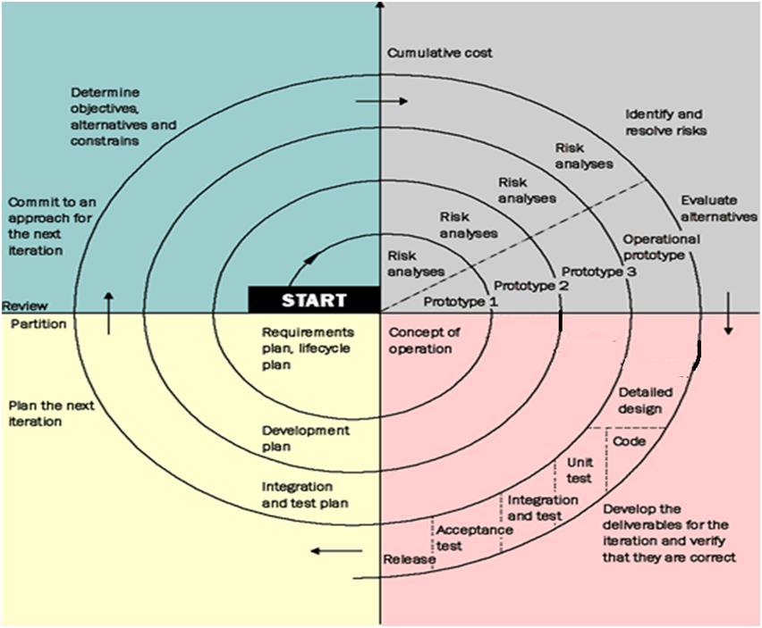2-Vaishalinagar, 3-vaishlinagar,
Raiya Road, Raiya Road,
Nr. Amrapali Railway Crossing, Nr. Amrapali Railway Crossing, Rajkot 360001, Rajkot 360001.

- Steps

The steps in the spiral model iteration can be generalized as follows:
  - The system requirements are defined in as much detail as possible. This usually involves interviewing a number of users representing all the external or internal users and other aspects of the existing system.
  - A preliminary design is created for the new system. This phase is the most important part of "Spiral Model". In this phase all possible (and available) alternatives, which can help in developing a cost effective project are analyzed and strategies to use them are decided. This phase has been added specially in order to identify and resolve all the possible risks in the project development. If risks indicate any kind of uncertainty in requirements, prototyping may be used to proceed with the available data and find out possible solution in order to deal with the potential changes in the requirements.
  - A first prototype of the new system is constructed from the preliminary design. This is usually a scaled-down system, and represents an approximation of the characteristics of the final product.
  - A second prototype is evolved by a fourfold procedure:

evaluating the first prototype in terms of its strengths, weaknesses, and risks;
  - defining the requirements of the second prototype;
  - planning and designing the second prototype;

Shree H.N. Shukla College of I.T. &Mgmt, Rajkot
2-Vaishalinagar, 3-vaishlinagar,
Raiya Road, Raiya Road,
Nr. Amrapali Railway Crossing, Nr. Amrapali Railway Crossing, Rajkot 360001, Rajkot 360001.

- Constructing and testing the second prototype.
 |  | NO. | QUESTION | ANSWER
 |  | 1. | Spiral Model also known as…. | spiral lifecycle model
 |  | 2. | SDM | systems development method (SDM)
- TOPIC: - Big Bang Model. (3 OR 5 MARKS)

Big Bang Model

Big bang Phased adoption Parallel adoption adoption

  - Big bang adoption is the adoption type of the instant changeover, when everybody associated with the new system moves to the fully functioning new system on a given date.
  - When a new system needs to be implemented in an organization, there are three different ways to adopt this new system:
    - The big bang adoption, phased adoption and parallel adoption.
    - In case of parallel adoption the old and the new system are running parallel, so all the users can get used to the new system, and meanwhile do their work using the old system.
    - Phased adoption means that the adoption will happen in several phases, so after each phase the system is a little nearer to be fully adopted.

SAD, Software Quality Assurance and Testing Page No:14

Shree H.N. Shukla College of I.T. &Mgmt, Rajkot
2-Vaishalinagar, 3-vaishlinagar,
Raiya Road, Raiya Road,
Nr. Amrapali Railway Crossing, Nr. Amrapali Railway Crossing, Rajkot 360001, Rajkot 360001.

    - With the big bang adoption, the switch between using the old system and using the new system happens at one single date, the so called instant changeover of the system. Everybody starts to use the new system at the same date and the old system will not be used anymore from that moment on.
    - The big bang adoption type is riskier than other adoption types because there are fewer learning opportunities incorporated in the approach, so quite some preparation is needed to get to the big bang. This preparation will be described below, illustrated by the process-data model of the big bang adoption.

Advantages and disadvantages

- This sudden changeover is quite drastic. This has advantages, but because of the instant changeover there are also disadvantages.

The advantages of this method:
  - Training is only needed for the new method, not also for the changeover period.

User documentation does not need to be updated during the implementation process, because it happens in such a short period.
  - The changeover is at one date and this date is clear for everyone.
  - There are no special interfaces needed to be able to get used to the new system, because the new system is all there is.

- The disadvantages on the other hand are:
- There is no time for extra additions
- The completeness and validity of the converted data is not completely proved, only in the pre-phases, but not in the whole system situation.
- Start up problems are a problematic factor
- The operation is complex, one of the main complexities is tuning all activities to happen on one moment: the big bang
SAD, Software Quality Assurance and Testing Page No:15

Shree H.N. Shukla College of I.T. &Mgmt, Rajkot
2-Vaishalinagar, 3-vaishlinagar,
Raiya Road, Raiya Road,
Nr. Amrapali Railway Crossing, Nr. Amrapali Railway Crossing, Rajkot 360001, Rajkot 360001.

- ‘Fall back’-plans are hard to develop and become more impossible when the big bang has taken place There can be a catch up period (as explained above)
- This adoption is vulnerable because of the limited possibilities to maneuver. There is a lot of pressure because the deadline must be met.

Convert system with BigBang
 |  | NO. | QUESTION | ANSWER
 |  | 1. | What is Big bang adoption? | the adoption type of the instant changeover, when everybody associated with the new system moves to the fully functioning new  system on a given date.
 |  | 2. | How many different ways to adopt this new system? | The big bang adoption, phased adoption and parallel adoption.
 |  | 3. | What is Phased Adoption? | Phased adoption means that the  adoption will happen in several phases
 |  | SAD, Software Quality Assurance and Testing Page No:16

Shree H.N. Shukla College of I.T. &Mgmt, Rajkot
2-Vaishalinagar, 3-vaishlinagar,
Raiya Road, Raiya Road,
Nr. Amrapali Railway Crossing, Nr. Amrapali Railway Crossing, Rajkot 360001, Rajkot 360001.

- TOPIC: - PROTOTYPING MODEL (3 OR 5 MARKS)
Prototyping paradigm may offer the best approach
PROTOTYPING MODEL

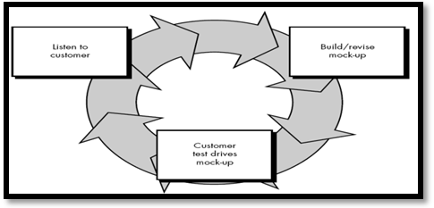

  - Often, a customer defines a set of general objectives for software but does not identify detailed input, processing, or output requirements.

In other cases, the developer may be unsure of the efficiency of an algorithm, the adaptability of an operating system, or the form that human/machine interaction should take. In these, and many other situations, a prototyping paradigm may offer the best approach.
  - The prototyping paradigm (Display in Figure) begins with requirements gathering. Developer and customer meet and define the overall objectives for the software, identify whatever requirements are known, and outline areas where further definition is mandatory.
  - A "quick design" then occurs. The quick design focuses on a representation of those aspects of the software that will be visible to the customer/user (e.g., input approaches and output formats).

SAD, Software Quality Assurance and Testing Page No:17

Shree H.N. Shukla College of I.T. &Mgmt, Rajkot
2-Vaishalinagar, 3-vaishlinagar,
Raiya Road, Raiya Road,
Nr. Amrapali Railway Crossing, Nr. Amrapali Railway Crossing, Rajkot 360001, Rajkot 360001.

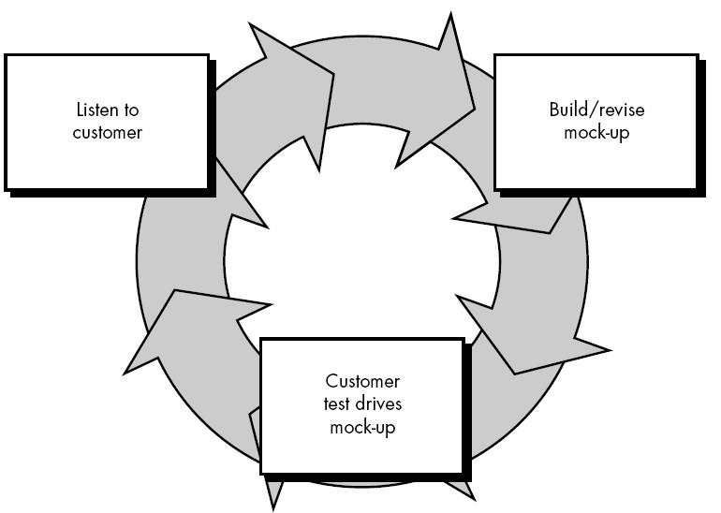

- The quick design leads to the construction of a prototype. The prototype is evaluated by the customer/user and used to refine requirements for the software to be developed.
- Iteration occurs as the prototype is tuned to satisfy the needs of the customer, while at the same time enabling the developer to better understand what needs to be done.
- Ideally, the prototype serves as a mechanism for identifying software requirements. If a working prototype is built, the developer attempts to use existing program fragments or applies tools (e.g., report generators, window managers) that enable working programs to be generated quickly.
- In most projects, the first system built is barely usable. It may be too slow, too big, and awkward in use or all three.
- There is no alternative but to start again, smarting but smarter, and build a redesigned version in which these problems are solved.
- When a new system concept or new technology is used, one has to build a system to throw away, for even the best planning is not so omniscient as to get it right the first time.
 |  | NO. | QUESTION | ANSWER
 |  | 1. | What is Prototyping Model? | a customer defines a set of general objectives for software but does not  identify detailed input, processing, or output requirements
 |  | 2. | What is Goal of Prototyping paradigm? | The prototyping paradigm begins with requirements gathering.  Developer and customer meet and define the overall objectives for the software
 |  | SAD, Software Quality Assurance and Testing Page No:18

2-Vaishalinagar, 3-vaishlinagar,
Raiya Road, Raiya Road,
Nr. Amrapali Railway Crossing, Nr. Amrapali Railway Crossing, Rajkot 360001, Rajkot 360001.

SUMMARY:-
- Waterfall Model.
  - The waterfall model is a sequential software development process, in which progress is seen as flow like a waterfall.
  - It is also called the classic life cycle or the waterfall model or the linear sequential model.
  - Progress flows from the top to the bottom, like a waterfall.
  - To follow the waterfall model, one proceeds from one phase to the next in a sequential manner.
  - When the design is fully completed, an implementation of that design is made by coders.

Iterative Model.
  - Iterative and incremental development
  - Iterative and Incremental development is a cyclic software development process developed in response to the weaknesses of the waterfall model.
  - It starts with an initial planning and ends with deployment with the cyclic interaction in between.
  - Essential part of the Rational Unified Process, the Dynamic Systems Development Method, Extreme Programming and generally the agile software development frameworks.

V Model.
  - The V-model is a software development process which can be presumed to be the extension of the waterfall model.
  - Instead of moving down in a linear way, the process steps are upwards after the coding phase, to form the typical V shape.
  - The V-Model demonstrates the relationships between each phase of the development life cycle and its associated phase of testing.
  - The horizontal and vertical axes represents time or projectcompleteness (left-to- right) and level of abstraction (coarsest-grain abstraction uppermost), respectively.
    - Verification Phases
    - Requirements analysis
    - System Design

- Vaishalinagar, 3-vaishlinagar,
Raiya Road, Raiya Road,
Nr. Amrapali Railway Crossing, Nr. Amrapali Railway Crossing, Rajkot 360001, Rajkot 360001.

  - Architecture Design
  - Module Design

Spiral model.
  - Software development process combining which elements of design and prototyping-in-stages in an effort to combine advantages of top-down and bottom- up concepts.
  - Also known as the spiral lifecycle model (or spiral development).
  - Systems development method (SDM) used in information technology (IT).
  - This model was not the first model to discuss iterative development, but it was the first model to explain why the iteration matters.

Steps
  - The system requirements are defined
  - A preliminary design is created for the new system.
  - First prototype of the new system is constructed from the preliminary design.
  - A second prototype is evolved by a fourfold procedure:
  - Evaluating the first prototype in terms of its strengths, weaknesses, and risks;
  - Defining the requirements of the second prototype;
  - Planning and designing the second prototype;
  - Constructing and testing the second prototype.

Big Bang Model.
  - Adoption type of the instant changeover
  - There are three different ways to adopt this new system:
    - The big bang adoption, phased adoption and parallel adoption.
    - In parallel adoption the old and the new system are running parallel.
    - Phased adoption means that the adoption will happen in several phases, so after each phase the system is a little nearer to be fully adopted.
    - With the big bang adoption, the switch between using the old system and using the new system happens at one single date
    - The big bang adoption type is riskier than other adoption types

PROTOTYPING MODEL
  - The developer may be unsure of the efficiency of an algorithm, the adaptability of an operating system, or the form that human/machine interaction should take.
  - In these, and many other situations, a prototyping paradigm may offer the best approach.

2-Vaishalinagar, 3-vaishlinagar,
Raiya Road, Raiya Road,
Nr. Amrapali Railway Crossing, Nr. Amrapali Railway Crossing, Rajkot 360001, Rajkot 360001.

  - The prototyping paradigm begins with requirements gathering.
  - Developer and customer meet and define the overall objectives for the software.
  - A "quick design" then occurs.
  - The quick design focuses on a representation of those aspects of the software that will be visible to the customer/user.
  - The quick design leads to the construction of a prototype.
  - The prototype is evaluated by the customer/user and used to refine requirements for the software to be developed.

2-Vaishalinagar, 3-vaishlinagar,
Raiya Road, Raiya Road,
Nr. Amrapali Railway Crossing, Nr. Amrapali Railway Crossing, Rajkot 360001, Rajkot 360001.

UNIT–3 (PART – 2)
AUTOMATED TESTING
- TOPIC: - Introduction

(Concept of Freeware, Sharewere, Licensed Tools)
Test automation is the use of software to control the execution of tests
AUTOMATED TESTING
Freeware
Sharewere
Licensed Tools
Code-driven testing.
Graphical user interface testing.

Means

- Test automation is the use of software to control the execution of tests, the comparison of actual outcomes to predicted outcomes, the settingup of test preconditions, and other test control and test reporting functions. Commonly, test automation involves automating a manual process already in place that uses a formalized testing process.
- There are two general approaches to test automation:

2-Vaishalinagar, 3-vaishlinagar,
Raiya Road, Raiya Road,
Nr. Amrapali Railway Crossing, Nr. Amrapali Railway Crossing, Rajkot 360001, Rajkot 360001.

  - Code-driven testing. The public (usually) interfaces to classes, modules, or libraries are tested with a variety of input arguments to validate that the results that are returned are correct.
  - Graphical user interface testing. A testing framework generates user interface events such as keystrokes and mouse clicks, and observes the changes that result in the user interface, to validate that the observable behavior of the program is correct.
- Test automation tools can be expensive, and it is usually employed in combination with manual testing. It can be made cost-effective in the longer term, especially when used repeatedly in regression testing.

- Freeware (1 MARK OR 2 MARKS)

Freeware (from "free" and "software") is computer software that is available for use at no cost or for an optional fee.
  - The term freeware was coined by Andrew Fluegelman when he wanted to sell a communications program named PC-Talk that he had created but for which he did not wish to use traditional methods of distribution because of their cost. Fluegelman actually distributed PC-Talk via a process now referred to as shareware. Current use of the term freeware does not necessarily match the original concept by Andrew Fluegelman.
  - Software classified as freeware is normally fully functional for an unlimited time with no cost, monetary or otherwise. Freeware can be proprietary software available at zero price. The author usually restricts one or more rights to copy, distribute, and make derivative works of the software.
  - The software license may impose restrictions on the type of use including personal use, individual use, non-profit use, non-commercial use, academic use, commercial use or any combination of these. For instance, the license may be "free for personal, non-commercial use".
  - Accordingly, freeware may or may not be free and open source software and, in order to distinguish, the Free Software Foundation asks users to avoid calling "freeware" free software.
  - The principal difference being that free software can be used, studied, and modified without restriction; free software embodies the concept of "free speech" while freeware that of "free beer". Freeware is also different from shareware; the

2-Vaishalinagar, 3-vaishlinagar,
Raiya Road, Raiya Road,
Nr. Amrapali Railway Crossing, Nr. Amrapali Railway Crossing, Rajkot 360001, Rajkot 360001.

latter obliges the user to pay after some trial period or to gain additional functionality.

Shareware (1 MARK OR 2 MARKS)

  - The term shareware, popularized by Bob Wallace, refers to proprietary software that is provided to users without payment on a trial basis and is often limited by any combination of functionality, availability or convenience.
  - Shareware is often offered as a download from an Internetwebsite or as a compact disc included with a periodical such as a newspaper or magazine. The aim of shareware is to give buyers the opportunity to use the program and judge its usefulness before purchasing a license for the full version of the software.
  - Shareware is usually offered as a trial version with certain features only available after the license is purchased, or as a full version, but for a trial period. Once the trial period has passed the program may stop running until a license is purchased.
  - Shareware is often offered without support, updates, or help menus, which only become available with the purchase of a license. The words "free trial" or "trial version" are indicative of shareware.
  - The term shareware is used in contrast to retail software, which refers to commercial software available only with the purchase of a license which may not be copied for others, public domain software, which refers to software not copyright protected, and freeware, which refers to copyrighted software for which the author solicits no payment (though he or she may request donations).

License (1 MARK OR 2 OR 3 MARKS)
  - The verb license or grant license means to give permission. The noun license (licence in British and Canadian spelling) refers to that permission as well as to the document memorializing that permission. License may be granted by a party ("licensor") to another party ("licensee") as an element of an agreement between those parties. A shorthand definition of a license is "an authorization (by the licensor) to use the licensed material (by the licensee)."

A licensor may grant license under intellectual property laws to authorize a use (such as copying software or using a (patented) invention) to a licensee, sparing the licensee from a claim of infringement brought by the licensor.

2-Vaishalinagar, 3-vaishlinagar,
Raiya Road, Raiya Road,
Nr. Amrapali Railway Crossing, Nr. Amrapali Railway Crossing, Rajkot 360001, Rajkot 360001.

  - A license under intellectual property commonly has several component parts beyond the grant itself, including a term, territory, renewal provisions, and other limitations deemed vital to the licensor.
    - Term: many licenses are valid for a particular length of time. This protects the licensor should the value of the license increase, or market conditions change. It also preserves enforceability by ensuring that no license extends beyond the term of IP ownership.
    - Territory: a license may stipulate what territory the rights pertain to. For example, a license with a territory limited to "North America" (United States/Canada) would not permit a licensee any protection from actions for use in Japan.
    - Mass licensing of software:Mass distributed software is used by individuals on personal computers under license from the developer of that software. Such license is typically included in a more extensive end-user license agreement (EULA) entered into upon the installation of that software on a computer.
    - Under a typical end-user license agreement, the user may install the software on a limited number of computers.
    - The enforceability of end-user license agreements is sometimes questioned.

Trademark and brand licensing
    - A licensor may grant permission to a licensee to distribute products under a trademark. With such a license, the licensee may use the trademark without fear of a claim of trademark infringement by the licensor.

Artwork and character licensing
    - A licensor may grant permission to a licensee to copy and distribute copyrighted works such as "art" (e.g., Thomas Kincaid's painting "Dawn in Los Gatos") and characters (e.g., Mickey Mouse). With such license, a licensee need not fear a claim of copyright infringement brought by the copyright owner.
    - Artistic license is, however, not related to the aforementioned license. It is a euphemism that denotes approaches in art works where dramatic effect is achieved at the expense of factual accuracy.

 |  |  | 2-Vaishalinagar, Raiya Road,  Nr. Amrapali Railway Crossing, Rajkot 360001, | 3-vaishlinagar, Raiya Road,  Nr. Amrapali Railway Crossing, Rajkot 360001.
 |  | NO. | QUESTION | ANSWER
 |  | 1. | Freeware | "free" and "software"
 |  | 2. | freeware was coined by | Andrew Fluegelman
 |  | 3. | Freeware can be proprietary software available at?? | zero price
 |  | 4. | The term shareware, popularized by | Bob Wallace
 |  | 5. | Shareware is usually offered as a?? | a trial version with certain features only available after the license is  purchased.
 |  | 6. | Shareware also known as?? | free trial" or "trial version"
 |  | 7. | License means……… | give permission
 |  | 8. | Term | many licenses are valid for a particular length of time
 |  | 9. | Territory | a license may stipulate what territory the rights pertain to
 |  | 10. | Mass licensing of software | Mass distributed software is used by individuals on personal  computers under license from the developer of that software
 |  | 11. | EULA | end-user license agreement
 |  | 12. | What is Artwork and character licensing? | A licensor may grant permission to a licensee to copy and distribute  copyrighted works such as "art” and “character”.
 |  | - SUMMARY:-  - Freeware  - Freeware (from "free" and "software") is at no cost or for an optional fee.  - The term freeware was coined by Andrew |  | computer software that is available for use Fluegelman

2-Vaishalinagar, 3-vaishlinagar,
Raiya Road, Raiya Road,
Nr. Amrapali Railway Crossing, Nr. Amrapali Railway Crossing, Rajkot 360001, Rajkot 360001.

  - Software classified as freeware is normally fully functional for an unlimited time with no cost.
  - Freeware can be proprietary software available at zero prices.
  - The author usually restricts one or more rights to copy, distribute, and make derivative works of the software.
  - The principal difference being that free software can be used, studied, and modified without restriction;

Shareware
  - The term shareware, popularized by Bob Wallace.
  - Shareware is often offered as a download from an Internetwebsite or as a compact disc included with a periodical such as a newspaper or magazine.
  - The aim of shareware is to give buyers the opportunity to use the program and judge its usefulness before purchasing a license.
  - Shareware is usually offered as a trial version with certain features only available after the license is purchased
  - Shareware is often offered without support, updates, or help menus, which only become available with the purchase of a license.
  - The words "free trial" or "trial version" are indicative of shareware.

License
  - The verb license or grant license means to give permission.
  - The noun license refers to that permission as well as to the document memorializing that permission.
  - License may be granted by a party ("licensor") to another party ("licensee") as an element of an agreement between those parties.
  - A license is "an authorization (by the licensor) to use the licensed material (by the licensee)."
  - A license under intellectual property commonly has several component parts beyond the grant itself, including a term, territory, renewal provisions, and other limitations deemed vital to the licensor.

2-Vaishalinagar, 3-vaishlinagar,
Raiya Road, Raiya Road,
Nr. Amrapali Railway Crossing, Nr. Amrapali Railway Crossing, Rajkot 360001, Rajkot 360001.

TOPIC: - Theory and Practical case study of Testing Tools (Win runner,Load runner, QTP, Rational Suite)

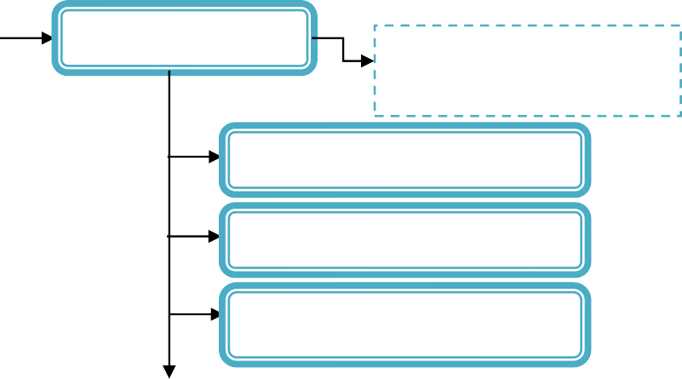case study of Testing Tools

Win runner

Load Runner
Part
Automated functional GUI testing tool

Performance and load testing product

Virtual User Generator

Controller

Analysis
Quick Test Professional

Rational Test Suite
Means
IBM Rational is a probably one of few organization
QTP

Tools

Rational Test Manager Rational Robot
Rational Functional Tester Rational Manual Tester Rational Administrator
Record and playback, Verification ,
l Exception Handling, Exception
automated functional Graphical User Interface
Handling,Data-driven testing, Automating Custom and Complex UI objects,Add-in Extensibility, Results, Quality Center Integration, UserInterface,Languages, drawbacks

2-Vaishalinagar, 3-vaishlinagar,
Raiya Road, Raiya Road,
Nr. Amrapali Railway Crossing, Nr. Amrapali Railway Crossing, Rajkot 360001, Rajkot 360001.

Win Runner: (3 OR 5 MARKS)(IMP 3 MARKS)
- HP/Mercury Interactive's WinRunner is an automated functional GUI testing tool that allows a user to record and play back UI interactions as test scripts.
- As a Functional test suite, it works together with HP QuickTest Professional and supports enterprise quality assurance.
- WinRunner is functional testing software for enterprise IT applications. It captures, verifies and replays user interactions automatically, so you can identify defects and determine whether business processes work as designed.
- The software implements a proprietary Test Script Language (TSL) that
allows customization and parameterization of user input.
- HP WinRunner’s intuitive recording process helps produce robust functional tests. To create a test, HP WinRunner simply records a typical business process by emulating user actions, such as ordering an item or opening a vendor account. During recording, it is possible to directly edit generated scripts to meet the most complex test requirements. Next, testers can add checkpoints, which compare expected and actual outcomes from the test run. HP WinRunner offers a variety of checkpoints, including test, GUI, bitmap and web links.
- HP WinRunner can also verify database values to determine transaction accuracy and database integrity, highlighting records that have been updated, modified, deleted and inserted. With a few mouse clicks, the DataDriver Wizard feature lets convert a recorded business process into a data driven test that reflects the real-life actions of multiple users. For further test enhancement, the Function Generator feature presents a quick and reliable way to program tests, while the Virtual Object Wizard feature permits to teach HP WinRunner to recognize, record and replay any unknown or custom object.
- As HP WinRunner executes tests, it operates the application automatically, as though a real user were performing each step in the business process. If test execution occurs after hours or in the absence of a quality assurance (QA) engineer, the Recovery Manager and Exception Handling mechanisms automatically troubleshoot unexpected events, errors and application crashes so that tests can complete smoothly. Once tests are run, HP WinRunner’s interactive reporting tools help interpret results by providing detailed, easy-to-read reports that list errors and their originations.

2-Vaishalinagar, 3-vaishlinagar,
Raiya Road, Raiya Road,
Nr. Amrapali Railway Crossing, Nr. Amrapali Railway Crossing, Rajkot 360001, Rajkot 360001.

- HP WinRunner is able to build reusable tests to repeat throughout an application’s lifecycle. Thus, if developers modify an application over time, testers do not need to modify multiple tests. Instead, they can apply changes to the Graphical User Interface (GUI) Map, a central repository of test-related information, and HP WinRunner automatically propagates changes to all relevant script.

Load Runner: (3 OR 5 MARKS)(IMP 3 MARKS)

- LoadRunner is a performance and load testing product by Hewlett-Packard (since it acquired Mercury Interactive in November 2006) for examining system behaviour and performance, while generating actual load. LoadRunner can emulate hundreds or thousands of concurrent users to put the application through the rigors of real-life user loads, while collecting information from key infrastructure components (Web servers, database servers etc). The results can then be analysed in detail, to explore the reasons for particular behaviour.
- Consider the client-side application for an automated teller machine (ATM). Although each client is connected to a server, in total there may be hundreds of ATMs open to the public. There may be some peak times — such as 10
a.m. Monday, the start of the work week — during which the load is much higher than normal. In order to test such situations, it is not practical to have a testbed of hundreds of ATMs. So, given an ATM simulator and a computer system with LoadRunner, one can simulate a large number of users accessing the server simultaneously. Once activities have been defined, they are repeatable. After debugging a problem in the application, managers can check whether the problem persists by reproducing the same situation, with the same type of user interaction.
- Working in LoadRunner involves using three different tools which are part of LoadRunner. They are Virtual User Generator (VuGen), Controller and Analysis.

Virtual User Generator
  - The Virtual User Generator (VuGen) allows a user to record and/or script the test to be performed against the application under test, and enables the performance tester to play back and make modifications to the script as needed. Such modifications may include Parameterization (selecting data for keyword-driven testing), Correlation and Error handling.
  - LoadRunner supports several protocols like Web HTTP/HTTPS, Remote Terminal Emulator, Oracle and Web Services. A protocol can be understood

2-Vaishalinagar, 3-vaishlinagar,
Raiya Road, Raiya Road,
Nr. Amrapali Railway Crossing, Nr. Amrapali Railway Crossing, Rajkot 360001, Rajkot 360001.

as a communication medium between the clients and the server. For example an AS400 or Mainframe based application use Terminal Emulator to talk to the Server where as a Web Online banking application uses HTTP/HTTPS with some Java and Web services. LoadRunner is capable of recording scripts in both single and multi-protocol modes.
  - During recording, VuGen records a tester's actions by routing data through a proxy. The type of proxy depends upon the protocol being used, and affects the form of the resulting script. For some protocols, various recording modes can be selected to further refine the form of the resulting script. For instance, there are two types of recording modes used in LoadRunner Web/HTTP testing: URL based, and HTML based.

- Controller
  - Once a script is prepared in VuGen, it is run via the Controller. LoadRunner provides for the usage of various machines to act as Load Generators. For example, to run a test of 1000 users, we can use three or more machines with a LoadRunner agent installed on them.
  - These machines are known as Load Generators because the actual load will be generated from them. Each run is configured with a scenario, which describes which scripts will run, when they will run, how many virtual users will run, and which Load Generators will be used for each script. The tester connects each script in the scenario to the name of a machine which is going to act as a Load Generator, and sets the number of virtual users to be run from that Load Generator.
  - LoadRunner uses monitors during a load test to monitor the performance of individual components under load. Some monitors include Oracle monitors, WebSphere monitors, etc... Once a scenario is set and the run is completed, the result of the scenario can be viewed via the Analysis tool.

Analysis

  - This tool takes the completed scenario result and prepares the necessary graphs for the tester to view. Also, graphs can be merged to get a good picture of the performance. The tester can then make needed adjustments to the graph and prepare a LoadRunner report. The report, including all the necessary graphs, can be saved in several formats, including HTML and Microsoft Word format.

2-Vaishalinagar, 3-vaishlinagar,
Raiya Road, Raiya Road,
Nr. Amrapali Railway Crossing, Nr. Amrapali Railway Crossing, Rajkot 360001, Rajkot 360001.

QTP(Quick Test Professional) (3 OR 5 MARKS)(IMP)

  - Quick Test Professional (QTP) is an automated functional Graphical User Interface (GUI) testing tool created by the HP subsidiary Mercury Interactive that allows the automation of user actions on a web or client based and desktop computer application. It is primarily used for functionalregressiontest automation. QTP uses a scripting language built on top of VBScript to specify the test procedure, and to manipulate the objects and controls of the application under test.
  - As part of a functional test suite, it works together with Mercury Interactive WinRunner and HP Quality Center and supports enterprise Quality Assurance.

Record and playback
  - Initial development of automated tests with QTP is usually done by record-and- playback. A user's actions are recorded and transposed into comprehensible actions using VBScript. Once recorded, the scripts are editable in either Keyword View or Expert View.
  - To execute, users select the playback button, which re-executes the commands against the application under test. In real world usage, simply recording and playing- back actions is generally not valuable, as it simply repeats a test already executed and may no longer be valid (because the record now exists in the system, for example).
  - This record/playback behavior is not unique to QTP, but is shared by comparable automated functional testing tools, such as IBM Rational Functional Tester, MicroFocus TestPartner, and Borland SilkTest. There are a few other tools which supports "capture & replay" options (with a difference of supported technologies) like free Selenium.

Verification
  - Checkpoints are a feature used for verifying that the application under test functions as expected. One can add a checkpoint to check if a particular object, text or a bitmap is present in the automation run. Checkpoints are used to verify that during the course of test execution, the actual application behavior or state is consistent with the expected application behavior or state.
  - There are 10 types of checkpoints available in QTP, enabling users to verify various aspects of an application under test, such as: the properties of an object, data within a table, records within a database, a bitmap image, or the text on an application screen. Users can also create user-defined checkpoints.

2-Vaishalinagar, 3-vaishlinagar,
Raiya Road, Raiya Road,
Nr. Amrapali Railway Crossing, Nr. Amrapali Railway Crossing, Rajkot 360001, Rajkot 360001.

Exception handling
  - Recovery is the name for exception handling in QTP, with the goal of enabling the tests to continue to run if an unexpected failure occurs. For instance if an application crash occurs and a message dialog appears, QTP can be instructed to attempt to restart the application and continue with the rest of the test cases from there. Because QTP hooks into the memory space of the applications being tested, some exceptions may cause QTP to terminate, and may be unrecoverable.

Data-driven testing
  - QTP has features to enable users to perform data-driven testing. For example, data can be output to a data table for reuse elsewhere. Data-driven testing is implemented as a Microsoft Excel workbook that can be accessed from within QTP.There are two types of Data Tables available in QTP: the Global data sheet and the local data sheets. The test steps read data from these data tables in order to (for example) drive variable data into the application under test, and verify the expected result.

Automating custom and complex UI objects
  - Customized user interface objects and other complex objects may not be recognized properly by QTP. QTP offers a Virtual Object concept to enable users to add some degree of support for these objects. Assuming that the required information can be extracted from the object, this allows the users to successfully record and playback against that object. In practice, this is not always possible.

Add-in Extensibility

  - QuickTest add-in extensibility, available for some environments, enables you to extend the relevant QuickTest add-in to support third-party and custom controls that are not supported out-of-the-box. QuickTest add-in extensibility is currently supported for the Web, .NET, Java, and Delphi add-ins

Results
  - QTP generates the result file for the test cases at the end of test in the form of XML tree. The result file provides detail regarding PASS and FAILS counts, error messages, and may provide supporting information that allows users to determine the

2-Vaishalinagar, 3-vaishlinagar,
Raiya Road, Raiya Road,
Nr. Amrapali Railway Crossing, Nr. Amrapali Railway Crossing, Rajkot 360001, Rajkot 360001.

underlying cause of a failure. Frequently, however, users may need to re-execute the test case and observe the failure directly.

Quality Center Integration

  - Using QuickTest Professional together with Quality Center provides you an intuitive and efficient system for managing your tests and their resources (actions, function libraries, object repositories, recovery scenarios, data table files, and environments variables). You can manage asset dependencies and versions, schedule and run tests, collect, analyze, and share results, report defects, and link your tests and defects to project requirements.

User interface
  - QuickTest provides two main views of a script: Keyword View and Expert View. They are selected from tabs at the bottom of the QuickTest Professional window.

Keyword view
    - Keyword View is QTP's default test procedure interface. It displays the automation steps of a test procedure as a descriptive tree of actions and functions. The tree contains columns listing the action or function name, parameters, and comments. This mode is useful for the beginners. This view allows the user to select the objects either from the application or from the Object Repository and the user can select the methods to be performed on those objects. The script is automatically generated. Users can also set checkpoints from the keyword view. Users without technical knowledge may be able to understand the Keyword View, but more experienced users and users needing to perform more complicated actions may need to switch to Expert View.

Expert view
    - In Expert View, QTP allows display and editing of the test's source code using VBScript. All test actions can be edited here except for the root Global action. Expert View acts as an IDE for the test. It includes many standard IDE features, such as breakpoints.

2-Vaishalinagar, 3-vaishlinagar,
Raiya Road, Raiya Road,
Nr. Amrapali Railway Crossing, Nr. Amrapali Railway Crossing, Rajkot 360001, Rajkot 360001.

- Languages

  - QTP uses VBScript as its scripting language. VBScript supports classes but not polymorphism and inheritance. Compared with Visual Basic for Applications (VBA), VBScript lacks the ability to use some Visual Basic keywords, does not come with an integrated debugger, lacks an event handler, and does not have a forms editor. HP has added some of these features to QTP, such as a debugger, but QTP's functionality is more limited in these areas compared with testing tools that integrate a full-featured IDE, such as those provided with VBA, Java, or VB.NET.

Drawbacks

  - QTP is not supported by non-Windows based applications. Neither can it be used by a plug-in in other environments. It fetches objects like ActiveX from the Windows environment which is not possible in any other OS. It also cannot be used via Remote Desktop Connection due to licensing issues.

Rational Test Suite
  - IBM Rational is a probably one of few organization, which touches entire life cycle of software development with its tool set. There are different tools from Rational right from Requirements management to Change Management, Testing and Project/ Portfolio Management.
  - Rational Test Suite is the entire test suite by Rational for supporting automated software quality. This test Suite Consists of different tools:
- Rational Test Manager
- Rational Robot
- Rational Functional Tester
- Rational Manual Tester
- Rational Administrator
  - Purpose of this page is to make you familiar with the Rational Test Suite and not with the individual products. There will be plenty of information about the individual tools as well in some time. Rational Administrator is the basic tool for managing the authentication for the different repositories of Rational Test Suite. It allows you to create different users with different levels of access. Main purpose of Rational Administrator is to manage authentication and authorization for different Rational Projects.

Shree H.N. Shukla College of I.T. &Mgmt, Rajkot
2-Vaishalinagar, 3-vaishlinagar,
Raiya Road, Raiya Road,
Nr. Amrapali Railway Crossing, Nr. Amrapali Railway Crossing, Rajkot 360001, Rajkot 360001.

- Rational Test Manager is the backbone for managing all your Test Assets. It is central console for

  - Managing test activity
  - Executing
  - Reporting
- Test manager acts as baton for guiding all your testing efforts. It allows you to store all the test cases. These test cases may be linked to the requirements in the Requisite Pro and Automated Scripts in Rational Robot.
- If test cases are connected to the Automated Test Scripts, they are organized in the form of test suites which can be triggered for execution either on the same machine or the different machines for remote executions with the help of Test Agent.
- After the execution of the Scripts the results are reported in the form of error logs and graphs for the suites depicting the percentage VP’s passed and failed. Rational Robot can be used for automating the test cases.
- It uses SQABasic scripting language which is similar to VBScript. Robot has the concept of header files and library files. It allows modularization of your automation by breaking it into different functions, which can be stored in the .sbl or .sbh files.
- Robot allows you to access the windows API by registering their dlls. You can also create your custom dlls and make calls to them from within the scripts. It has support for command line invocation and web/load testing in the form VU Scripting. Rational Manual Tester allows you to organize your manual testing.
- In manual Tester you can create different steps and specify some Verification Steps. All these steps are saved and you can execute these test cases, mark them for completion. Results of execution are stored and logged in the Test Manager.
It also has integration with Rational ClearQuest. ClearQuest can be launched from within the tool and file defects if found. It also fills some of the field of ClearQuest, based on the knowledge of test cases it has.
 |  | NO. | QUESTION | ANSWER
 |  | 1. | What is Winrunner? | automated functional GUI testing tool
 |  | 2. | TSL | Test Script Language
 |  | SAD, Software Quality Assurance and Testing Page No:36

Shree H.N. Shukla College of I.T. &Mgmt, Rajkot
2-Vaishalinagar, 3-vaishlinagar,
Raiya Road, Raiya Road,
Nr. Amrapali Railway Crossing, Nr. Amrapali Railway Crossing, Rajkot 360001, Rajkot 360001.
 |  | 3. | QA | quality assurance
 |  | 4. | GUI | Graphical User Interface
 |  | 5. | LoadRunner | performance and load testing product
 |  | 6. | ATM | automated teller machine
 |  | 7. | How many Different tools available in Loadrunner? | Virtual User Generator (VuGen), Controller and Analysis.
 |  | 8. | Controller | Once a script is prepared in VuGen, it is run via the Controller
 |  | 9. | QTP | Quick Test Professional
 |  | 10. | How many provides Quicktests view? | Keyword View and Expert View
 |  | 11. | What is Rational Test Suite? | IBM Rational is a probably one of few organization,
 |  | SAD, Software Quality Assurance and Testing Page No:37

