Shree H. N. Shukla Institute of Pharmaceutical
Education and Research, Rajkot

B. Pharm
Semester-IV

Subject Name: Physical Pharmaceutics II
Subject Code: BP403TP

MICROMERITICS

Particle Size and Size Distribution.
- Methods for determining particle size.
- Density and Flow properties of powders.

- Definition: It is the science and technology of small particles.
- The unit of particle size used in the micrometer (µm), micron (µ) and equal to 10-6 m.
- As particle size decreases ↓, area increases ↑

- Micromeritics is the science and technology of small particles. Knowledge and control of the size and the size range of particles are of significant importance in pharmacy because the size and surface area of a particle related to the physical, chemical and pharmacologic properties of a drug.

- The particle size of a drug can affect its release from dosage forms that are administered orally, parenterally, rectally and topically.

In the area of tablet and capsule manufacture, control of the particle size is essential in achieving the necessary flow properties and proper mixing of granules and powders.

Particle Size and Size Distribution
- In a collection of particles of more than one size, two properties are important, namely.

- The shape and surface are of the individual particles.

- The particle size and size distributions (The size range and number or weight of particles).

- The size of a sphere is readily expressed in terms of its diameter.
- The Surface diameter, ds, is the diameter of a sphere having the same surface area as the particle.
- The Volume diameter, dv, is the diameter of a sphere having the same volume as the particle.
- The Projected diameter, dp, is the projected diameter of a sphere having the same observed area as the particle.
- The Stokes diameter, dst, is the diameter which describes an equivalent sphere undergoing sedimentation at the same rate as the asymmetric particle.

- Any collection of particles is usually polydisperse. It is therefore necessary to know not only the size of a certain particle, but also how many particles of the same size exist in the sample.
- Thus, we need an estimate of the size range present and the number or weight fraction of each particle size.
- This is the particle-size distribution and from it we can calculate an average particle size for the sample.

- When the number or weight of particles lying within a certain size range is plotted against the size range or mean particle size, a so-called frequency distribution curve is obtained.

- This is important because it is possible to have two samples with the same average diameter but different distributions.

Release and dissolution.
- Absorption and drug action.
- Physical stability.
- Dose uniformity.

- Particle size and surface area influence the release of a drug from a dosage form.

- Higher surface area allows intimate contact of the drug with the dissolution fluids in vivo and increases the drug solubility and dissolution.

- Particle size and surface area influence the drug absorption and subsequently the therapeutic action.

- Higher the dissolution, faster the absorption and hence quicker and greater the drug action.

- The particle size in a formulation influences the physical stability of the suspensions and emulsions.

- Smaller the size of the particle, better the physical stability of the dosage form.

- Good flow properties of granules and powders are important in the manufacturing of tablets and capsules.

Methods for determining particle size
- Many methods available for determining particle size such as optical microscopy, sieving, sedimentation and particle volume measurement.

- Optical microscopy (range: 0.2-100 µm).
- Sieving (range: 40-9500 µm).
- Sedimentation (range: 0.08-300 µm).
- Particle volume measurement (range: 0.5-300 µm).

Range of particle sizes
A guide to range of particle sizes applicable to each method is

Particle size | Method
1 μm | Electron microscope, ultracentrifuge, adsorption
1 – 100 μm | Optical microscope, sedimentation, coulter counter, air permeability
>50 μm | Sieving

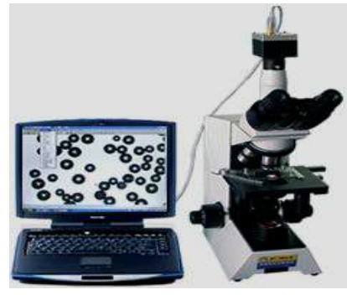

The microscope eyepiece is fitted with a micrometer by which the size of the particles may be estimated.

According to the optical microscopic method, an emulsion or suspension is mounted on ruled slide on a mechanical stage.
- The microscope eyepiece is fitted with a micrometer by which the size of the particles can be estimated.
- The ordinary microscope used for measurement the particle-size in the range of
0.2 to about 100 µm.

Disadvantage of microscopic method
- The diameter is obtained from only two dimensions of the particle.

- The number of particles that must be counted (300-500) to obtain a good estimation of the distribution makes the method somewhat slow and tedious.

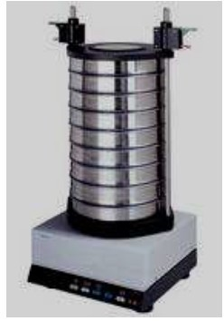
Standard size sieves are available to cover a wide range of size.
  - These sieves are designed to sit in a stack so that material falls through smaller and smaller meshes until it reaches a mesh which is too fine for it to pass through.

- The stack of sieves is mechanically shaken to promote the passage of the solids.
- The fraction of the material between pairs of sieve sizes is determined by weighing the residue on each sieve.
- The result achieved will depend on the duration of the agitation and the manner of the agitation.

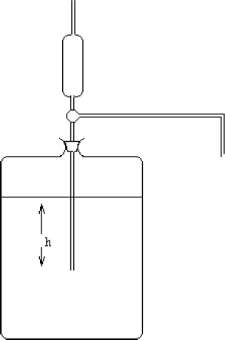
  - By measuring the terminal settling velocity of particles through a liquid medium in a gravitational centrifugal environment using Andreasen appartus.

Particle volume measurement (range: 0.5-300 µm)
- In this type of machine the powder is suspended in an electrolyte solution.
- This suspension is then made to flow through a short insulated capillary section between two electrodes and the resistance of the system is measured.
- When a particle passes through the capillary there is a momentary peak in the resistance, the amplitude of the peak is proportional to the particle size.
- Counting is done by a computer.

Particle volume measurement
(range: 0.5-300 µm)
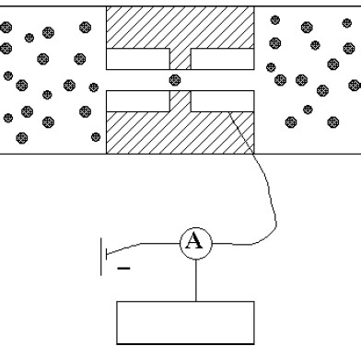

Density of powders

Density is defined as weight per unit volume (W/V).
- During tapping, particles gradually pack more efficiently, the powder volume decreases and the tapped density increases.
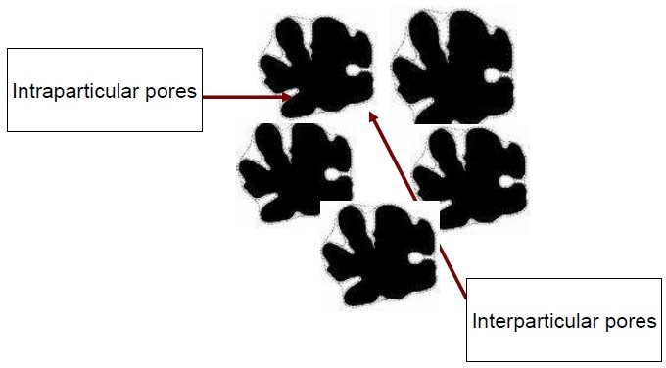

- True density: The true density or absolute density of a sample excludes the volume of the pores and voids within the powder sample.

- Bulk density: The bulk density value includes the volume of all of the pores within the powder sample.

- Powders may be free-flowing or cohesive (Sticky).
- Many common manufacturing problems are attributes to powder flow.
- Powder transfer through large equipment such as hopper.
- Uneven powder flow → excess entrapped air within powders → capping or lamination.
- Uneven powder flow → increase particle’s friction with die wall causing lubrication problems and increase dust contamination risks during powder transfer.

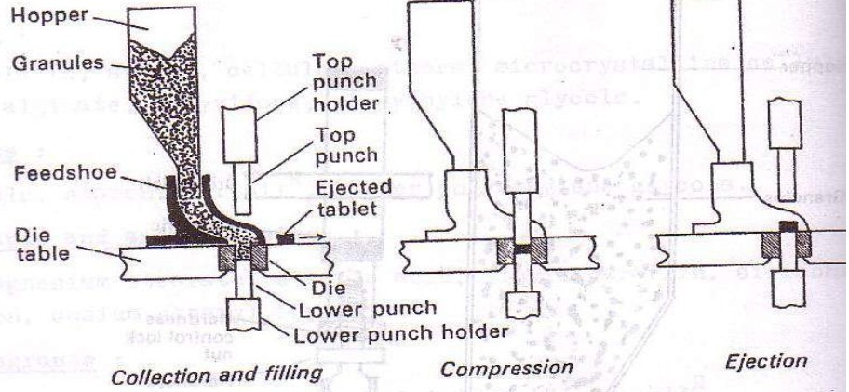

Powder storage, which for example result in caking tendencies within a vial or bag after shipping or storage time.
- Separation of small quantity of the powder from the bulk-specifically just before the creation of individual doses such as during tableting, encapsulation and vial filling which affect the weight uniformity of the dose (under or over dosage).

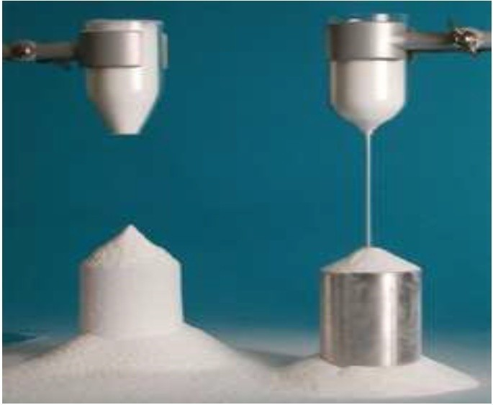

- Tests to evaluate the flowability of a powder.

- Carr’s compressibility index.

- Hausner ratio.

- The angle of repose (θ).

Carr’s compressibility index
- A volume of powder is filled into a graduated glass cylinder and repeatedly tapped for a known duration. The volume of powder after tapping is measure.

Tapped density- Poured or bulk density
Carr’s index (%)= X 100
Tapped density

Bulk density= weight/bulk volume
Tapped density=weight/true volume

Carr’s compressibility index
Relationship between powder flowability and % compressibility

Flow description | % Compressibility
Excellent flow | 5 – 15
Good | 16 – 18
Fair | 19 – 21
Poor | 22 – 35
Very Poor | 36 -40
Extremely poor | > 40

Hausner ratio =
Tapped density

Poured or bulk density

Hausner ratio was related to interparticle friction:

- Value less than 1.25 indicates good flow (=20% Carr).

- The powder with low interparticle friction, such as coarse spheres.
- Value greater than 1.5 indicates poor flow (= 33% Carr’s Compressibility Index)).
- More cohesive, less free-flowing powders such as flakes.
- Between 1.25 and 1.5 added glidant normally improves flow.
- > 1.5 added glidant doesn’t improve flow.

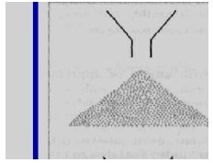
- The sample is poured onto the horizontal surface and the angle of the resulting pyramid is measured.

- The user normally selects the funnel orifice through which the powder flows slowly and reasonably constantly.

Angle of repose less than 20 (Excellent flow).
- Angle of repose between20-30 (Good flow).
- Angle of repose between 30-40 (Pass flow).
- Angle of repose greater than 40 (Poor flow).

- The rougher and more irregular the surface of the particles, the higher will be the angle of repose.

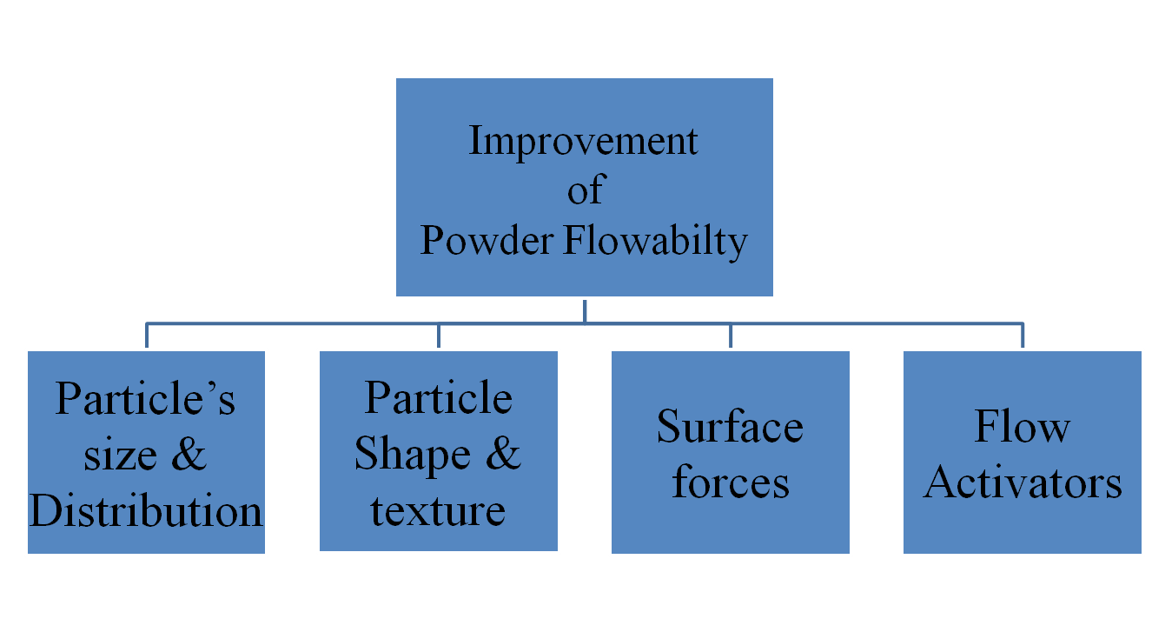

- Alteration of Particle’s size & Distribution

- Alteration of Particle shape & texture

- Alteration of Surface Forces

- Formulation additives (Flow activators)

Alteration of Particle’s size & Distribution
- There is certain particle size at which powder’s flow ability is optimum.
- Coarse particles are more preferred than fine ones as they are less cohesive.
- The size distribution can also be altered to improve flowability by removing a proportion of the fine particle fraction or by increasing the proportion of coarser particle’s such as occurs in granulation.

Factors affecting the flow properties of powder

Alteration of Particle shape & texture
Particle’s Shape
- Generally, more spherical particles have better flow properties than more irregular particles.
- Spherical particles are obtained by spray drying, or by temperature cycling crystallization.
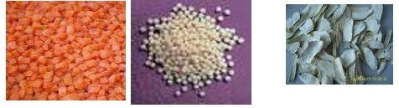

Alteration of Particle shape & texture Particle’s texture

Particles with very rough surfaces will be
more cohesive and have a greater tendency to interlock than smooth surfaced particles.

Alteration of Surface Forces
- Reduction of electrostatic charges can improve powder flowability.
- Electrostatic charges can be reduced by altering process conditions to reduce frictional contacts.
- Moisture content of particle greatly affects powder’s flowability.
- Adsorbed surface moisture films tend to increase bulk density and reduce porosity.
- Drying the particles will reduce the cohesiveness and improve the flow.
- Hygroscopic powder’s stored and processed under low humidity conditions.

Formulation additives (Flow activators)

Flow activators are commonly referred as a glidants.

- Flow activators improve the flowability of powders by reducing adhesion and cohesion.

e. g. Talc, maize starch and magnesium stearate.

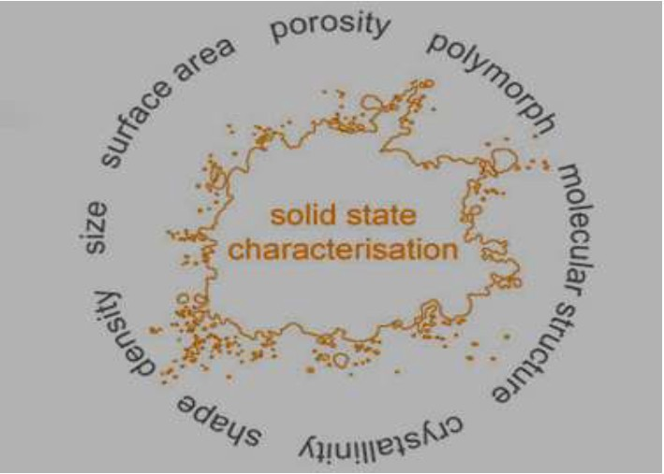

E-mail: nanjwadebk@gmail.com

