5 MAIN CATEGORIES OF COSMETIC PRODUCTS?

The cosmetic product industry is one of the fast-growing sectors in the last decade. The use of cosmetic products has increased tremendously in recent days, which accounts for its growth. Along with many chemicals, cosmetic products, the use of herbal cosmetic products is also growing. In the last years, there are a lot of herbal product manufacturersin India as people have become more aware and prefer natural products over chemical cosmetics.
There are a lot of products that are both manufactured and imported from other countries. These products fall under five major categories based on the body part on which it is used and the purpose of it. The major five main types of cosmetic products are,
- Skincare range
- Haircare range
- Face care range
- Personal care range
- Treatment range

Skincare ranges
These are items designed to make skin look and feel better. The skincare market accounts for around 20% of all cosmetics sold, which is the largest share in any category. Skincare products can be further classified by how they function and what they do. These include moisturizers, creams, powders, essential oils, toners, serums, etc.

Haircare ranges
Haircare products are the second most popular form of cosmetic that accounts for about 25 percent of sales. Like the skincare group, hair products can also be categorized according to how they work and what they do.The hair products most frequently purchased are the ones designed to remove things from the hair, like shampoos. Some are meant to be left on like leave-in conditioners, hair gels, essential oils, etc.

Face care ranges
This category includes herbal cosmetics that can only be used, particularly on the face. These range of products kind of overlap with the skincare products. This range of category accounts for 30% of market sales. The difference is while all the face care products are on the skin, not all skincare products can be used on the face. Some of the face care products include face wash, face scrub, toner, sun creams, face packs, facial kits, face gels, serums, etc.

Personal care ranges
Other personal care products are the new beauty product category. This category accounts for about 15 percent of market sales (depending on which goods you include). These include products for oral care, such as toothpaste, mouthwash, and whitening products. They also include soaps, bathing gel, soaps, massaging oils, etc.

Treatment care ranges
This type of treatment care product is designed to cure specific skin or hair problems. For example, there is a specific type of cream that is targeted to cure acne, or spots, etc. The same goes for hair fall or dandruff issues too.
There are also many subcategories under each category. Based on what you need, one can choose the herbal product. There are a lot of benefits to using herbal cosmetics as it is natural and doesn’t have many side effects.

The structure and functions of the skin

Structure of the skin

The skin is divided into several layers, The epidermis is composed mainly of keratinocytes. Beneath the epidermis is the basement membrane (also known as the dermo-epidermal junction). The layer below the dermis, the hypodermis, consists largely of fat. These structures are described below
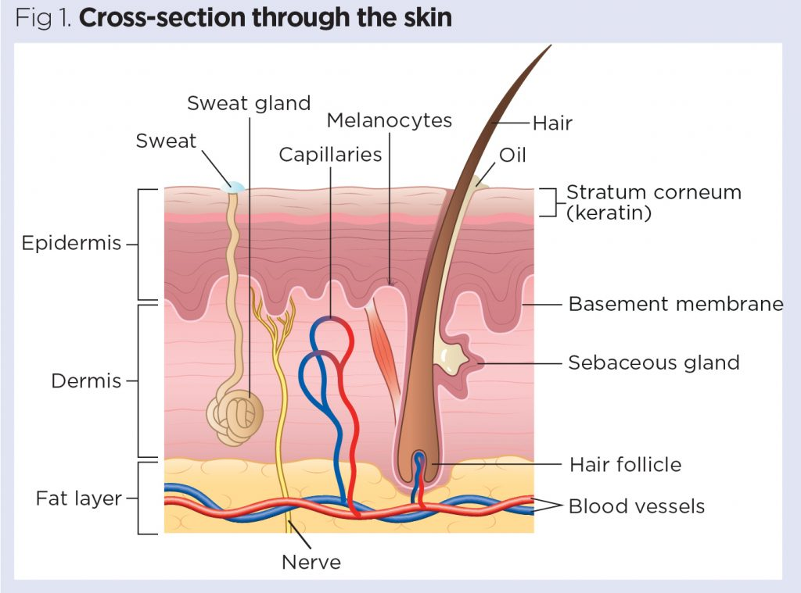

Epidermis

The epidermis is the outer layer of the skin, defined as a stratified squamous epithelium, primarily comprising keratinocytes in progressive stages of differentiation .Keratinocytes produce the protein keratin and are the major building blocks of the epidermis. As the epidermis is avascular it is entirely dependent on the underlying dermis for nutrient delivery and waste disposal through the basement membrane.
Functions

act as a physical and biological barrier to the external environment, preventing penetration by irritants and allergens.
it prevents the loss of water and maintains internal homeostasis.
The epidermis is composed of layers:
- Stratum corneum (horny layer);
- Stratum lucidum (only found in thick skin – that is, the palms of the hands, the soles of the feet and the digits);
- Stratum granulosum (granular layer);
- Stratum spinosum (prickle cell layer);
- Stratum basale (germinative layer).

Basement membrane zone

(dermo-epidermal junction)
This is a narrow, undulating, multi-layered structure lying between the epidermis and dermis, which supplies cohesion between the two layers (Amirlak and Shahabi, 2017; Graham-Brown and Bourke, 2006). It is composed of two layers:
- Lamina lucida;
- Lamina densa.
The lamina lucida is the thinner layer and lies directly beneath the stratum basale. The thicker lamina densa is in direct contact with the underlying dermis. It undulates between the dermis and epidermis and is connected via rete ridges called dermal papillas, which contain capillary loops supplying the epidermis with nutrients and oxygen.
This highly irregular junction greatly increases the surface area over which the exchange of oxygen, nutrients and waste products occurs between the dermis and the epidermis (Amirlak and Shahabi, 2017).

Dermis
The dermis forms the inner layer of the skin and is much thicker than the epidermis (1-5mm) (White and Butcher, 2005). Situated between the basement membrane zone and the subcutaneous layer, the primary role of the dermis is to sustain and support the epidermis. The main functions of the dermis are:
- Protection;
- Cushioning the deeper structures from mechanical injury;
- Providing nourishment to the epidermis;
- Playing an important role in wound healing.
The network of interlacing connective tissue, which is its major component, is made up of collagen, in the main, with some elastin. Scattered within the dermis are several specialised cells (mast cells and fibroblasts) and structures (blood vessels, lymphatics, sweat glands and nerves).
The epidermal appendages also lie within the dermis or subcutaneous layers, but connect with the surface of the skin (Graham-Brown and Bourke, 2006).

Layers of dermis. The dermis is made up of two layers:
- The more superficial papillary dermis;
- The deeper reticular dermis.
The papillary dermis is the thinner layer, consisting of loose connective tissue containing capillaries, elastic fibres and some collagen. The reticular dermis consists of a thicker layer of dense connective tissue containing larger blood vessels, closely interlaced elastic fibres and thicker bundles of collagen . It also contains fibroblasts, mast cells, nerve endings, lymphatics and epidermal appendages. Surrounding these structures is a viscous gel that:

- Allows nutrients, hormones and waste products to pass through the dermis;
- Provides lubrication between the collagen and elastic fibre networks;
- Gives bulk, allowing the dermis to act as a shock absorber .

Specialised dermal cells and structures.

The fibroblast is the major cell type of the dermis and its main function is to synthesise collagen, elastin and the viscous gel within the dermis.

Collagen – which gives the skin its toughness and strength – makes up 70% of the dermis and is continually broken down and replaced; elastin fibres give the skin its elasticity. However both are affected by increasing age and exposure to UV radiation, which results in sagging and stretching of the skin as the person gets older and/or is exposed to greater amounts of UV radiation.

Mast cells contain granules of vasoactive chemicals. They are involved in moderating immune and inflammatory responses in the skin.

Blood vessels in the dermis form a complex network and play an important part in thermoregulation.
The lymphatic drainage of the skin is important, the main function being to conserve plasma proteins and scavenge foreign material, antigenic substances and bacteria.
About 1 million nerve fibres serve the skin – sensory perception serves a critically important protective and social/sexual function. Free sensory nerve endings are found in the dermis as well as the epidermis (Merkel cells) and detect pain, itch and temperature. There are also specialised receptors – Pacinian corpuscles – that detect pressure and vibration; and Meissner’s corpuscles, which are touch-sensitive.
The autonomic nerves supply the blood vessels and sweat glands and arrector pili muscles (attached to the hair).

Hypodermis
The hypodermis is the subcutaneous layer lying below the dermis; it consists largely of fat. It provides the main structural support for the skin, as well as insulating the body from cold and aiding shock absorption. It is interlaced with blood vessels and nerves.
Functions of the skin
The skin has three main functions:
- Protection;
- Thermoregulation;
- Sensation.
Within this, it performs several important and vital physiological functions, as outlined below (Graham-Brown and Bourke, 2006).

Protection
The skin acts as a protective barrier from:
- Mechanical, thermal and other physical injury;
- Harmful agents;
- Excessive loss of moisture and protein;
- Harmful effects of UV radiation.

Thermoregulation
One of the skin’s important functions is to protect the body from cold or heat, and maintain a constant core temperature. This is achieved by alterations to the blood flow through the cutaneous vascular bed. During warm periods, the vessels dilate, the skin reddens and beads of sweat form on the surface (vasodilatation = more blood flow = greater direct heat loss). In cold periods, the blood vessels constrict, preventing heat from escaping (vasoconstriction = less blood flow = reduced heat loss). The secretion and evaporation of sweat from the surface of the skin also helps to cool the body.

Sensation
Skin is the ‘sense-of-touch’ organ that triggers a response if we touch or feel something, including things that may cause pain. This is important for patients with a skin condition, as pain and itching can be extreme for many and cause great distress. Also touch is important for many patients who feel isolated by their skin as a result of colour, disease or the perceptions of others as many experience the fact that they are seen as dirty or contagious and should not be touched.

Immunological surveillance
The skin is an important immunological organ, made up of key structures and cells. Depending on the immunological response, a variety of cells and chemical messengers (cytokines) are involved. These specialised cells and their functions will be covered later.

Biochemical functions
The skin is involved in several biochemical processes. In the presence of sunlight, a form of vitamin D called cholecalciferol is synthesised from a derivative of the steroid cholesterol in the skin. The liver converts cholecalciferol to calcidiol, which is then converted to calcitriol (the active chemical form of the vitamin) in the kidneys. Vitamin D is essential for the normal absorption of calcium and phosphorous, which are required for healthy bones (Biga et al, 2019). The skin also contains receptors for other steroid hormones (oestrogens, progestogens and glucocorticoids) and for vitamin A.

Social and sexual function
How an individual is perceived by others is important. People make judgements based on what they see and may form their first impression of someone based on how that person looks. Throughout history, people have been judged because of their skin, for example, due to its colour or the presence of a skin condition or scarring. Skin conditions are visible – in this skin-, beauty- and image-conscious society, the way patients are accepted by other people is an important consideration for nurses.

