Shree H. N. Shukla Institute of Pharmaceutical Education and Research, Rajkot

B. Pharm
Semester-VIII

Subject Name: Pharma Marketing Management
Subject Code: BP803TT

Marketing CHANNELS

Learning Objectives
Describe what are marketing channels and their functions in pharmacy practice
Summarize the arguments for and against using intermediaries in channels
Map out general pharmacy channel structures Identify the sources of channel conflict
Suggest strategies for managing conflict in marketing channels
Define key terms: channels, intermediaries, just-in-time, outsourcing

3

Channels are…
paths through which goods, information, and payment travel on their way from the producer (e.g., manufacturer) to ultimate consumer (e.g., patient).

4

Channels in Pharmacy
In pharmacy, there are channels for distributing medications, financing and paying for those medications, insuring risk associated with medications, and facilitating their appropriate use.
Channels of distribution are a prominent concern for pharmacists.

5

A Channel of Distribution…
consists of the producer of a good (e.g., drug), the ultimate user, and any intermediaries (i.e., middlemen) through which the goods pass

6

Typical Channels for Drugs

Producer

Intermediary

Intermediary

End User
Pharmaceutical
Company

Patient
Pharmaceutical
Company

Pharmacy

Patient
Pharmaceutical Company

Wholesaler

Pharmacy

Patient
7

Intermediaries…
improve the efficiency of distribution channels by decreasing the number of required interactions between members of the channel.

8

Buyer

Seller

Basic Marketing Channels

Seller

Buyer

One Seller, Many Buyers (e.g., Pharmaceutical Company Selling to Retail Pharmacies)

Buyer

Seller

One Buyer, Many Sellers (e.g., Health Care Providers

Buyer

Seller
Selling to the Federal Government)

Seller

Buyer

Seller

Buyer

Seller

Buyer

Seller
Inter- med- iary

Buyer

Seller

Buyer

Seller

Buyer

Many Sellers & Many Buyers With No Intermediary (e.g., Famers Market)
Many Sellers & Many Buyers With An Intermediary (e.g., Wholesaler Mediating Transactions
Between Pharmaceutical Companies and Retailers)
9

Producers benefit from working with channel intermediaries
Intermediaries offer platforms which can be used by large numbers of producers in an economical way
Intermediaries reduce the amount of upfront investment required by producers
Specialization of intermediaries adds quality and efficiency to the system
Specific skills and capabilities can be efficiently outsourced to channel partners.

10

Functions of Marketing Channels

Production/
Value Added
Repackaging
Value Added
Services
Compound-
ing
Selling/
Promotion
Promotional
Communi- cations
Point of
Purchase Selling
Distribution
Face-to-face
Mail Order
Self-Service
Storage
Wholesaling
Warehous-
ing
Financing/
Payment
Credit
Insurance
Contracts
Patient Cost
Sharing
Risk Sharing
Risk Sharing
Contracts
Participation
in Networks
Regulation
State & Local
Federal
Non-govern-
mental
Relationship
Management
Customer
Relationship Manage- ment (CRM)
Managed
Care Networks

11

Marketing Channel Functions and Examples of
Physical Distribution

Channel Function | Example of pharmacist role
Production & Adding Value | Providing MTM & clinical services
Promotional  Communications | Persuading patients to adhere to medications
Distribution | Dispensing medications
Storage | Inventory & formulary management
Financing & Payment | Assisting patients & providers in cost effective  therapeutic plans
Risk Sharing | Managing risk of adverse outcomes of medications
Regulation | Ensuring that all other channel members adhere to laws & regulations
Relationship  Management | Developing & maintaining therapeutic relationships  with patients
12

Channel Relationships
Marketing channels consist of different organizations, each with their own goals and objectives.
In pursuing their goals, organizations frequently
- Have conflicts
- Cooperate

13

Channel Members…
Can be partners, allies, or competitors depending on the channel functions they choose to serve
Competing for channel functions is a major source of conflict

14

MANAGING CHANNEL CONFLICT

Commitment of partners to a productive channel relationship is a function of:
The benefits of being in that relationship The costs of terminating that relationship Shared goals and values
Trust between partners

Source: The commitment-trust theory of relationship marketing. Journal of
Marketing 1994;20-38. 15

Managing Channel Relationships
Pharmacists need to effectively manage how partners perceive them and their contributions to the relationship
They must
  - make a continual case for the value they provide to partners and the customers served by partners
  - seek partners who share similar goals and values
  - continually work to gain and maintain their partners' trust

16

OMNI-CHANNEL RETAILING
"an integrated sales experience that melds the advantages of physical stores with the information-rich experience of online shopping
Omnichannel retailing tries to provide a seamless experience in which consumers switch back and forth through all available shopping channels

*The future of shopping. Harvard Business Review 2011;89(12):65-76. 17

Omni-Channel Experience for the Pharmacy Customer

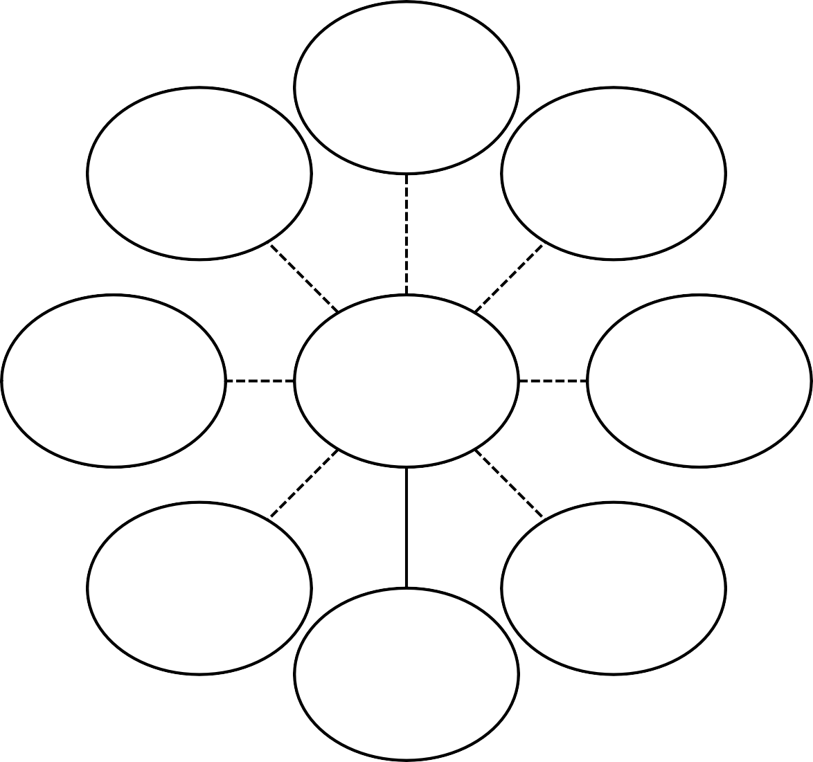Retail Store

Mobile Applications

Kiosk

Telemedicine
Customer
Internet

ATM-Type Technology
Mail Order

Social Media
18

Summary
Roles of pharmacists in channels continue to change
Serving pharmacy customers requires collaboration with channel partners but often leads to conflict too
Pharmacists are intermediaries in most pharmacy channels, meaning that their value results from how well they serve their new and established roles within the supply chain.
Pharmacists can add value in more ways than just by selling merchandise, and increasingly they are stepping into roles outside of the distribution function.

19

