B.COM SEM – III
Syllabus

No. | Unit Name | Marks
1 | Concept And Objective Of Communication  *introduction, definition, process, and objectives of communication | 10
2 | Methods of communication  *Verbal & Non- Verbal Communication | 15
3 | Types of communication  *formal and informal channels of communication | 05
4 | Barriers to communication  *barriers to communication  *how to break the barriers | 10
5 | Written communication : business  Letters  *parts of business letters  *outward appearance of business letters  *essential of business letters | 10
6 | Practical letter writing  *letters of inquiry and reply | 10
7 | Practical letter writing  *letters of order and execution | 10

UNIT – 1
CONCEPT AND OBJECTIVES OF COMMUNICATION

- What is Communication? Give few definitions of Communication. :

- Introduction to Communication:

Communication is as old as human civilization. Man used to communicate with his fellow beings by means of sounds, signals, gestures when there was no language developed. Minus communication, human society could not have been as it is today. It is communication which has transformed mankind into the most developed rational and prosperous group on the earth.
Communication is the activity of conveying information. It basically involves a sender, a message and a receiver.
Communication can be defined as the process of transmitting information and common understanding from one person to another (Keyton, 2011). The word communication is derived from the Latin word, communis, which means common. Communis adding to meaning “common opinion” or “a generally accepted view”.
Communication establishes relationships and makes organizing possible. Every message has a purpose or objective. The sender intends -- whether consciously or unconsciously -- to accomplish something by communicating. In organizational contexts, messages typically have a definite objective: to motivate, to inform, to teach, to persuade, to entertain, or to inspire.
Communication is usually a two-way process. It is not just giving information or signaling someone; it also involves the comprehension of the information or the signal by the receiver. When the act of giving information or sending message reaches the recipient and gets comprehended by him/her and the receiver sends feedback as desired by the sender, the process of communication is said to be complete. Communication, therefore, involves more than one person.
Communication is a continuous and dynamic process involving more than one person. It is a cyclic process denoting continuous flow of information. It essentially involves sender, message and recipient. The sender conceives ideas and encodes them into suitable medium (facts, figures, pictures), sends them through appropriate channel (email, phone, speech) to the recipient. The recipient decodes the message, understands it and encodes feedback and sends it to the sender. The process continues.

- Definitions of Communication:
- Keith Davis: Communication is a process of passing information and understanding from one person to another.

- John Adair: Communication is essentially the ability of one person to make contact with another and make himself or herself understood.

- William Newman and Charles Summer: Communication is an exchange of ideas, facts, opinions or emotions of two or more persons.

- Louis Allen: Communication is a bridge of meaning. It involves a systematic and continuous process of telling, listening and understanding.

- Peter Little: Communication is a process by which information is transmitted between individuals and / or organizations so that an understanding response results.

- Fred G. Meyer: Communication is the intercourse by words, letters or messages.

- G.G. Brown: Communication is transfer of information from one person to another, whether or not it elicits confidence. But the information transferred must be understandable to the receiver.

8. Ordway Tead: Communication is a composite of (a) information given and received, (b) of a learning experience in which certain attitudes, knowledge and skills change, carrying with them alternations of behaviour, (c) of a listening effort by all involved, (d) of a sympathetic fresh examination of issues by communicator himself, (e) of a sensitive interaction of points of view leading to a higher level of shared understanding and common intention.

Let’s Revise
Sr. No. | Questions | Answers
1 | According to whom, communication can be defined as the process of transmitting information and common understanding from one person to another? | Keyton
2 | Basically who is involved in communication apart from sender and a message? | Receiver
3 | The word communication is derived from the ______ word, communis, which means common. | Latin
4 | Every message has a purpose or ___________. | Objective
5 | Communication is usually a _________-way process. | Two
6 | Who gave the definition: Communication is a process of passing information and understanding from one person to another. ? | Keith Davis
7 | Who gave the definition: Communication is a process by which information is transmitted between individuals and / or organizations so that an understanding response results. ? | Peter Little
8 | Is it true that persuading is one of the objective of communication? | Yes
9 | Who gave the definition: Communication is a bridge of meaning. It involves a systematic and continuous process of telling, listening and understanding.? | Louis Allen
10 | Is communication possible without a sender? | No

- Explain the objectives/ purpose of Business Communication. :

- Objectives of business communication/ Purposes of business communication:

Communication has many objectives. Its primary objective is to exchange ideas, opinions, thoughts, beliefs and information between human beings. In the fields of business, the main objective of communication is to help managers in performing all managerial functions smoothly. Different objectives of business communication are discussed below:

- Achieving organization goals: The main objective of communication is to help managers in achieving organization goals. It helps managers to perform all managerial functions and to achieve predetermined goals.

- Exchanging of information: Another objective of communication is to exchange information between employees of an organization. It helps to make contact with the external forces of an organization.

- Formulation and execution of plans: Communication supplies information to the managers who

- prepares effective plans for the organization. Managers collect information from different sources and prepare and execute organizational plans through the help of communication.

- Increasing efficiency: Communication helps to increase the efficiency of the employees of an organization by supplying information timely relating to the work.

- Directing the subordinates: An important objective of communication is to give effective direction to the employees of an organization. Communication helps to reach executive orders to the subordinates.

- Create consciousness: Another remarkable objective of communication is to create consciousness among the employees about their duties and responsibilities by supplying various information.

- Coordination and cooperation: Another important objective of communication is to help in coordinating and cooperating the activities of various work groups and departments working within the organization.

- Persuasion: To persuade the employees to work hard for the organization and the buyers to buy organization’s products are two other important objective of communication.

- Facilitating joint effort: No organization can achieve its goal by individual effort. It requires joint effort. Communication helps in taking joint effort in the organization.

- Education and training of employees: Communication helps to provide education and training of employees of the organization.

- Develop labor-management relations: Another objective of communication is to improve relationship between management and workforce within the organization. It removes misunderstanding between the two parties and helps to develop and maintain better relationship.

- Creating relationship with external parties: Communication helps to create good relationship with external parties of the organization.

- Monitoring and controlling the activities: Monitoring and controlling the activities of the subordinates is other important objective of organization communication.

- Solving problem: One of the most important objectives of communication is help solving different organizational problems. It creates bases for discussion by supplying information which helps in removing the differences among the disputed parties.

- Initiate to change: Another objective of communication is to initiate change within the organization. Communication supplies various information to the employees which helps in changing their attitude and brings changes in the organization.

- Decision making: Communication helps managers to take decisions. It helps in exchanging ideas and opinions with others which help managers to take appropriate decisions.

- Making aware of future change: In earth everything in changing continuously. To adopt with the changing environment management has the initiate different organizational change. Here communication helps to make employees aware of future change.

- Building image: Strong image of the organization helps to gain competitive advantage in the market. Communication helps to build up image of the organization through timely contact with the stakeholders, advertising etc.

In addition to these, there are some other objectives as well, so let us have a brief look upon those as well-
- Bringing dynamism in the organization
- Ensuring effective employee orientation
- Creating better consciousness in the workforce
- Adeptly directing the subordinates
- Providing effective facilitation of policies
- Discouraging rumors, misinformation, and ambiguity
- Giving facts rather than just sharing impressions
- Persuading others and offering recommendations
- Stimulating demand and supporting a brand

Let’s Revise
Sr. No. | Questions | Answers
1 | The main objective of communication is to help whom in achieving organization goals? | Managers
2 | Another objective of communication is to exchange _______ between employees of an organization. | Information
3 | Communication helps to increase the _______ of the employees of an organization by supplying information timely relating to the work. | Efficiency
4 | An important objective of communication is to give effective ______ to the employees of an organization. | Direction
5 | Monitoring and ______ the activities of the subordinates is other important objective of organization communication. | Controlling
6 | Does communication help is creating smooth relations with third parties as well? | Yes
7 | Does communication help the managers to take decisions? | Yes
8 | Strong image of the organization helps to gain _______ advantage in the market. | Competitive
9 | Does communication initiate change in the organization? | Yes
10 | Discouraging ______, misinformation, and ambiguity is also an important objective of communication. | Rumors

- What are the elements of Communication? Explain in detail the elements of Communication.

- Elements of Communication:

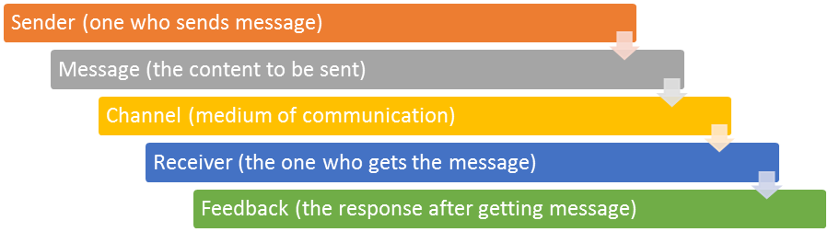

- Elements of Communication Process:

Communication process involves elements like sender, receiver, message, channel/ media and feedback. These elements are explained below:
- The different elements of communication are as under:

- Sender: He is the person who sends his ideas to another person. For example, if a manager wants to inform his subordinates about the introduction of a new product, he is the sender.

- Message: The idea, feeling, suggestion, guidelines, orders or any content which is intended to be communicated is message. For example, message can be about the introduction of new product.

- Channel/ Media: It is the medium, passage or route through which encoded message is passed by the sender to the receiver. There can be various forms of media-face to face communication, letters, radio, television, e-mail etc. For example, manager informs about the introduction of a new product in a meeting through presentation.

- Receiver: He is the person to whom the message has been sent. For example, subordinates are receivers as mentioned in the above example.

5. Feedback: It is the response by the receiver. It marks the completion of the communication process.
Let’s Revise
Sr. No. | Questions | Answers
1 | What is the person who sends information to others known as? | Sender
2 | The idea, feeling, suggestion, guidelines, orders or any content which is intended to be communicated is ___________. | Message
3 | What is the route called through which encoded message is passed by the sender to the receiver? | Channel/ Media
4 | The person to whom the message has been sent is known as ___________. | Receiver
5 | ___________ is known as the response by the receiver. | Feedback

- Explain the process of Communication.

- Process of Communication:
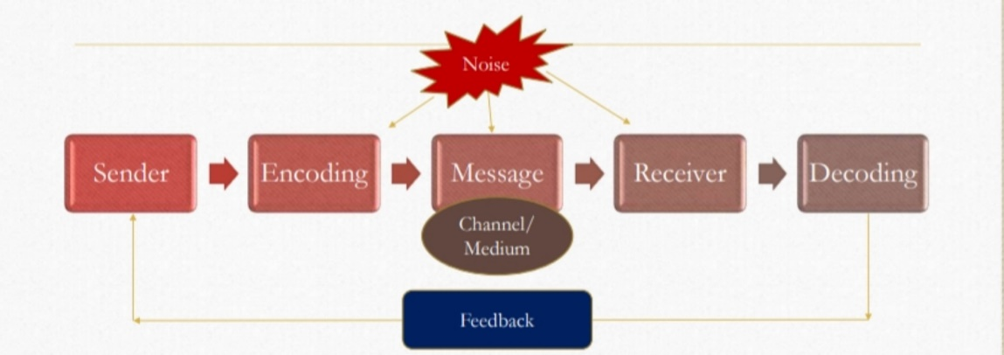
- Communication process consists of following steps:
Sender: He is the person who sends his ideas to another person. The sender formulates the message that he wants to convey to the receiver.

Encoding: It is the process of converting the idea, thinking or any other component of message into symbols, words, actions, diagram etc. For example, message is connected in words and actions. The sender encodes or translates his message. He may take the help of symbols, words, actions, diagrams, pictures etc.
Channel/ Medium and Message: He selects an appropriate channel or medium through which the message is to be transmitted. It can be face to face communication, letters, radio, television, e-mail etc.

Receiver: He is the person to whom the message has been sent. The message is received by the receiver.

Decoding: It means translating the encoded message into language understandable by the receiver. Received message is decoded by the receiver so that the receiver can draw the meaning of the message.
Feedback/ Response: The receiver sends his response to the sender. In case of any confusion, the same is conveyed and necessary clarification sought.

Noise: It is the hindrance in the process of communication. It can take place at any step in the entire process. It reduces the accuracy of communication.
e.g. 1) Disturbance in the telephone lines, 2) An inattentive receiver 3) Improper Decoding of Message etc.

Let’s Revise
Sr. No. | Questions | Answers
1 | The person who sends the message in the communication channel is known as _______. | Sender
2 | The process of converting the idea, thinking or any other component of message into symbols, words, actions, diagram etc. is known as _________. | Encoding
3 | The person to whom the message has been sent is known as ____________. | Receiver
4 | _________ means translating the encoded message into language understandable by the receiver. | Decoding
5 | The receiver sends his response to the sender known as ______________. | Feedback
6 | The hindrance caused in the communication process is known as ___________. | Noise

- Explain the Principles of Communication :

- Following principles of communication make it more effective:

1. Principle of Clarity:
The idea or message to be communicated should be clearly spelt out. It should be worded in such a way that the receiver understands the same thing which the sender wants to convey. There should be no ambiguity in the message. It should be kept in mind that the words do not speak themselves but the speaker gives them the meaning. A clear message will evoke the same response from the other party. It is also essential that the receiver is conversant with the language, inherent assumptions, and the mechanics of communication.

2. Principle of Integrity:
Integrity means honesty and truthfulness in what we communicate. Communication should be able to introduce all the employees in the enterprise with its honest objectives so that all the employees move unitedly towards the goal.

3. Principle of Informality:
Formal communication is generally used for transmitting messages and other information. Sometimes formal communication may not achieve the desired results, informal communication may prove effective in such situations. Management should use informal communication for assessing the reaction of employees towards various policies. Senior management may informally convey certain decisions to the employees for getting their feedback. So this principle states that informal communication is as important as formal communication.

4. Principle of Attention:
In order to make communication effective, the receiver’s attention should be drawn towards message. People are different in behaviour, attention, emotions etc. So they may respond differently to the message. Subordinates should act similarly as per the contents of the message. The acts of a superior also draw the attention of subordinates and they may follow what they observe. For example, if a superior is very punctual in coming to the office then subordinates will also develop such habits. It is said that ‘actions speak louder than words.’

5. Principle of Consistency:
This principle states that communication should always be consistent with the policies, plans, programmes and objectives of the organization and not in conflict with them. If the messages and communications are in conflict with the policies and programmes then there will be confusion in the minds of subordinates and they may not implement them properly. Such a situation will be detrimental to the interests of the organization.

6. Principle of Adequacy:
The information communicated should be adequate and complete in all respects. Inadequate information may delay action and create confusion. Inadequate information also affects efficiency of the receiver. So adequate information is essential for taking proper decisions and making action plans.

7. Principle of Timeliness:
This principle states that communication should be done at proper time so that it helps in implementing plans. Any delay in communication may not serve any purpose rather decisions become of historical importance only.

8. Principle of Feedback:
The principle of feedback is very important to make the communication effective. There should be a feedback information from the recipient to know whether he has understood the message in the same sense in which the sender has meant it.

9. Principle of Network/ Proper Medium:
In order to make communication effective it is necessary not only to have clarity of ideas, consistency and completeness but also to make a proper choice of medium. For example- the managers should make use of oral communication for individual communication and written communication for policy matters. So a proper channel or medium of communication is important to be decided in order to deliver the communication to the receivers properly.
Let’s Revise
Sr. No. | Questions | Answers
1 | The idea or message to be communicated should be clearly spelt out. This is principle of _____________. | Clarity
2 | _________ means honesty and truthfulness in what we communicate. | Integrity
3 | Management should use informal communication for assessing the reaction of employees towards various policies. This is principle of _____________. | Informality
4 | According to principle of ______, in order to make communication effective, the receiver’s attention should be drawn towards message. | Attention
5 | Communication should always be _______ with the policies, plans, programmes and objectives of the organization and not in conflict with them. | Consistent
6 | Should the information communicated be adequate and complete in all respects? | Yes
7 | According to which principle, it states that communication should be done at proper time so that it helps in implementing plans? | Timeliness
8 | There should be a ______ information from the recipient to know whether he has understood the message in the same sense in which the sender has meant it. | Feedback

- Explain the characteristics of Business Communication.

- Following are the characteristics of Business Communication

A two-way traffic:
It is a two-way traffic – upward and downward. Messages, directives, opinions are communicated downward. Likewise grievances, complaints, opinions, feelings, are communicated upward along the line.

Continuous Process:
It is continuous process. It is repeated to achieve the desired results. It is not a one-time shot.

A short-lived process:
It is complete as soon as the message is received and understood by the receiver in the right perspective.

Needs proper understanding:
There may be numerous media of communication but the main purpose of conveying the message is a proper understanding of the message by the other party. For this purpose, it should be clearly and concisely worded.

Leads achievement of the organizational goals:
Effective communication does this by creating the sense of object orientation in the organization.

Dispels misunderstanding:
It provides clear understanding between persons and thus builds a bridge of companionship among people.

Let’s Revise
Sr. No. | Questions | Answers
1 | Is communication a two way traffic? | Yes
2 | IS communication a continuous process? | Yes
3 | It is complete as soon as the message is received and understood by the receiver in the right perspective and so it is a ________ lived process. | Short
4 | For the proper understanding of communication, it should be clearly and concisely __________. | Worded
5 | Effective communication does this by creating the sense of object _______ in the organization. | Orientation
6 | Does good communication remove misunderstandings? | Yes

- Mention the advantages of Effective Business Communication.

- Advantages of Effective Business Communication:

- Organizational Goals are Clearly Defined
Confusing goals or instructions and unclear guidelines are bad for everyone. When communicating with employees, managers have to be clear about what they want and expect. That applies whether the communication is through meetings, instructions, performance reviews or employee handbooks. If workers understand their duties and responsibilities, everything flows more smoothly.

- Helps to Build the Team
Effective, honest communication can bind employees together. If the staff are talking with each other on the job, that's a major step towards building a good team. Employees who look forward to talking with their colleagues are more enthused about coming to work. If they know they can talk to the boss about problems and that the boss will listen, that binds them to the company. Good communication builds teams and increases employee loyalty.

- Boosts Employee Morale
Team morale is one of the key benefits of effective communication in business. When there isn’t good communication within a team, there is usually a failure to pass on information. The members of the team that are kept in the dark will eventually develop feelings of resentment toward their teammates and leaders because they will feel like people are keeping secrets. If an employee or team member believes that they are being left out of the loop, the trust within the team will slowly face and create negative energy in the workplace. The result is a reduction in team morale and in overall productivity as a result. When there isn’t good communication within a team, there can also be surprises that aren’t especially pleasant, such as the miscommunication of a project's missing deadlines, and errors that go unreported. On the other hand, when a team communicates effectively, the team members develop trust because everyone feels like they are in the loop and that they're getting the complete picture of what is going on in the business. Additionally, everyone can focus on what matters, which is their work. They know that if anything happens or changes, they will be told about it in a timely manner and will know where to get assistance on the matter.

- Increases Customer Satisfaction
Effective communication is contagious. When the communication within the company flows smoothly, then it will flow on to the customer with the same ease and smoothness. A team that communicates well with each other will also communicate well with the business’s customer. Customers, in general, do not like it when they get conflicting information from different employees in a business. The sales representative tells them that a product will be ready for delivery or deployment within a certain time frame. Meanwhile, the engineering department, which is in charge of making the product, has no idea that such a promise has been made and is likely to miss it. The end result is that the customer begins to lose their trust in the business and become suspicious of whatever they are told by representatives of the business. The situation is almost just the same as with employees within a business. The major difference is that, while the lack of trust within the team leads to decreased employee morale, the same leads to reduced sales and the loss of opportunities when it is the customer that is losing trust. On the other hand, a team that communicates well will foster trust in the customer because the customer will know they can always count on them. They won’t be as quick to switch to another company.

- Improves Productivity
Perhaps the greatest and most positive effect of effective business communication is the increase in the rate of return of the investments the business makes across the board. This doesn’t just apply not only to monetary investments, but also to investments of labor and time, as well. When your team members and employees know their roles and tasks, the roles and tasks of their colleagues, and what is expected of them, they can apply more focus and effort to their work and less effort and focus on the general workplace within which they are situated. When the team leader has a clear view of the big picture in terms of the resources available within the organization, then they are better able to distribute work among their team members and also to balance it so that no single team member is overwhelmed with work while another one is just cruising by. As a result, the team leader can get the team to work to its maximum potential. Issues that could potentially distract the team from the important stuff are resolved in a quick and effective manner. Customers don’t have to keep asking for rework, and the gains just multiply themselves by allowing the team to be even more productive.
Ultimately, the benefits of effective communication within a business are countless and any business would do well to recognize this. When you work to improve the flow of information within the business, you are, in effect, working to improve the long-term productivity and profitability of the business, as well.

- Increases Efficiency of Employees
Communication plays an essential role in increasing efficiency of employees. Employees need to interact with each other more often to break the ice and feel comfortable at the workplace. Problems arise when information does not flow in its desired form. Effective communication facilitates free flow of information among employees and reduces misunderstandings and confusions. Effective communication ensures that everyone is on the same page.

Let’s Revise
Sr. No. | Questions | Answers
1 | In business communication, which goals should be clearly defined? | Organizational
2 | Good communication builds teams and increases employee ________. | Loyalty
3 | Team _______ is one of the key benefits of effective communication in business. | Morale
4 | When the communication within the ______ flows smoothly, then it will flow on to the customer with the same ease and smoothness. | Company
5 | Does good communication improve productivity in the organization? | Yes
6 | Communication plays an essential role in increasing _________ of employees. | Efficiency

- What are the challenges faced during Business Communication?
OR
What are the disadvantages of Business Communication?

- Challenges faced during business communication:

1. A Lack of Feedback
If communication moves in one direction only, discourse will quickly become ineffective. Feedback is important on many levels. Not only does it help you determine how well your employees have met their goals, but it also shows how well they collaborate with their teams, their co-workers, and their managers. Feedback also shows how well employees handle stress and adversity. A lack of feedback can lead to demotivation and slack work attitudes, whereas positive feedback can make work more fun, engaging people and pushing positive development. But no matter whether feedback is good or bad, it is a necessity. For management, it's important to not only to receive feedback but to act on it. Surveys are useless if their results are ignored. The aim of collecting feedback should be to use it as a difference-maker.

2. Email Overload﻿
In addition to phone calls, text messages, group chats, social networks, and internal meetings, an average person in business can receive as many as 120 emails every day. This communication overload often results in important information being lost, deleted, forgotten, or ignored. Employees are easily frustrated by overloaded inboxes. Combining your existing channels into one in order to cut down on email overload is an easy way to streamline work. An employee app like Staffbase gives companies a way to avoid having to send mass emails and instigating confusing or irrelevant "cc" conversation threads. The emails you do send should be clear of jargon and shouldn't invite too many people into a dialogue.

3. Device Chaos
People tend to avoid communication if it's happening on a device they don't feel comfortable using. Gone are the days when we only worked on desktop computers. We now use tablets, smartphones, laptops, notepads, ultrabooks, smartwatches etc. People have an average of five email addresses, three phones, two laptops, and four telephone numbers, making it hard to cut through the noise. To ensure that information gets to your employees on the right channels, why not let them work on a device that they're comfortable using. Most of the time that means a smartphone. It's the device we pick up more than 85 times a day, and it's generally the first and last thing we look at in our waking hours. In addition, the Pew Research Center has found that 90% of our text messages are read within the first three minutes of receipt, compared to only 22% of our emails.

4. Language Barriers
While having a diverse and global workforce is something many companies actively seek and take pride in having, the resulting language barriers can be challenging, both within teams, as well as between different corporate locations. Multi-language communication can be slow, ineffective, and sometimes nonexistent. That's why it's important to try and avoid misunderstandings by displaying news in multiple languages, offering easy translation options, and encouraging intercultural training. This might sound like a lot of extra work and expense, but if you ask around, you're likely to find people within your company who are willing to help. Language classes can be made available to your workforce, and even if you have to pay for it, it's well worth the price. Don't try to save money when it comes to enriching your employees ability to communicate. In addition to language barriers, cultural differences can also cause communication difficulties. Especially within international companies, even simple things like meetings can prove to be a challenge.

5. An Overload of Irrelevance
To communicate or not to communicate, that is the question. Similar to the email situation, it's important to know which information actually needs to be shared—as well as when and where it needs to go—and to filter it accordingly. It's therefore useful to create different groups, closed as well as open ones, and to communicate specific information on specific channels. An employee app will allow you to define specific user groups based on an array of criteria (location; project; team, etc.) and to target your content accordingly.

6. A Lack of Mutual Respect
Ideally, groups of people working together consist of individuals from diverse backgrounds with unique experiences. On the downside, this can sometimes lead to misunderstandings if employees don't fully respect one another or they fail to consider the range of experience outside their own from which they could profit. Sharing is caring. When employees are encouraged to share their experiences, respect for one another grows, work environments improve, and communication automatically becomes more beneficial.

7. Budget Constraints﻿
Many companies and HR departments either don't have the necessary resources for developing their own internal communication system, or they feel the perceived results aren't worth the costs. But with recent improvements in technology and software, third-party providers like Staffbase are able to provide affordable opportunities to make communication effective.

Let’s Revise
Sr. No. | Questions | Answers
1 | If communication moves in one direction only, discourse will quickly become ineffective and so __________ is important on many levels. | Feedback
2 | Employees are easily frustrated by _________ inboxes. | Overloaded
3 | People tend to avoid communication if it's happening on a _______ they don't feel comfortable using. | Device
4 | Is multi language communication slow and ineffective? | Yes
5 | Does lack of mutual respect create problems in the communication? | Yes
6 | Does budget constraints affect the communication in the organization? | Yes

- Give an example of Business Communication.
Example:

The top-level management may instruct managers of different departments on certain new rules and regulations in the work area that need to be carried out in routine activities of different departments. Like there may be a change in the office working hours or office timings by the management and the same is communicated to employees by circular or notice or through the e-mail system.

Other examples:
- User – friendly user’s manual
- Best Customer Service to the Customer Feedback
- A Great Meeting Agenda
- Excellent Corporate Apology Letters
- Placing/ Returning of orders/services

CONCLUSION:
Thus, Business Communication is an important task to be carried out effectively for the smooth functioning of the business/ organization.
Business communication encompasses topics such as marketing, brand management, custom relations, consumer behavior, advertising, public relations, corporate communication, community engagement, reputation management, interpersonal communication, employee engagement, event management, etc.
It is closely related to the field of professional communication and technical communication.

UNIT – 2
METHODS OF COMMUNICATION

- What is communication? Give the diagrammatic representation of different categories of communication.

Communication is simply the act of transferring information from one place, person or group to another.
Every communication involves (at least) one sender, a message and a recipient. This may sound simple, but communication is actually a very complex subject.
The transmission of the message from sender to recipient can be affected by a huge range of things. These include our emotions, the cultural situation, the medium used to communicate, and even our location. The complexity is why good communication skills are considered so desirable by employers around the world: accurate, effective and unambiguous communication is actually extremely hard.
The sender ‘encodes’ the message, usually in a mixture of words and non-verbal communication. It is transmitted in some way (for example, in speech or writing), and the recipient ‘decodes’ it.
Of course, there may be more than one recipient, and the complexity of communication means that each one may receive a slightly different message. Two people may read very different things into the choice of words and/or body language. It is also possible that neither of them will have quite the same understanding as the sender.
In face-to-face communication, the roles of the sender and recipient are not distinct. The two roles will pass back and forwards between two people talking. Both parties communicate with each other, even if in very subtle ways such as through eye-contact (or lack of) and general body language. In written communication, however, the sender and recipient are more distinct.

- Categories of communication:

There are a wide range of ways in which we communicate and more than one may be occurring at any given time.
The different categories of communication include:
Spoken or Verbal Communication, which includes face-to-face, telephone, radio or television and other media.
Non-Verbal Communication, covering body language, gestures, how we dress or act, where we stand, and even our scent. There are many subtle ways that we communicate (perhaps even unintentionally) with others. For example, the tone of voice can give clues to mood or emotional state, whilst hand signals or gestures can add to a spoken message.
Written Communication: which includes letters, e-mails, social media, books, magazines, the Internet and other media. Until recent times, a relatively small number of writers and publishers were very powerful when it came to communicating the written word. Today, we can all write and publish our ideas online, which has led to an explosion of information and communication possibilities.
Visualizations: graphs and charts, maps, logos and other visualizations can all communicate messages.

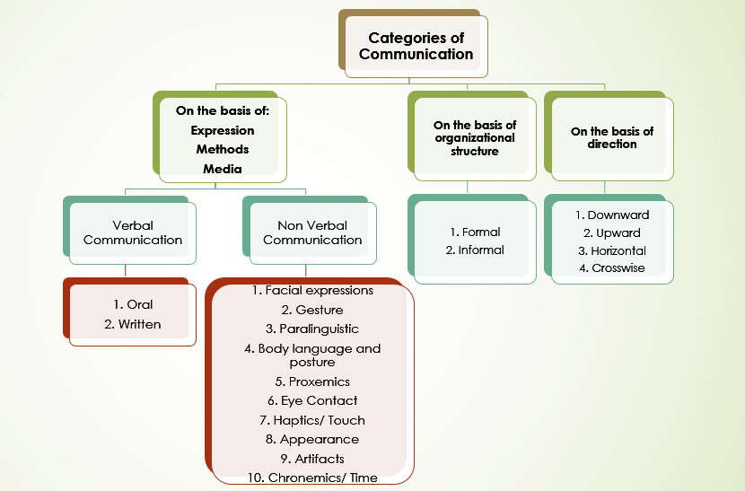

- Explain Verbal Communication in detail. State the advantages of oral and written communication. :

Verbal communication is the use of sounds and words to express yourself, especially in contrast to using gestures or mannerisms (non-verbal communication). An example of verbal communication is saying “No” when someone asks you to do something you don't want to do.
Verbal communication is the use of words to share information with other people. It can therefore include both spoken and written communication. However, many people use the term to describe only spoken communication. The verbal element of communication is all about the words that you choose, and how they are heard and interpreted.
Verbal communication is any communication that uses words to share information with others. These words may be both spoken and written.

- Types of Verbal Communication:
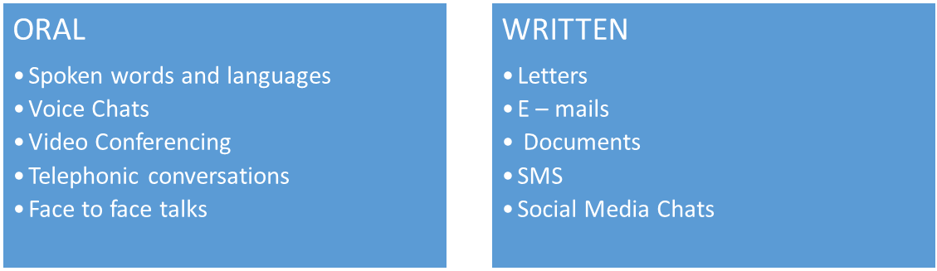
- Oral Communication:
Face-to-face oral communication is the most recognized type of oral communication. Here, what you express comes directly from what you speak.
Again, this can be formal or informal: with your friends and family, in a formal meeting or seminar, at work with your colleagues and boss, within your community, during professional presentations, etc.
Main types of oral communication includes:
- Spoken words and languages
- Voice Chats
- Video Conferencing
- Telephonic conversations
- Face to face talks
This types of communication
- Gets better with practice. The more you practice with awareness, the more control you will have on your oral expressions.
- Is vibrantly a-live! This means that despite all past rehearsals, oral communication offers you a present-moment opportunity to tune, revise, revoke and fix what you express. It is hence the most powerful type of communication and can work for or against you with every expression.
- Engages your audience more than other types of communication. The listener (or an audience) often expects to speak-back to you with oral communication, enabling two-way communication more than any other channel.
For better/ superior face-to-face communication,
- Always meet the eyes of your audience with confidence, conviction and openness.
- Practice before a mirror to perfect your tone and expressions, so they suit the message you want to convey. They two facets often convey more than your words do.
- Practice using role-play. This means that even when you rehearse before a mirror, candidly ask yourself, “Am I ready to receive this message with this tone and expression?” If you aren’t convinced, your audience won’t be either. So practice again until you get it right.
- Consciously engage your audience’s participation. This is the strength of this type of communication, so never let your oral expression be a one-way rant to yourself. You can do this by asking questions, getting their opinion and encouraging expression of new ideas.
- Finally, become an active listener. An effective oral communicator not only speaks, but also actively listens to his audience.

- Oral Communication (Distance) :

Distance (oral) communication has made the world a smaller and more accessible place.
Mobile phones, VOIP (Voice Over Internet Protocol), video-conferencing, 2-way webinars, etc. are all modern expansions of distance communication, taking its expression to the next subtle level.
And in this type of communication, your tone of voice and pace of delivery take priority over other expressions.
For effective oral communication over distance,
Give higher priority to your listening. When you fail to listen, you will find that multiple people attempt to speak at the same time, undermining the value of this form of communication.
Speak slightly slower than you would in face-to-face communication. This will make sure that you remain aware of the subtle nuances of your tone, and the receiver has time to grasp what you convey.
Always re-iterate what you understand when you listen. This type of communication misses the non-verbal signals that you would receive in face-to-face communication (that can indicate subtle expressions like anger, friendliness, receptivity, sarcasm, etc.) So paraphrase what understand and confirm that this is indeed what the other party also meant to convey.
Where appropriate, wear your friendly face with a smile on your lips and eyes. Feel this friendly face. Your tone will automatically convey your openness and receptivity to the other person. (This may not be appropriate if you expect to convey a warning on the phone, so ensure that your face suits your message.)
Finally, back this up with written communication where possible. The intent is to confirm the take-away from the communication so all parties are on the same page. This makes sense even for an informal call with your friend – perhaps you can send a quick text message to re-iterate how pleasurable it was to speak to him, and then confirm the final call-for-action.
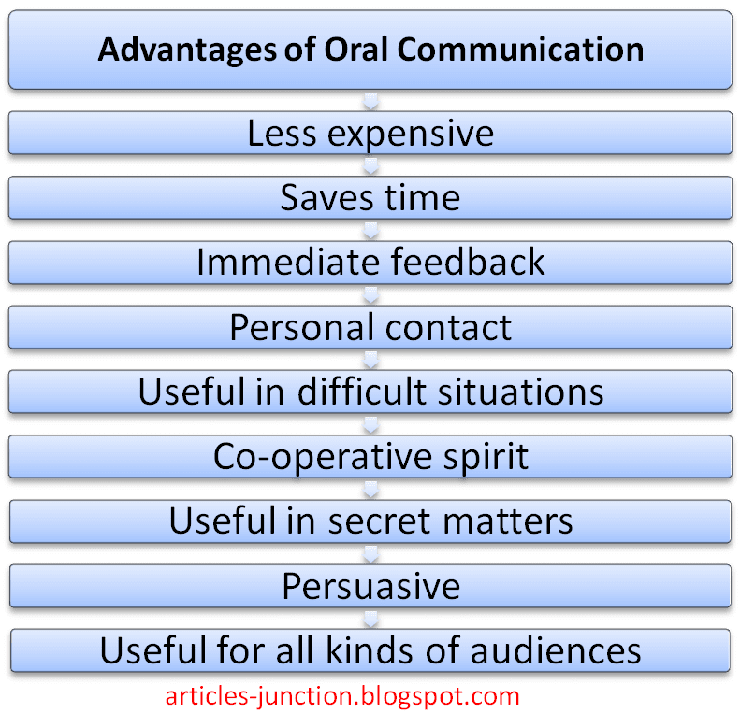
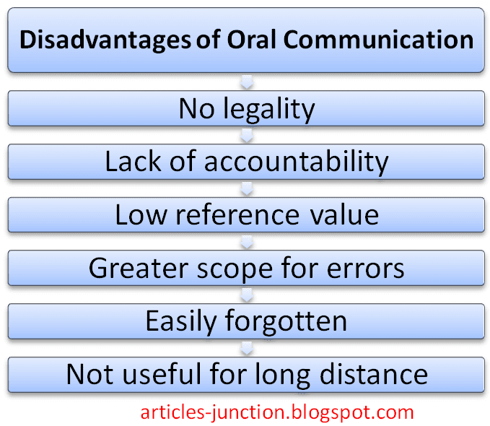

- Written Communication :
A ‘Written Communication’ means the sending of messages, orders or instructions in writing through letters, circulars, manuals, reports, telegrams, office memos, bulletins, etc.
It is a formal method of communication and is less flexible. A written document preserved properly becomes a permanent record for future reference.
It can also be used as legal evidence. It is time-consuming, costly and unsuitable for confidential and emergent communication.
Written communication, to be effective, should be clear, complete, concise, correct, and courteous.

- Five elements of written communication skills:

In professional settings, great written communication skills are made up of five key elements. Look at some examples of each of these elements below:
- Clarity
- Conciseness
- Tone
- Active voice
- Grammar and punctuation
Here are a few tips you should keep in mind whenever you are writing anything, whether it’s a quick email or a detailed report:
- Know your goal before you begin writing
- Include only need-to-know details
- Make use of outlines
- Keep it professional
- Edit thoroughly

- Advantages of Written Communication:

1. It is suitable for long distance communication and repetitive standing orders.
2. It creates permanent record of evidence. It can be used for future reference.
3. It gives the receiver sufficient time to think, act and react.
4. It can be used as legal document.
5. It can be sent to many persons at a time.
6. It is suitable for sending statistical data, chart, diagram, pictures, etc.
7. Order, allocation of work, job distribution, etc. in written form reduce ambiguity and help in fixation of responsibility.
8. Uniformity in work procedure can be maintained through written communication.
9. It is easy to send unpleasant or bad news through written communication.
10. A good written communication can create goodwill and promote business.

- Limitations or Disadvantages of Written Communication:

1. It is time-consuming. Composing a message in writing takes much time. Writing letters, typing orders, notices, etc. and sending to appropriate destination require time. Feedback process also is not instant.
2. It is expensive not so much due to postal charges but in terms of so many people spending so much of their time.
3. It cannot maintain strict secrecy which would have been possible in oral communication.
4. Written communication has no scope for immediate clarification if not understood properly.
5. Being written in nature it is less flexible and cannot be changed easily.
6. It is not effective in the case of emergency.

- Non Verbal Communication Skills:

According to experts, a substantial portion of our communication is nonverbal. Every day we respond to thousands of nonverbal cues and behaviors, including postures, facial expressions, eye gaze, gestures, and tone of voice. From our handshakes to our hairstyles, nonverbal details reveal who we are and impact how we relate to other people.
Nonverbal communication plays an important role in how we convey meaning and information to others, as well as how we interpret the actions of those around us.
The important thing to remember when looking at such nonverbal behaviors is to consider the actions in groups. What a person actually says along with his or her expressions, appearance, and tone of voice might tell you a great deal about what that person is really trying to say.

Facial Expression:
Facial expressions are responsible for a huge proportion of nonverbal communication. Consider how much information can be conveyed with a smile or a frown. The look on a person's face is often the first thing we see, even before we hear what they have to say.
While nonverbal communication and behavior can vary dramatically between cultures, the facial expressions for happiness, sadness, anger, and fear are similar throughout the world.

- Gestures:

Deliberate movements and signals are an important way to communicate meaning without words. Common gestures include waving, pointing, and using fingers to indicate numeric amounts. Other gestures are arbitrary and related to culture.
In courtroom settings, lawyers have been known to utilize different nonverbal signals to attempt to sway juror opinions. An attorney might glance at his watch to suggest that the opposing lawyer's argument is tedious or might even roll his eyes at the testimony offered by a witness in an attempt to undermine his or her credibility.
These nonverbal signals are seen as being so powerful and influential that some judges even place limits on what type of nonverbal behaviors are allowed in the courtroom.

- Paralinguistics:

Paralinguistic refers to vocal communication that is separate from actual language.
This includes factors such as tone of voice, loudness, inflection, and pitch.
Consider the powerful effect that tone of voice can have on the meaning of a sentence. When said in a strong tone of voice, listeners might interpret approval and enthusiasm. The same words said in a hesitant tone of voice might convey disapproval and a lack of interest.
Consider all the different ways that simply changing your tone of voice might change the meaning of a sentence. A friend might ask you how you are doing, and you might respond with the standard "I'm fine," but how you actually say those words might reveal a tremendous amount of how you are really feeling.
A cold tone of voice might suggest that you are actually not fine, but you don't wish to discuss it. A bright, happy tone of voice will reveal that you are actually doing quite well. A somber, downcast tone would indicate that you are the opposite of fine and that perhaps your friend should inquire further.

- Body Language (Kinesics) and Posture:

Posture and movement can also convey a great deal of information. Research on body language has grown significantly since the 1970s, but popular media have focused on the over-interpretation of defensive postures, arm-crossing, and leg-crossing, especially after publishing Julius Fast's book Body Language.
- 55% body language
- 38% tone of voice
- 7% words
While these nonverbal behaviors can indicate feelings and attitudes, research suggests that body language is far more subtle and less definitive than previously believed.

Proxemics: (Space/ Distance)

People often refer to their need for "personal space," which is also an important type of nonverbal communication. The amount of distance we need and the amount of space we perceive as belonging to us is influenced by a number of factors including social norms, cultural expectations, situational factors, personality characteristics, and level of familiarity.
The amount of personal space needed when having a casual conversation with another person usually varies between 18 inches to four feet. On the other hand, the personal distance needed when speaking to a crowd of people is around 10 to 12 feet.
- Intimate distance (physical contact to 18 inches)
- Personal distance (18 inches to 4 ft)
- Social distance (4 ft – 12 ft)
- Public distance (12 ft to range of seeing and hearing)

- Eye Contact:

The eyes play an important role in nonverbal communication and such things as looking, staring and blinking are important nonverbal behaviors. When people encounter people or things that they like, the rate of blinking increases and pupils dilate. Looking at another person can indicate a range of emotions including hostility, interest, and attraction.
People also utilize eye gaze as a means to determine if someone is being honest.
Normal, steady eye contact is often taken as a sign that a person is telling the truth and is trustworthy. Shifty eyes and an inability to maintain eye contact, on the other hand, is frequently seen as an indicator that someone is lying or being deceptive.

- Haptics/ Touch:

Haptics is a form of non- verbal communication using a sense of touch. Some forms of Haptics communication is Handshake, or a gentle pat on back, or a high five. The sense of touch allows one to experience different sensations.
Haptics can be categorized into five types :
- Functional/Professional
- Social/ Polite
- Friendship/Warmth
- Love/Intimacy
- Sexual/Arousal

- Appearance: (Dressing & Grooming) :

Personal appearance is an often-disregarded part of communication and presentation skills.
When you are speaking in public, you may be representing your organisation or just yourself. It is still you at the front. It is you that the other person, group or audience sees and before you have time to open your mouth and say anything, certain assumptions, both consciously and subconsciously, have been made.
First impressions are very important - they can be about attitude as well as dress.
Visual impact is at least as important as verbal impact. People will very quickly make assumptions based on your personal appearance, including your facial expressions, the clothes you wear, how well-groomed you are and your body language.

- Artifacts:

Artifacts are physical objects, such as clothing, homes, and cars, that indicate to others a person's personal and social beliefs and habits.
- Clothing
- Jewelry
- Body piercing
- Space decoration

- Chronemics/ Time :

The use of time in nonverbal communication is formally defined as chronemics - the study of the way we both use and perceive the use of time.
In direct communication, the use of time can convey a powerful nonverbal message. This message is often communicated through the following two uses of timing:
- punctuality / the patience to wait
- the speed of speech / how long people are willing to listen
With respect to punctuality / the patience to wait, time can be used as an indicator of status. For example, in most companies the boss can interrupt progress to hold any sort of meeting in the middle of the work day, yet the average worker would have to make an appointment to see the boss.
The speed of speech / how long people are willing to listen, can have a significant impact on the effectiveness of the verbal message.

- Communication on the basis of direction:

- Downward Communication:

Downward communication represents the most stereotypical form of formal communication. Information flows from management level down to lower levels. It is the most common form of formal communication. Downward communication includes orders and instructions represented in oral or written format. Reports, emails, letters and manual communication are commonly used downward communication tools.

- Upward Communication:

Upward communication contains information which passes from subordinate levels up to management and senior levels. Common forms of upward communication include (from employees to managers and above) reports, suggestions, requests, instructions and complaints.

- Horizontal Communication:

Horizontal communication refers to communication between individuals who are at the same or similar levels within an organization but have different areas of responsibility. Horizontal communication is slightly more fluid and dependent on cross-individual communication. Typical examples exist as communication between managers of different departments (HR, Marketing, Sales, etc.).

- Crosswise/ Diagonal Communication:

This occurs when employees of different departments at different levels communicate with each other irrespective of the chain of command. Communication between a floor manager and a Sales team is a prime example of diagonal communication.

UNIT – 3
TYPES OF COMMUNICATION
- INTRODUCTION :

Business communication may be defined as, the passing of information message or news within or outside the company for the financial benefit of the organization.
To elaborate, communication is the process through which an idea, opinion, or information is transferred to others.
It is a process of exchanging idea, meaning, message, feeling, emotion, or understanding from one mindset to another mindset, this may include the use of various services for exchange process.
A lot of communication among organizational members is required to achieve the corporate goals. Therefore, understanding of communication and how it can be made efficient is important for managers.
There is a different kind of organizations or business entities, for example, organizations having a business only within the country and companies which are multinationals. However, the process, method, types, the principle remains almost same with those of general communication. The primary difference lies in their area of application.

- Formal channel/ network :

‘Formal Communication’ refers to the flow of information through a structured path in a formal organisation.
It maintains superior-subordinate relationship and follows the chain of command. It is a two-way communication.
A formal communication channel transmits information such as the goals, policies and procedures of an organization. Messages in this type of communication channel follow a chain of command. This means information flows from a manager to his subordinates and they in turn pass on the information to the next level of staff.
An example of a formal communication channel is a company's newsletter, which gives employees as well as the clients a clear idea of a company's goals and vision. It also includes the transfer of information with regard to memorandum, reports, directions, and scheduled meetings in the chain of command.
A business plan, customer satisfaction survey, annual reports, employer's manual, review meetings are all formal communication channels.

- Purpose of formal communication :

The purpose of formal communication is
- to give orders,
- convey instructions and
- fulfill the objective of the organisation through some pre-determined rules and regulations.

- Characteristics of formal communication:

1. Formal communication flows through structured path.
2. It is official and formal in nature.
3. It is mainly in writing but sometimes verbal communication is also considered as formal communication.
4. It requires sanction of higher authority.
5. It may be downward, upward or two-way.
6. The rank, position and authority have great significance in such communication.
7. A standard is maintained in such communication.

- ADVANTAGES OF FORMAL CHANNEL:

Increase overall efficiency: This type of communication is used by following the predetermined rules so it increases the overall efficiency of the organization.

Easy communication system: The top level management communicates with their employees by using formal downward communication system. Again the employees communicate with their higher authority to use this system. It is very much easy to communicate with each other.

Permanent record: The copy of formal communication is always preserved in the file and it is used as reference. As a result, it is easy to seek the copy of it if necessary.

Quick accomplishment of work: Sometimes the rapid communication is to be needed with the employees. To use the formal downward communication system it is possible to communicate with the employees quickly. So the work may be done timely.

Maintenance of discipline: Under the formal communication system the workers are bound to be careful to their own duty. So ultimately it makes discipline in the organization.

Ease of cooperation and coordination: Cooperation and coordination is very much essential to carry out the business activity smoothly. Formal communication is a part of coordination. So, coordinated activities can be done properly and easily through formal communication.

Use as reference: Documents of formal communication is recorded by the organization. So, these recorded documents are used as a source of the employees.

Ease of delegation of authority: Authority is delegated by the superiors to the subordinates through the help of this communication.

Free from mistakes: Since formal communication has well-defined rules and regulations. So, there is a little chance of mistakes in exchanging information within the employees.

Others: Increasing attention, reliability, accuracy, smooth communication system, free form distortion, easy to understand, increasing company goodwill, etc.

- DISADVANTAGES OF FORMAL CHANNEL:

Wastage of time: Top-level management communicates with their employees by maintaining the board of succession, not by-passing any executive or any level. That is why it takes a lot of time and it wastages much time of the concerned person.

Inflexibility: Ordinarily the formal communication is inflexible. If somebody out of the channel intends to change his views it is not possible. Even when it is needed to change, it is very much difficult.

Lack of initiative: Under this communication system everybody does their duty by following specific predetermined system. So it makes the obstacle to develop the creativeness of the employee.

Authoritarian attitude: In this system the sender is higher authority and the receiver is lower staffs. Generally the superior’s order cannot be disobeyed. It creates an authoritarian culture in the organization.

- INFORMAL CHANNEL/ NETWORK :

The Informal Communication is the casual and unofficial form of communication wherein the information is exchanged spontaneously between two or more persons without conforming the prescribed official rules, processes, system, formalities and chain of command.
The informal communications are based on the personal or informal relations such as friends, peers, family, club members, etc. and thus is free from the organizational conventional rules and other formalities. In the business context, the informal communication is called as a “grapevine” as it is difficult to define the beginning and end of the communication.

Why grapevines are formed?
- Organization passing through crisis, feeling of uncertainty and lack of sense of direction.
- Discrimination between favorites and non favorites
- Lack of self confidence among employees
- Intentionally hurting other person’s reputation

- TYPES OF INFORMAL (GRAPEVINE) COMMUNICATION:
There are four types of Informal Communication (Grapevine) network that show how the communication is facilitated. These are:
- Single Strand Chain
- Gossip Chain
- Probability Chain
- Cluster Chain
The gossip in the organization is the best example of informal communication, wherein the employees of different department irrespective of their hierarchical positions come together and communicate with each other. The grapevine satisfies the social needs of people and smoothens the formal relations by filling in the gaps and even bring together different people who do not fall under the common chain of command.
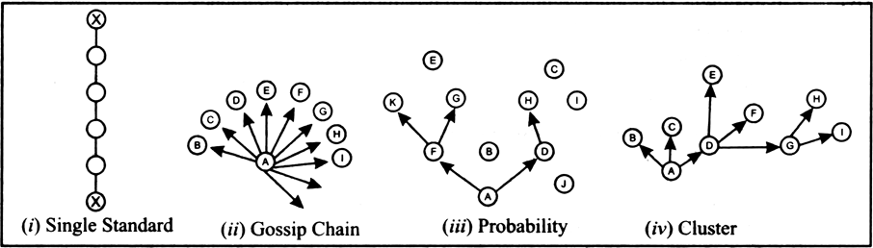

- SINGLE STRAND CHAIN:

The information flows from one person to another in a sequential order. For example, A passes to B, then B passes to C, then C passes to D and so on.

- GOSSIP CHAIN :

The information which is of interest to all but does not normally relate to official works is passed on by one person alone to the rest of the organizational members.

- PROBABILITY CHAIN :

Not too important information, but which is likely to be shared with others is randomly passed on by one person to whomsoever comes in contact with him.

- CLUSTER CHAIN :

One person passes on the information to a selected group of people who further passes it on to other selected group of people.

- ADVANTAGES OF GRAPEVINE/ INFORMAL CMMUNICATION :

- Interpret: The information is given by the top-level management under the formal system. It is easy for the employees to take the explanation by informal system. So this system plays a vital role to complete the work properly.

- Present grievance: Under the informal system the employees disclose their needs, sentiment and their emotions to others authority without feeling any hesitation.

- Alternate system: The management sometimes does not able to reach all information by formal system. Informal system covers the gap or familiarity of formal system.

- Improved relationship: Any problem between the workers and the management can be solved by informal system. So it makes good relationships among the employees and the management.

- Increase efficiency: Under the informal system, the employees discuss their problems openly and they can solve it. For this, the work is done properly and it develops the efficiency of the employee.

- Providing recommendation: In this system the employees inform their superior about their demands, problem and the way to develop the implementation system of the work. As a result it creates an opportunity to send the recommendation to their management.

- Flexibility: Informal communication is more flexible than formal communication because it is free from all types of formalities.

Rapid communication: Informal communication transmits very fast. Especially miss-information or rumor spread rapidly to others in the organization.

Improve interpersonal relationship: Cooperation and coordination in informal communication leads to improve interpersonal relationship which is very much essential to carry out the business activity smoothly.

Others: Improve labor-management relationships. Free flow of information. Remove mental distance. Evaluation of employees. Obtain immediate feedback. Reliving frustration. Increasing efficiency. Solution of problems and helping decision-making. Enhance mutual trust etc.

- DISADVANTAGES OF GRAPEVINE/ INFORMAL COMMUNICATION:

- Distort meaning: Something the meaning and the subject matter of the information is distorted in this system.

- Spread rumor: In this system, the miss-information or rumor spread rapidly. The original information may be transformed to wrong information.

- Misunderstanding: Under this system, generally, the employees do not obey the formal authorization system. So it creates the opportunity to develop misunderstanding.

- Maintaining secrecy is impossible: In informal communication system maximum communication is made by open discussion. So it is impossible to maintain the secrecy of the information.

- Difficulty in controlling: Under informal communication system no established rules or policy is obeyed. So it is very much difficult to control the information.

- Non-cooperation: Informal communication system sometimes develops the adversary culture among the employees. So they are not to be cooperative with each other and their efficiency may be reduced.

- Others: Providing partial information. Not reliable. No documentary evidence. Damaging discipline. Contradicting to formal information etc.

- Comparison between: Formal and Informal communication :
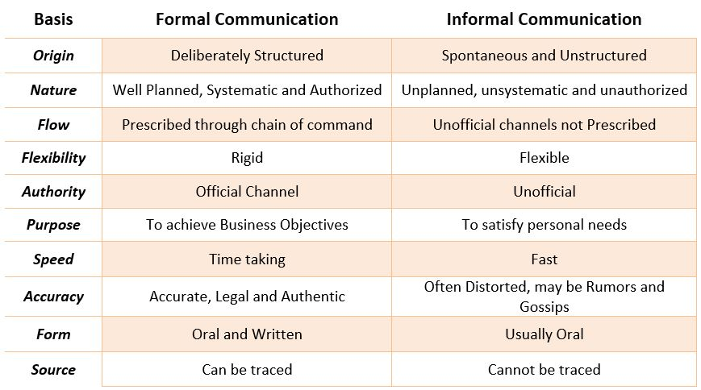
UNIT – 4
BARRIERS TO COMMUNICATION
- INTRODUCTION :

- There are many reasons why communications may fail.
- In many communications, the message may not be received exactly the way the sender intended and hence it is important that the communicator seeks feedback to check that their message is clearly understood.
- The skills of Active Listening, Clarification and Reflection, may help but the skilled communicator also needs to be aware of the barriers to effective communication. There exist many barriers to communication and these may occur at any stage in the communication process.
- Barriers may lead to your message becoming distorted and you therefore risk wasting both time and/or money by causing confusion and misunderstanding.
- Effective communication involves overcoming these barriers and conveying a clear and concise message.

- COMMON BARRIERS TO EFFECTIVE COMMUNICATION:

- Use of jargon – Over-complicated or unfamiliar terms/ difficult words
- Emotional barriers and taboos
- Lack of attention, interest, distractions, or irrelevance to the receiver
- Differences in perception and viewpoint
- Physical disabilities such as hearing problems or speech difficulties
- Physical barriers to non-verbal communication
- Language differences and the difficulty in understanding unfamiliar accents
- Expectations and prejudices which may lead to false assumptions or stereotyping
- Cultural differences - The norms of social interaction vary greatly in different cultures, as do the way in which emotions are expressed.

- Linguistic/ Semantic Barriers:

- The language barrier is one of the main barriers that limit effective communication. Language is the most commonly employed tool of communication. The fact that each major region has its own language is one of the Barriers to effective communication. Sometimes even a thick dialect may render the communication ineffective.
- As per some estimates, the dialects of every two regions changes within a few kilometers. Even in the same workplace, different employees will have different linguistic skills. As a result, the communication channels that span across the organization would be affected by this.

- Psychological Barriers :
- There are various mental and psychological issues that may be barriers to effective communication.
- Some people have stage fear, speech disorders, phobia, depression etc.
- All of these conditions are very difficult to manage sometimes and will most certainly limit the ease of communication.

- Emotional Barriers :
- The emotional intelligence of a person determines the ease and comfort with which they can communicate. A person who is emotionally mature will be able to communicate effectively. On the other hand, people who let their emotions take over will face certain difficulties.
- A perfect mixture of emotions and facts is necessary for effective communication.
- Emotions like anger, frustration, humour, can blur the decision-making capacities of a person and thus limit the effectiveness of their communication.

- Physical Barriers to Communication :
- They are the most obvious barriers to effective communication. These barriers are mostly easily removable in principle at least.
- They include barriers like noise, closed doors, faulty equipment used for communication, closed cabins, etc.
- Sometimes, in a large office, the physical separation between various employees combined with faulty equipment may result in severe barriers to effective communication.

- Cultural Barriers of Communication :

- As the world is getting more and more globalized, any large office may have people from several parts of the world. Different cultures have a different meaning for several basic values of society. Dressing, Religions or lack of them, food, drinks, pets, and the general behavior will change drastically from one culture to another.
- Hence it is a must that we must take these different cultures into account while communication. This is what we call being culturally appropriate. In many multinational companies, special courses are offered at the orientation stages that let people know about other cultures and how to be courteous and tolerant of others.

- Organisational Structure Barriers :

- As we saw there are many methods of communication at an organizational level.
- Each of these methods has its own problems and constraints that may become barriers to effective communication.
- Most of these barriers arise because of misinformation or lack of appropriate transparency available to the employees.

- Attitude Barriers :

- Certain people like to be left alone. They are the introverts or just people who are not very social. Others like to be social or sometimes extra clingy! Both these cases could become a barrier to communication. Some people have attitude issues, like huge ego and inconsiderate behaviours.
- These employees can cause severe strains in the communication channels that they are present in. Certain personality traits like shyness, anger, social anxiety may be removable through courses and proper training. However, problems like egocentric behaviour and selfishness may not be correctable.

- Perception Barriers :
- Different people perceive the same things differently.
- This is a fact which we must consider during the communication process.
- Knowledge of the perception levels of the audience is crucial to effective communication.
- All the messages must be easy and clear. There shouldn’t be any room for a diversified interpretational set.

- Physiological Barriers :

- Certain disorders or diseases or other limitations could also prevent effective communication between the various channels of an organization.
- The shrillness of voice, dyslexia, etc are some examples of physiological barriers to effective communication.
- However, these are not crucial because they can easily be compensated and removed.

- Technological Barriers & Socio-religious Barriers :

- Other barriers include the technological barriers. The technology is developing fast and as a result, it becomes difficult to keep up with the newest developments. Hence sometimes the technological advance may become a barrier. In addition to this, the cost of technology is sometimes very high.
- Most of the organizations will not be able to afford a decent tech for the purpose of communication. Hence, this becomes a very crucial barrier. Other barriers are socio-religious barriers. In a patriarchal society, a woman or a transgender may face many difficulties and barriers while communicating.

- FEW OTHER TYPES OF BARRIERS :

- Sender oriented barriers :

  - Badly expressed message
  - ‘I’ – attitude
  - Loss of transmission
  - Over/ under communication
- Receiver oriented barriers :

  - Poor retention
  - Inattentive listening
  - Resistance to change
  - Differing status and position

- Goal Conflicts :

- Differing goals
- Bifurcation of interests
- Competing to fulfill their narrow interests

- Information Overload :

  - Inflow of unchecked information
  - Delay of processing and responding

- OVERCOMING BARRIERS :

- Eliminating differences in perception:
  - The organization should ensure that it is recruiting right individuals on the job. It’s the responsibility of the interviewer to ensure that the interviewee has command over the written and spoken language. There should be proper Induction program so that the policies of the company are clear to all the employees. There should be proper trainings conducted for required employees

- Flexibility in meeting the targets:
  - For effective communication in an organization the managers should ensure that the individuals are meeting their targets timely without skipping the formal channels of communication. There should not be much pressure on employees to meet their targets.

- Use of Simple Language:
  - Use of simple and clear words should be emphasized. Use of ambiguous words and jargons should be avoided.

- Reduction and elimination of noise levels:
  - Noise is the main communication barrier which must be overcome on priority basis. It is essential to identify the source of noise and then eliminate that source.

- Active Listening:
  - Listen attentively and carefully. There is a difference between “listening” and “hearing”. Active listening means hearing with proper understanding of the message that is heard. By asking questions the speaker can ensure whether his/her message is understood or not by the receiver in the same terms as intended by the speaker.

- Emotional State:
  - During communication one should make effective use of body language. He/she should not show their emotions while communication as the receiver might misinterpret the message being delivered. For example, if the conveyer of the message is in a bad mood then the receiver might think that the information being delivered is not good.

- Simple Organizational Structure:
  - The organizational structure should not be complex. The number of hierarchical levels should be optimum. There should be a ideal span of control within the organization. Simpler the organizational structure, more effective will be the communication.

- Avoid Information Overload:
  - The managers should know how to prioritize their work. They should not overload themselves with the work. They should spend quality time with their subordinates and should listen to their problems and feedbacks actively.

- Give Constructive Feedback:
  - Avoid giving negative feedback. The contents of the feedback might be negative, but it should be delivered constructively. Constructive feedback will lead to effective communication between the superior and subordinate.

- Proper Media Selection:
  - The managers should properly select the medium of communication. Simple messages should be conveyed orally, like: face to face interaction or meetings. Use of written means of communication should be encouraged for delivering complex messages. For significant messages reminders can be given by using written means of communication such as : Memos, Notices etc.
UNIT – 5
WRITTEN COMMUNICATION: BUSINESS LETTERS (THEORY)
- Introduction :

- Business Letter is a letter which is used by organizations to communicate in a professional way with customers, other companies, clients, shareholders, investors, etc. Business letter uses formal language and a specific format.
- Companies use it to convey important information and messages. An individual can also use it while writing an application for a job, cover letters, or any formal document.

- Business Letter Definition:
- A letter written for business purpose is a business letter. Inquiry letter, offer letter, order letter, cover letter, notices, termination of employment are some of the business letters. Suppose a person wants to write any of these business letters.
- There is a pre-specified format for writing a business letter. There are some parts of a business letter and rules associated with them.

- Parts/ Inward Structure of a Business Letter :
- A business letter will be more impressive if proper attention is given to each and every part of the business letter.
There are basically 8 Parts of Business Letter
- The Heading or Letterhead
- Date
- Inside Address/ Receiver’s address
- Salutation
- Subject line
- Body of the letter
- Complimentary Close
- Signature and Writer’s Identification
- Enclosures (optional)

- The Heading or Letterhead (Crown of business letter) (Window of the firm):
- It usually contains the name and the address of the business or an organization. It can also have an email address, contact number, fax number, trademark or logo of the business.

2. Date :
- We write the date on the right – hand side or left – hand side corner of the letter below the heading.

3. The Inside Address :
- It includes the name, address, postal code, and job title of the recipient. It must be mentioned after the reference. One must write inside address on the left-hand side of the sheet.

4. The Salutation/ Greeting :
- It contains the words to greet the recipient. It is also known as the salutation. The type of salutation depends upon the relationship with the recipient.
- It generally includes words like Dear, Respected, or just Sir/Madam. A comma (,) usually follow the salutation.

5. Subject :
- It is a brief statement mentioning the reason for writing the letter. It should be clear, eye catchy, short, simple, and easily understandable.

6. The Body Paragraphs :
- This is the main part of the letter. It contains the actual message of the sender. The main body of the mail must be clear and simple to understand. The body of the letter is basically divided into three main categories.
- Opening Part: The first paragraph of the mail writing must state the introduction of the writer. It also contains the previous correspondence if any.
- Main Part: This paragraph states the main idea or the reason for writing. It must be clear, concise, complete, and to the point.
- Concluding Part: It is the conclusion of the business letter. It shows the suggestions or the need of the action. The closing of the letter shows the expectation of the sender from the recipient. Always end your mail by courteous words like thanking you, warm regards, look forward to hearing from your side etc.

7. The Complimentary Close :
- It is a humble way of ending a letter. It is written in accordance with the salutation. The most generally used complimentary close are Yours faithfully, Yours sincerely, and Thanks & Regards.

8. Signature and Writer’s Identification :
- It includes the signature, name, and designation of the sender. It can also include other details like contact number, address, etc. The signature is handwritten just above the name of the sender.

9. Enclosures :
- Enclosures show the documents attached to the letter. The documents can be anything like cheque, draft, bills, receipts, invoices, etc. It is listed one by one.
- Additional Parts of a Business Letter
Copy Circulation
- It is needed when the copies of the letter are sent to other persons. It is denoted as C.C.
PostScript
- The sender can mention it when he wants to add something other than the message in the body of the letter. It is written as P.S.

- Essentials of a Good Business Letter :

- Correctness: A letter must be correct in every aspect. Especially in: 1) in appearance and form of layout 2)in grammar, spelling and use of language 3) in the information it conveys. Completeness of a letter is dependent on the correctness of the letter. Following correctness should be taken care of:
  - Correctness of details: It is necessary that the facts presented in the business letter is correct. in fact, one should not transmit any message unless he is absolutely sure of its correctness.
  - Correct time: Send your message at correct time. All messages must be transmitted and responded to at the proper time. Outdated information is a waste of time and efforts.
  - Correct language: The letter should be correct from the language point of view. It means that the writer should be careful in spellings, grammar and other aspects of language.
  - Correctness of format: The writer of the letter should be careful about the format of letter. It means all the parts of the business letter should be placed properly.

- Clarity: A letter must have clarity. The underlying message should be expressed in clear terms. Care should be taken to avoid ambiguity. The purpose of communication should be made clear. Whether it is to inform, invite, reiterate, emphasize, remind, announce, seek participation or clarity and correct the earlier message, the purpose should clearly be stated.
If a letter writer is writing a letter on behalf of somebody else, it should be done after obtaining clear instructions. There are occasions when one may receive a letter informing the date and the venue of a meeting without an accompanying invitation or request to attend.
The reader or the receiver of the communication, in such an instance, will be in a dilemma. Is the invitation intended and implied but not specifically stated? Or is the letter just meant to be informative and no invitation is being extended? One way or the other, the message should be clear.
- Conciseness/ Brevity: Any business will have to value the receiver’s time. Brevity in letter writing, therefore, is a must. Long letters, whatever are their merits, are often kept aside for ‘later reading’. Brevity in communication is also referred to as conciseness.
Conciseness refers to the skill of conveying what one wants to convey in the fewest possible words, without sacrificing completeness or courtesy. Conciseness eliminates unnecessary words and phrases, repetitive sentences and keeps the letter focused.
A good letter makes economical use of words. Brevity is a skill that a business communicator must develop. As people move up in an organizational hierarchy, their ability to condense messages into brief and focused letters counts for a lot.
- Courtesy: Good writing style should also encompass politeness or courtesy. It should respect the reader as an individual. It should reflect the basic minimum courtesies that any transaction or relationship demands.
It should be appreciative and complimentary to the extent appropriate in the given context. Business letters, by and large, seek to strengthen the relationships that are good for the business when the occasion demands. The writer should not hesitate to apologize for omissions or errors.
- Character: Here, character means individuality. A business letter should reflect the personality of the writer. Every person writes the business letter differently. This difference is due to the different personality. Each and every person selects words and phrases differently. To create a desirable impact on the reader’s mind, the writer should make the letter avoid writing it in monotonous manner. The reader should understand the personality of the writer through the letter.

- Cheerfulness/ Appeal: A good letter should appeal to the reader’s sensibilities. It should go beyond the message it conveys and make a good impression. It should have elegance, which means taste, beauty and decency.
A good letter also ensures certain aesthetic appeal. No letter can be called elegant or aesthetically appealing if it does not give due attention to appearance. Mistakes and corrections, striking, overwriting, improper ink flow, unintended gaps and other such deficiencies rob an otherwise good letter of all its elegance.
A letter is appealing when it shows consideration. Consideration means thoughtfulness. It means keeping in mind the reader and putting oneself in the reader’s shoes while writing the letter. Consideration means visualizing the reactions of the reader and accommodating them in the approach to the communication.
- Concrete: Imagine a letter received from a departmental store announcing the opening of a new branch and seeking your patronage that does not give details of the new address or timings. Another requirement of a business letter is concreteness.
A communication is said to be concrete when it is specific, definite and to the point and not vague and generalized. Often the letters are so rambling in nature that one can imagine the reader screaming, ‘Please come to the point and be specific.’ A concrete letter does not ramble and is sharp and focused.
- Coherent (Logical): Yet another requisite of an impact-creating letter is coherence. It is necessary to use words, phrases and clauses clearly, so as to form balanced sentences. Coherence seeks to establish a proper relationship and links sentences to make the intended message clear. Coherence brings consistency and orderliness to the encoded message.
A letter succeeds in creating the desired impact when it ensures purpose orientation, lays the right emphasis, establishes an appropriate wavelength and is coherent. Some of the common questions asked or statements made in relation to these attributes are:
1. What is one trying to convey? (Purpose orientation)
2. Which of these is really urgent⁹ (Emphasis)
3. Is it too elementary or is it an overhead transmission? (Wavelength)
4. What is the sequence? (Coherence)
It is necessary to give due attention to these areas and build up skills so that the letters become impact-creating.
- Complete: The principle of communication that we are referring to here is also known as adequacy or completeness. A communication can be said to be complete only when it contains all the facts and details which the receiver needs to know in order to respond or act on the basis of that communication.
Not giving all the required details leads to protracted correspondence, loss of customers or lack of response. Worse still, although non-submission of full details maybe due to an oversight or inadequate attention to details, the receiver may infer that there is a deliberate attempt to withhold or conceal facts and figures.
(You can also refer above points for 7C principles of a business letter)
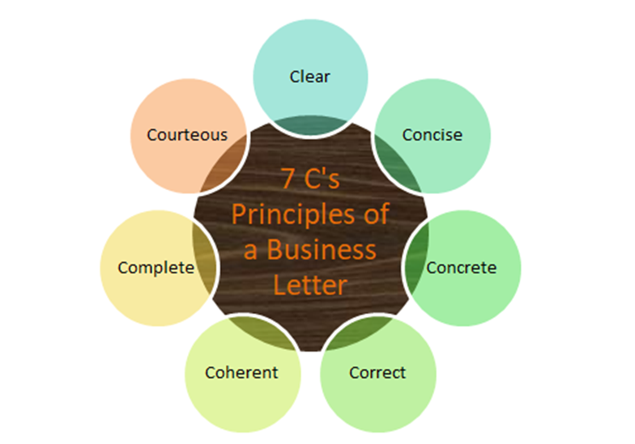
- Outward Appearance of a Business Letter :

- Stationery: Business concerns should take extra care while selecting paper/ stationery, for the purpose of writing a business letter. The paper selected should be smooth, durable and white or light in color. Coarse and ruffled paper spoils the image of the firm. As business letters are to be filled and recorded for a longer period, the texture of the paper should also be of fine quality.

- Letterhead: A sheet of paper on which the firm's name and its full postal address are printed at top centre is known as letterhead. Letterhead also contain the symbol of the firm. Letterhead can be made attractive by limiting information to be conveyed. Letterheads are available in two popular size:
  - 1. The standard size - 8.5" x 11" is convenient for standard messages
  - 2. The smaller size - 5" x 8" for short messages

- Paragraphing: Paragraphing is not merely a matter of drafting. It is a matter of appearance too. Paragraphing enables us to divide the content of the letter into logical and readable units. A business letter has three paragraphs: Beginning, middle and closing. Although they are separate, they contribute to another. A business letter should give a unified impression to the reader.

- Typing : Usually personal letters are hand written. On the contrary, business letters are type written. Typing must be neat and even. A good business letter must be free from typing errors. Strikeovers, faint Ribbon impression, smearing and poor erasing reflect adversely on the firm. There are no hard and fast rules regarding spacing but it should look balanced. The typist should take care of proper punctuation marks and correct spellings.

- Margin: Proper spacing and margin is pleasing to see. The width of the margin depends on the size of the letter and the length of the content of letter. Generally margin of an inch and a half is kept on either side of the letter. Margin is also useful while filing the letter. It enables proper filing of the letter without any loss of the content.

- Folding: It is a common impression that folding of a letter is the least important aspect of letter writing. But folding requires special skill on the part of business letter writing. Generally two or three folds lengthwise and one or two folds breadthwise are advisable.

- Envelope: The envelop matches with the inside letter in terms of colour, quality and size. Envelopes are available in various sizes but the most popular among them are: [1] 3.5”x5.5” for single sheet letters and [2] 4.5”x10.5” for letters with more sheets. Window envelops have transparent panel where the receiver’s address is to be printed. This save the time and energy of the despatcher.

- YOU ATTITUDE:

- Because we are self-centered, we tend to see each situation form our own points of view. In letter writing situations, this attitude may lead us to a writer-oriented, we-view point approach-one that places emphasis on ourselves and our interests rather than on our readers and their interests.
- The ‘you attitude’ is writing style that emphasizes readers rather than the writer. To write business letter we should not focus or put our self in the place of receivers. Their desires, problems, circumstances, emotions and probable reactions are to be taken into consideration. Business letter must be written from ‘you viewpoint’ instead of ‘I or we viewpoint’. You viewpoint emphasize reader’s interest and help to win the reader’s mind and attention.
- For example:
- I or We attitude: We are sure that our view discount policy will attractive to you.
You attitude: You will surely appreciate new discount policy.
- I or We attitude: I am happy to hear that you have selected our firms.
You attitude: Thank you for giving us the opportunity to serve you.
- I or we Attitude: I will give you 10% discount
You attitude: You can get 10% discount

- Benefits of You attitude:
- Creation of friendly atmosphere
- Motivation the reader
- Establishment of mutual trust
- Can create favorable outcome even in a bad-news situation
- Accomplishment of the goal of the letter
- Enhance goodwill of the firm

- Format of Layout of Business letters:
- Indented form
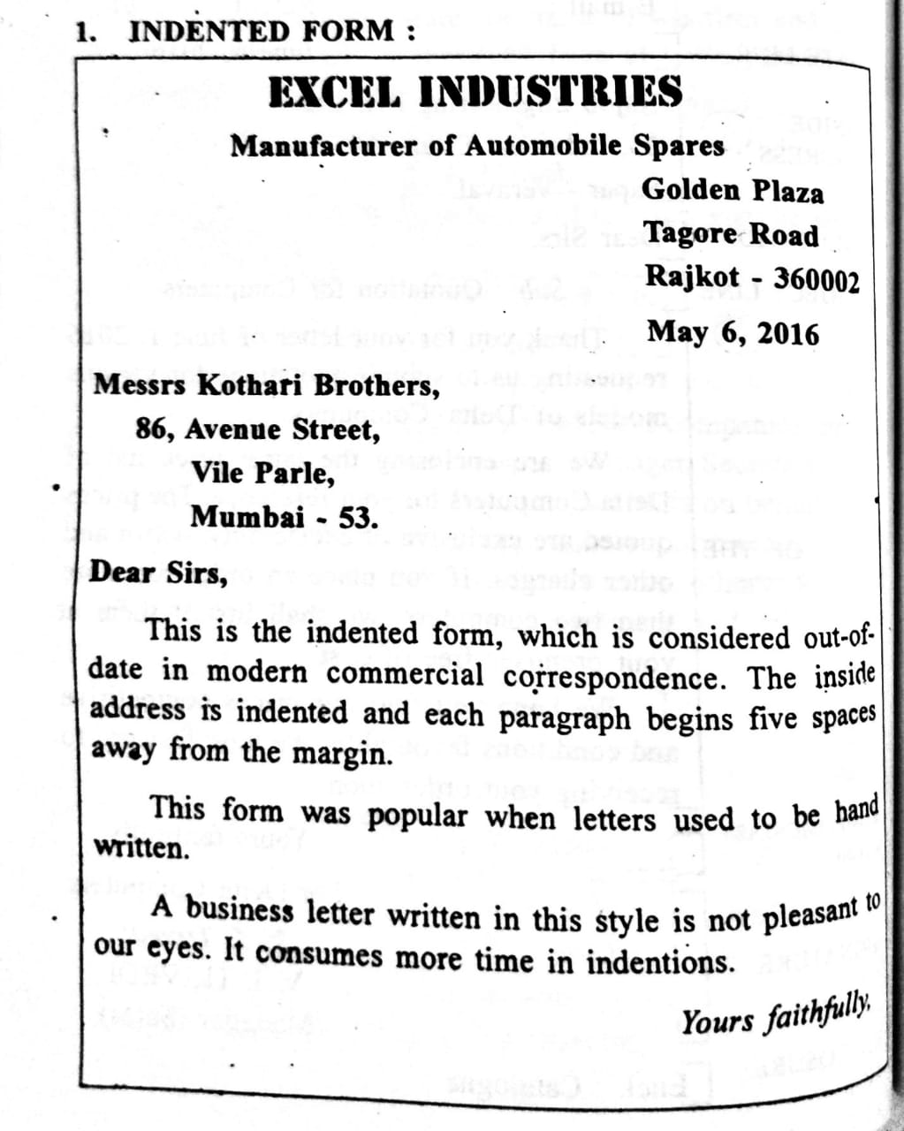
- Semi Block form
- Modified Block form
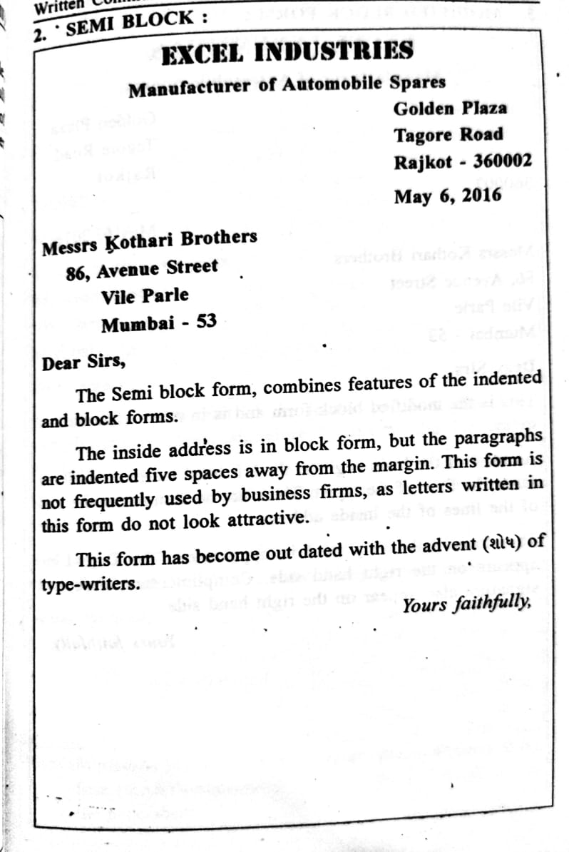
- Full Block form

The inside address is in single line without space from margin.

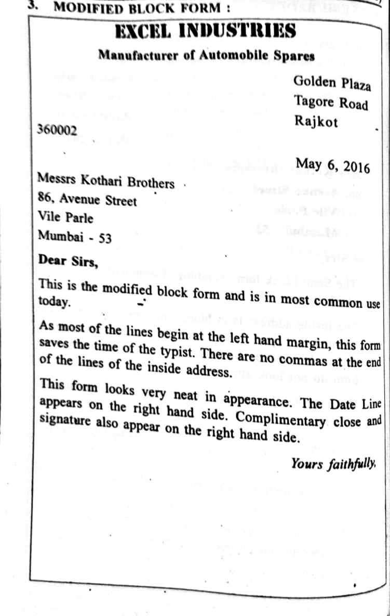
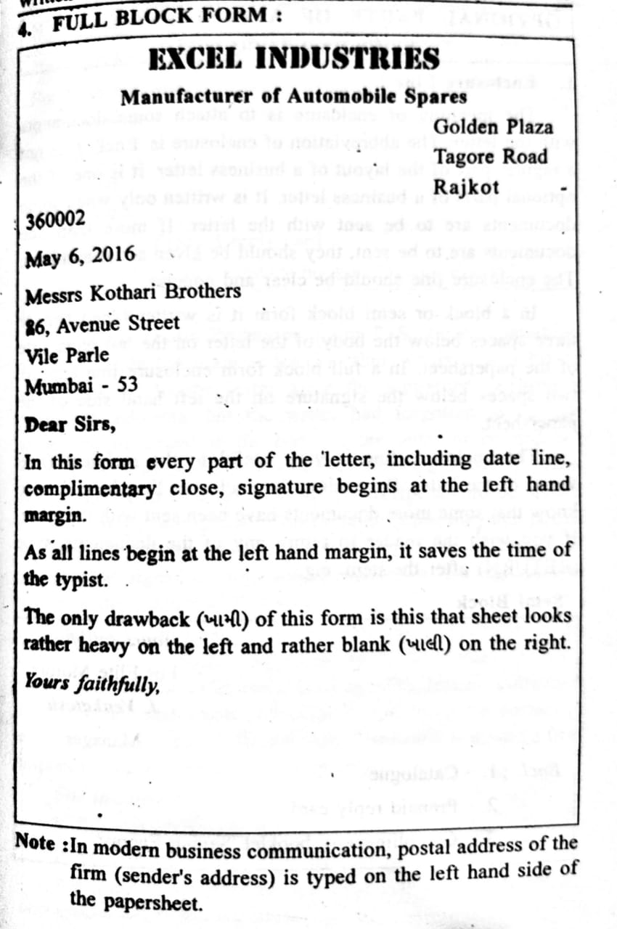

UNIT 6 – PRACTICAL LETTER WRITING: LETTER OF INQUIRY AND REPLY
- Write an inquiry letter for the purchase of home appliances from the wholesaler.

Jaisons Home Appliances
Raiya Road
Rajkot - 230001
Telephone no. 0281 – 2456789 website: www.jaisons.in

12th September 2020

Tristar Home Products
101 D, Industrial Estate
Veraval

Dear Sir,

Re: Inquiry for home appliances

We would like to introduce ourselves as a reputed dealer of home appliances and other electronic items. You company’s name has been recommended by our business friend Gayatri Collections, Rajkot.
We are interested in purchasing home appliances manufactured by you. Please let us know the terms and conditions along with the prices of the following home appliances:
Tristar Microwave Oven - 10
Tristar Juice Maker - 20
Tristar Grinder - 15
Tristar hand Blender - 25

We expect considerable discounts as we wish to place a large order with you. We appreciate if you could send us the latest catalogue for our reference. We hope to hear from you soon.

Yours faithfully,
Jaisons Home Appliances

NayanC.
Mr. Nayan Chauhan
(Sales Head)

- On behalf of Pari Garments, Porbandar, write a letter of inquiry to Prince Fashions, Rajkot, for different types of children garments. :
Pari Garments
180 ft. Ring Road
Porbandar – 457765
Contact No. +91 – 976760797 e-mail: parigarments@yahoo.com

12th September 2020

Prince Fashion
Kalawad Road
Rajkot – 360005

Dear Madam,

Re.: Inquiry for children garments

We are a highly reputed children’s garment store at Porbandar. Your store’s recommendation was given to us by one of our dear customer who told us that you are her friend.
We would like to inquire about the prices of following garments and also would like to request you to send us few of them so that we can sell it in Porbandar in your brand name. Following is the list of garments:
Boys shirts - 10
Boys trousers - 10
Girls Traditional wear – 20
Girls Skirts - 15
Common nightwear - 15

We look forward to hear from you soon. Also expecting to have good business terms in future as well.

Yours Sincerely
Pari Garments

ManishaA.
Ms. Manisha Agrawal
(Store Incharge)

- Draft a letter of inquiry to ‘Anchor Electric Co.’ inquiring about the electronic products

BHUSHAN ELECTRONICS
150 ft. Ring Road
Raiya Chowkdi
Rajkot – 360005
Contact No.: 0281 – 24566667 e-mail: bhushan@gmail.com

19th September 2020

Anchor Electric Co.
Industrial estate gate no.2
Surendranagar

Dear Sir,

Re.: Inquiry about the electric products
This is to bring to your notice that we would like to place an order with you for certain electric products and for that please send your lowest quotations for the following accessories:
Sr. No. | Product | Quantity
1 | Anchor boards & switches | 100
2 | Anchor fans | 80
3 | Anchor tubelights | 100
4 | Anchor bulbs | 50

Please consider the following terms for the payment:
Mode of payment: Cash on Delivery
Delivery: within Fortnight
Kindly also provide us with your catalogue with the latest and competitive prices of your products.
We promise to place a large order with you if you quote us with most competitive prices. Please feel free to contact us for further clarifications if required.
We look forward to hear from you.
Yours faithfully
__________________
Nitin Shah
(Partner at Bhushan Electric Co.)

- Write an inquiry letter for hiring services of an internet service provider.

TASK PLACEMENT CONSULTANCY
2/3 H Star Chambers
Harihar Chowk
Rajkot – 360003
Telephone No.: 0281 – 2445566 E-mail:taskplacement@gmail.com

14 October 2020

STAR INFOTECH
Gayatri Plaza
Satellite Road
Ahmedabad – 345001

Subject: Inquiry about Internet Services
Respected Sir,
We would like to introduce ourselves as a reputed placement consultancy provider of Rajkot. We provide feedback to different organizations enabling them to locate suitable candidates.
Keeping up with the pace of the demands of the information technology era, we have decided to expand our horizons to a larger section of society with the help of internet services. We would like to hire you for this purpose and hence we wish to inquire about the same.
We would like to know your charges for preparing the web pages and the content for our organization. If your terms and conditions are favourable, we shall give you yearly contract for the same. We look forward for an early reply informing us about your services and charges on which they can be made available to us.

Yours faithfully,
Neha Bhojani
Ms. Neha Bhojani
(Marketing Manager)
Task Placement Consultancy

- Read the following assignment summary and draft a suitable letter:

Letter From: The Fashion House
Relief Road
Ahmedabad – 1
Letter To: The Beauty Products Ltd.
15 Bank Street
Bombay – 400001
Subject: Inquiry for cosmetics
Objective: To get the details about the beauty products and state the time of delivery and terms of payment.

THE FASHION HOUSE
RELIEF ROAD
AHMEDABAD – 1
Mo. No. +91 – 7865432101 E-mail: thefashionhouse@gmail.com

14 October 2020
THE BEAUTY PRODUCTS LTD.
15 Bank Street
Bombay – 400001

Respected Ma’am,
Re.: Inquiry for cosmetics
We hope you remember “The Fashion House”, Ahmedabad who had previously ordered for your products. We really loved your products and would again like to place an order with you. Our customers appreciated your products and have been demanding again for it. Hence we would like to make an inquiry for few of your products. Here is the list of the products:
Sr. No. | Product | Quantity | Description
1 | Lakme foundation | 50 | Foundation of most used shades
2 | HudaBeauty Lipstick | Pink – 40  Brown – 30  Red – 30 | General shades (pink, brown and red)
3 | Maybelline Kajal | 150 | Dark shades
4 | Lakme Concealer | 50 | General used products

We expect this order to be delivered within a fortnight. We would like to make the payment using COD method. It would be highly appreciated if you can agree with our terms and deliver the required products. We look forward for your response.

Yours sincerely,
AartiKakkad
Ms. Aarti Kakkad
(Owner – The Fashion House)

REPLY LETTERS
Reply letters can be:
- Simple reply letters
- Quotation for specific order
- Delay in sending quotation
- Informing customers that their order cannot be granted
- Quotation with special terms

Format: (Sender’s address and contact information, date, receiver’s address, salutation, subject, [re.], body, complimentary close, signature, enclosures if any)

- Reply to a letter of inquiry for hiring of a structural consultant :

ORBIT CONTRACTOR & CO.
2, City Plaza
Satellite Road
Ahmedabad
Contact: +91-9988776655 website: www.orbitco.com

26th October 2020

Nasreen Builders Pvt. Ltd.
Shauna Towers
Near Stock Exchange
Rajkot

Respected Sir,
Re.: Your letter of 15th October 2020
Thank you for your letter of 15th October 2020 showing us the willingness to hire our services. We are happy to inform you that we shall provide our services as desired by you.

Usually we charge 5% of the construction cost or repairing cost as our consultation fees. But keeping in mind the current scenario of the damages in business due to Covid -19, we have currently reduced it to 2%. We will not charge anything extra for issuing certificates for insurance claims.

Sarjan Consultants of Rajkot are our authorized representative in the city. If you need further clarifications, you can freely approach them. We look forward to receiving your final reply.

Yours faithfully
SajanR.
Sajan Ram
Partner (Orbit Contractor & Co.)

- Submit quotation for various laptops and printers on behalf of Ankita Comtech. Clarify terms and conditions for payment, guarantee, warranty, and replacement. Assure for the best after sales services. :

ANKITA COMTECH
203, Golden Square
Kalawad Road
Rajkot
Contact: +91-9988776655 e-mail: ankitacomtech@gmail.com

26th October 2020

The Manager
Union Bank of India
Gondal Branch
Rajkot

Respected Sir,
Re: Quotation for laptops and printers
We thank you for your letter on 20th October 2020 asking us to submit the quotations for the supply of laptops and printers. Our prices and terms are as follows:
Sr. No. | Ref. No. | Description | Qty. | Price/unit
1 | HCL 2013 | HCL laptop | 2 | 34,000
2 | CM 2193 | Compaq laptop | 1 | 35,000
3 | AC 3123 | Acer laptop | 3 | 25,000
4 | HP 423 | HP Laser printer | 2 | 8,000
5 | HP 308 | HP combo printer | 1 | 15,000

Terms & Conditions:
The prices are inclusive of taxes and transportation charges. We are also enclosing our latest price list for your reference. We would like to deal with you on COD basis. Keeping the current scenario in consideration, we are also accepting E-payments if COD is not possible. The goods carry one year warranty and guarantee of repairing/ replacing the goods if damaged within one year. We shall be providing best after –sales services on the predetermined time period.
We look forward to receiving your confirmation letter of order.

Yours faithfully
MilanK.
Milan Kothari
Partner-Ankita Comtech

Encl.: Latest price list

- Draft a reply letter conveying about the delay in sending a quotation for plastic tanks to Ramesh Stores, Dharmendra road, Rajkot – 360001 :

KWALITY PLASTICS LTD.
210, Subhash Road
Mumbai – 400029
Contact: +91-9090909090 e-mail: kwalitypalstics@gmail.com

27th October 2020

Ramesh Stores
Dharmendra Road
Rajkot – 360001

Respected Sir,

Re.: Delay in sending the quotation
Thank you for the inquiry about the prices and conditions of supply of plastic tanks.

We regret to inform that we are unable to quote immediately because of shortage of raw materials and therefore our production is slow. We are trying our level best to manage the raw materials from our suppliers. We will be in a position to send you the quotation only after we receive the fresh stock of raw materials.

We shall try to submit our quotation latest by 15th November 2020. Please bear with us for this delay.
Yours faithfully,
AmalH.
Amal Hegde
Secretary – Kwality Plastics

- Draft a reply letter mentioning that the order cannot be granted due to certain issue and that you can offer a substitute for the ordered product. :

R & G STORES
SADHUVASVANI ROAD
RAJKOT
Contact No. 9999988888 e-mail ID: r&gstores@gmail.com

24th November 2020

Mayur Garments
MG Road
Junagadh

Respected Sir,
Re.: Substitute offer for Raymond shirts order no. e-986
It is a pleasure to let you know that we are overwhelmed on receiving your order for the Raymond shirts. We apologize for not being able to execute your order as there is shortage of Raymond shirts’ stock. Although we have placed an order for these shirts, we haven’t received it yet. So here we offer an alternate brand of shirts which is of good quality linen fabric and has been accepted by many customers in the market.
We would like to offer ‘Peter England’ shirts to you instead of Raymond brand. Although their prices might differ a little, we assure you of the quality of these shirts. We are also sending you the catalogue of Peter England shirts in which you can refer the colors and prices for more convenience.
We request you to consider this substitute offer by us. We look forward to receiving your order soon.

Yours sincerely
KiritP.
Kirit Padia
(Partner)

Encl.: Catalogue of Peter England shirts

- On behalf of Marshal Electric Co., Dhanraj Complex, Relief Road, Ahmedabad, draft a reply letter mentioning quotation with special terms. :

MARSHAL ELECTRIC CO.
DHANRAJ COMPLEX
RELIEF ROAD
AHMEDABAD
Contact No. 7766788998 website: www.marshal.in

24th November 2020

Gayattri Electricals
Dhebar Road
Rajkot

Respected Sir,
Re.: Quotation with special terms
Thank you for the order letter you had sent us for certain electrical products. It is a pleasure to let you know that we are offering certain special benefits exclusively for you as you are our valued customer.
As December month is approaching, we have planned for certain special Christmas offers for few of our valued customers. We are planning to give 5% discount on the purchase of any electric products and also giving a benefit of bulk purchase wherein if you place an order of 100 LED bulbs, you get an additional benefit of 10 extra LED bulbs.

Sr. No. | Product | Offer
1 | Smart TV | 10% discount on purchase of 50 Smart Tv order
2 | Bajaj Fans | Additional fan free with the purchase of 10 fans
3 | Kelvinator Refrigerator | On purchase of 10 Fridge, 20% discount

We hope that you are really happy with this special terms exclusively for you. We look forward for your orders at the earliest.

Thanking You
Yours faithfully
SajanPatel.-
Mr. Sajan Patel
(Manager)

UNIT 7 – LETTERS OF ORDER & EXECUTION
- Order Letters :

- On behalf of B.K. Institute of Management, Navrangpura, Ahmedabad, draft an order letter for the supply of certain magazines, newspapers and journals to Mayur Agencies, Rajkot.

BK INSTITUTE OF MANAGEMENT
NAVRANGPURA
AHMEDABAD
Contact No. 77788665544 E-mail: bkmahmd@gmail.com

25th November 2020

Mayur Agencies
Kalawad Road
Rajkot

Dear Sir,

Re.: Supply of magazines, newspapers and journals

We thank you for quoting subscription rates of various newspapers, magazines and journals. We would like to again place and order with you for the following newspapers, magazines and journals:
Sr. No. | Names | Frequency | No. of copies
1 | The Times of India | Daily | 10 copies
2 | The Economic Times | Daily | 5 copies
3 | Forbes India | Weekly | 5 copies
4 | The Reader’s Digest | Weekly | 5 copies
5 | Journal of Management studies | Quarterly | 3 copies
6 | Indian Journal of Medical Research | Weekly | 3 copies

We would like to inform you that it would be preferable if we receive our order by 30th November 2020 by 6:00 p.m. We are enclosing a crossed cheque No. CA 768654 for Rs. 15,000/- towards the subscription of the above mentioned newspapers, magazines and journals.

Please confirm the order and do the needful.

Yours faithfully
For BK Institute of Management
sd/- Mr. Kabir Khan
Director

Encl.: Cheque No. CA 768654 for Rs. 15,000/-

- Draft a letter: Order for crockery items

PATEL GLASSWARE
KALAWAD ROAD
RAJKOT
Contact No. 0281-24455665 e-mail: patelglassware@yahoo.in

25th November 2020

Saurashtra Glassware
Nr. Government Hospital
Bedi Road
Jamnagar

Dear Sir,

Re.: Order for crockery items
We are happy with the products sent by you all these years and our customers have also appreciated the quality of the products. Hence we look forward to carry on our business with you and so we would like to place an order for the following crockery items:
Sr. No. | Product description | Quantity
1 | Cup and saucers | 50
2 | Coffee Mugs | 100
3 | Water jars | 80
4 | Laopala Plates | 25 sets each of 5 plates
We request you to take care about the packaging of these items as they are breakable. Hence, kindly handle with care during transportation. We shall make the payment through cheque once we receive the order. Kindly confirm before the dispatch of the above mentioned order through a phone call or an email.

We look forward for the safe delivery of the orders products.
Yours faithfully
For Patel Glassware
sd/- Ms. Rubina Patel
Owner

- Place an order for purchase of salt with specific instructions.

ADANI FOOD PRODUCTS PVT. LTD
GALAXY COMPLEX
JAWAHAR ROAD
JETPUR
Contact No. 9977665533 e-mail: adanifoods@gmail.com

26th November 2020

Tata Chemicals
Mithapur

Respected Sir,
Re.: Purchase of ‘A’ grade salt
We thank you for your letter mentioning the prices, terms and conditions regarding the supply of ‘A’ grade salt. We found your prices to be competitive and your terms to be favourable. We would like to place an order for one thousand ton of ‘A’ grade salt.
Due to the Covid situations, we would specifically request you to deliver our order through goods train as rail route is preferable over the roadways. another requirement is regarding the batches, we would prefer the quantity mentioned above to be delivered in four different batches each consisting of 250 tons of salt. We require the delivery of each batch of 250 tons at an interval of 15 days each. The first batch should reach us latest by 10th of December 2020.
We hope that you would be able to deliver us our order based on the above specifications. please confirm the order through email.

Yours faithfully
For Adani Food Prducts Pvt. Ltd.
sd/- Mr. Yatin Adani
Purchase Manager

- Execution Letter :
- Draft a letter informing your customer that goods cannot be supplied at old prices.

OSWAL WOOLLEN PRODUCTS LTD.
PRAGATI NAGAR
JAIPUR
Contact No. 7766776677 email: oswal@yahoo.com
25th November 2020

JP Brothers
Royal Chambers
Morbi

Respected Sir,

Re.: Revised prices for your last order
We received your order on 25th October 2020 for the supply of certain woolen clothes. But we regret to inform you that we are not in a position to deliver you the goods at the old prices due to the Covid situation.
The prices mentioned previously in our last catalogue which you had referred have been revised now as we were running into losses due to the current situation. So therefore we have increased the cost by 5% in order to keep up with the pace of the competitive market. We therefore request you to consider the new prices and rethink over the previous order.
Kindly let us know your decision after referring the new catalogue that has been enclosed with this letter. We would be highly obliged if you still continue with your order. Hope you understand the situation.
Yours faithfully,
For Oswal Woollen Products
sd/- Mr. JP Khanna
Sales Manager

Encl.: Catalogue of Revised prices

- Draft a letter of acknowledgement of order for the supply of plastic chairs.

KWALITY PLASTIC LIMITED
Malad – (E)
Mumbai
Contact No. +91-7766556655 e-mail: kwalityplastic@gmail.com

30th November 2020

Regal Furniture
Dhebar Road
Rajkot

Dear Sir,

Re.: Your order letter dated 25th November 2020
We thank you for the letter of 25th November 2020, placing an order for the supply of plastic chairs. Please confirm the order below:
Ref. No. | Description | Quantity
CHR – 3001 | Classic White | 100
CHR – 4003 | Brown Royals | 80
CHR – 4005 | Elegant Gray | 50

We have executed your order and sent the above mentioned chairs through Transport Corporation India and it will be delivered to you by 3 December 2020. The bill of Rs. 10,000 is also sent with it. Kindly make sure that you proceed with the payment as soon as you receive the goods. For your reference, we are also enclosing the copy of invoice.
Looking forward for future orders as well from you.

Yours faithfully
Gupta.
Mr. J.D. Gupta
(Sales Manager)

Encl.: Copy of invoice

- Refuse to execute an order till such time the outstanding bill is paid off.

REGAL GLASSWARE
Dev Nagar
New Delhi
Contact no.: 8889988221 website: www.regalglassware.in

30th November 2020

Manish Traders
Gayatri Chambers
Amreli

Respected Sir,
Re.: Payment of outstanding bill
We are really thankful to you for being our valued customer all these times. But as you know, every business has certain rules of functioning and so do we. We work on the conditions of strict payments and therefore we regret to inform you that we might not be able to execute your latest order until your last outstanding bill is paid off.
We also would like to remind you that the outstanding amount is Rs. 8000 for which we had delivered few crockery items to you. For us also, it is difficult to function without the payments from our customers. So kindly make the payment as soon as possible and then we shall execute your new order.
We look forward to receiving your payment either through cheque or cash.

Yours faithfully,
For Regal Glassware
sd/- Mr. JM Khanna
(Partner)

- Avni Jewelers, Bhuj, have received an urgent order for specific types of jewelry items. But because the workers are on leave, they are not in a position to prepare the order in time. Draft a suitable reply on behalf of Avni Jewelers, Bhuj.

AVNI JEWELERS
3-B PRAGATI COMPLEX
GAURAV PATH
BHUJ
Contact No.: +91- 886655543 e-mail id: avnijewelers@yahoo.com

30th November 2020

Radhika Jewelers
Station Road
Jetpur

Respected Sir,
Re.: Delay in executing the order
It has been a privilege to have a customer like you with us all these years, but we are sorry to inform you that for the first time, we won’t be able to execute your order as per the time given to us.
As you know the current scenario of the pandemic times, our workers were sent back to their native place as we wanted to prevent the outbreak of Covid in our working place. The workers shall return back to work by 5th December 2020 and thereafter they shall start working on your order. We shall try our level best to deliver your order by 15th December 2020 but till then, kindly bear with us.
We request you to consider our situation and give us an extension till 15th December 2020. We hope you shall continue with this order and we are extremely sorry for the inconvenience.

Yours faithfully,
For Avni Jewelers
avnimalhotra.
Ms. Avni Malhotra
(In-charge)

☺ ALL THE BEST!! DO WELL!! ☺

